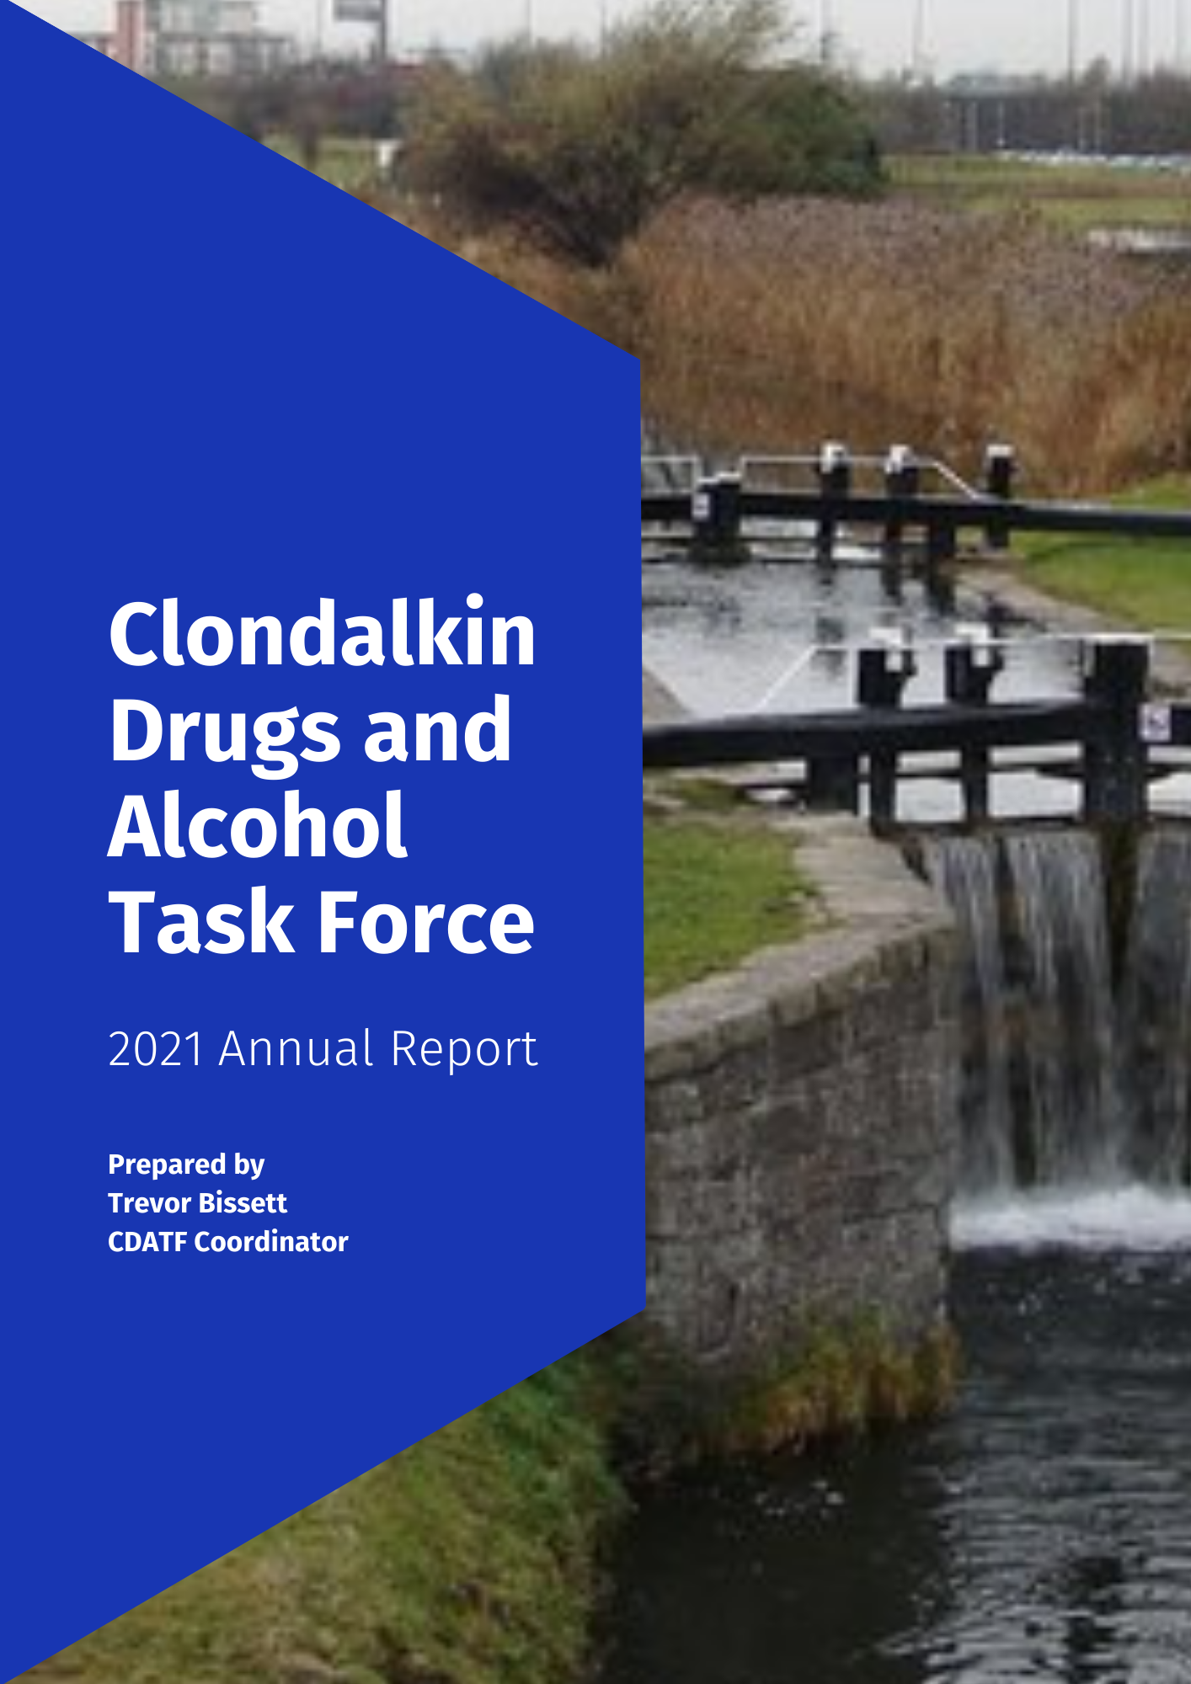
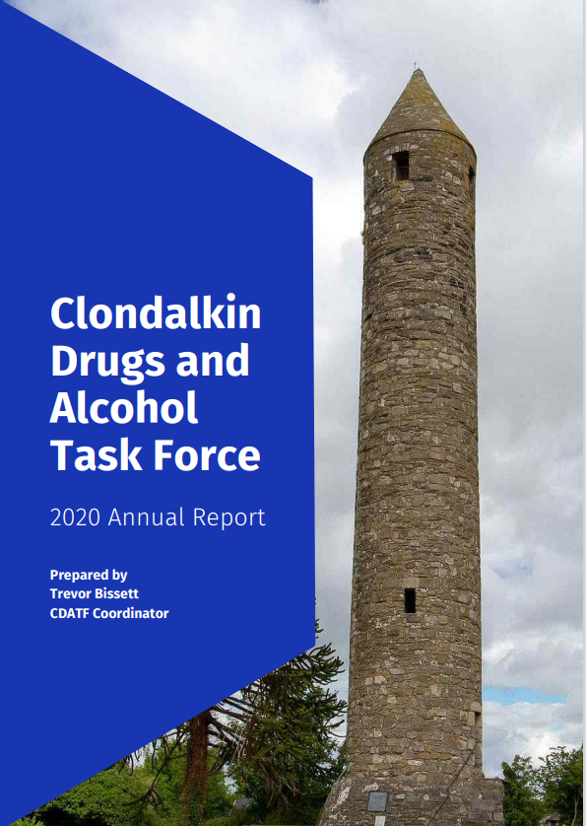
ruth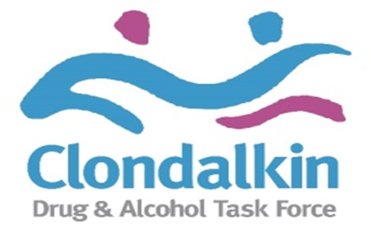
Contents
Introduction Page 3
1 CDATF Overview Page 4
2 Strategic Direction Page 7
3 Governance Page 8
4 Detailed Analysis of CDATF Area Page 9
5 Profile of Drugs Use in CDATF Area Page 13
6 Emerging Trends in Drugs Use Page 19
7 Activity Report 2020 Page 24
7.1 Staffing Page 24
7.2 Organisational Review 2021 Page 24
7.3 CDATF Achievements 2021 Page 25
7.4 Funded Projects Achievements 2021 Page 32
8 Board Membership Page 39
9 Appendices Page 40
A References Page 40
B Strategy Plan Implementation Table Page 41
C Accounts Page 50

Introduction
This is my second time to present the annual report for the Clondalkin Drugs and Alcohol Task Force, (CDATF). The 2021 Annual Report highlights the work being carried out throughout the year. Established in 1997, Drugs Task Forces are local area responses to the causes and consequences of drugs use in areas most badly affected by these issues.

The Task Force model was founded as a partnership response to the complex issues presented by drugs. The establishment of CDATF reflected the belief that problematic substance use and its associated problems are generated and intensify largely due to socioeconomic issues. Through the work of the CDATF the aim is to tackle these issues using a joined-up approach. This joined up approach is coordinated by the CDATF in collaboration with other projects funded to provide services and is crystalised in our strategic plan and three strategic goals. These strategic goals are progressed through the efforts of the CDATF, funded projects and other key stakeholders in the area.

In 2021 the CDATF organisation and funded projects continued their work in support of the local area strategy. Covid-19 continued to impact on service delivery, but it was tremendous to see services respond to the new challenges presented by this and by the gradual reopening of society in 2021. Funded services can be proud of their many achievements from 2021.

The CDATF organisation itself underwent an overhaul as part of an organisational review carried out in early 2021. This included identifying new ways of working, ensuring the work of the task force is underpinned by good governance and reviewing our strategy. The CDATF subgroups were relaunched. These subgroups are a vital element in our interagency work. New initiatives such as the Education Prevention Initiative and Community Reps Forum were developed and progressed. The highly popular Addiction Studies Certificate ran in conjunction with Maynooth continued in 2021. CDATF also continued to provide targeted grants to funded projects in 2021 where possible.

The board and staff of CDATF changed significantly in 2021. A new coordinator was appointed in February. The financial administrator Eleanor Floyd who had been with CDATF since 2000 retired. We thank Eleanor for her commitment to the CDATF over the past 20 years. A service user representative joined the task force in a voluntary capacity. New board members and directors joined us in 2021. I am grateful to the staff, board, volunteers and funded projects for their continued passion and motivation in driving the work of the CDATF in 2021.

Pat Bennett
Chairperson
CDATF

1 CDATF Overview

1.1 History of Clondalkin
Clondalkin is a suburban town situated 10 kilometres west of Dublin city centre within the administrative jurisdiction of South Dublin. It is one of three new western Dublin towns proposed in the Myles Wright Report to cater for the growing population of the Dublin region at the time. The other proposed towns were Tallaght and Blanchardstown (1). The vision for these new towns was that they would be partially self-sufficient communities (2).
During the early 1970s and 1980s these towns experienced rapid growth in population, continuing to this day. This growth was fuelled by, a demand for low-cost housing, the decentralisation of industry from Dublin city, and the development of industrial infrastructure. This growth was not without issues and areas of Clondalkin came to be severely affected by poverty and social disadvantage (3).
The centre point of Clondalkin is its historic village which features a round tower dating from the 8th century. The village is bordered by the neighbourhoods of Surleen and Knockmitten. To the north of the village is the Grand Canal. Beyond the canal are the neighbourhoods of Quarryvale, Rowlagh, Neilstown and Balgaddy. To the south and west of the canal the neighbourhoods of Bawnogue, Deansrath and Clonburris can be found.
1.2 Early Demographic Profile
It is 30 years since the 1991 Census which recorded a very high percentage of young people relative to other age groups residing in Clondalkin. At the time, 37% of the population were aged 1-14 years and only 3% of the population were over 65 (4). Also, at this time it was reported that households headed by lone parents made up 17.9% of households in Clondalkin (5). There were few employment opportunities at the time which was reflected by a high unemployment rate. As a whole, the Clondalkin unemployment rate was 26% but this was as high as 44% in some areas (4). A damaging pattern of early school leaving was also evident in the 1991 census that reported that 40% of the population in Clondalkin left school at the age of 15 or under (4).
1.3 Emergence of Opiate Use and Community Response
Much of Dublin experienced a large increase in opiate use during the 1980’s peaking around 1985 (6). At the time the problem was overwhelmingly concentrated among young males between 15 – 24 years old (7). Though initially associated with inner city neighbourhoods the ‘opiate epidemic’ also reached out to the newly established suburb of Clondalkin.
In the early days the heroin problem in Clondalkin was mainly situated in North Clondalkin. Community groups in the Quarryvale area of North Clondalkin emerged and were instrumental in establishing Clondalkin Addiction Support Programme (CASP) as a grass roots response to the growing problem of heroin use in the area. Needs related to opiate use also emerged in Southwest Clondalkin at a later stage.
The Clondalkin Drug and Alcohol Task Force was established in 1997 as a statutory response to the issues associated with opiate use (8). It was one of 14 Local Drugs Task Forces established by the Government in response to the heroin epidemic occurring mainly in the Dublin region. The aim of these Task Forces was to take a partnership approach to complex issues and provide locally appropriate responses.
Since then, problematic drug use in Ireland has changed significantly and while heroin use remains a significant problem there is growing public concern regarding problems associated with polydrug use including cannabis, cocaine, alcohol and prescribed drugs such as benzodiazepines and other Z drugs (9).
1.4 Catchment Area and Strategy Response
The title of the Clondalkin Task Force is a misnomer. It serves Clondalkin and the surrounding areas of Lucan, Palmerstown and Newcastle. These areas form the Dublin Mid-West Dail constituency with a population of 117,976 in 2016 (10).
To date, the CDATF has developed three local area strategies. Under our current strategy, the CDATF aims to respond to drugs and alcohol issues, work all stakeholders and improve the coordination and delivery of services in the area (11). This strategy was developed with local stakeholders to synthesise the views and needs of the local community with the goals of the government’s national drugs strategy Reducing Harm, Supporting Recovery (12). It is delivered on through the work of local service providers in partnership with the community, voluntary and statutory sectors.

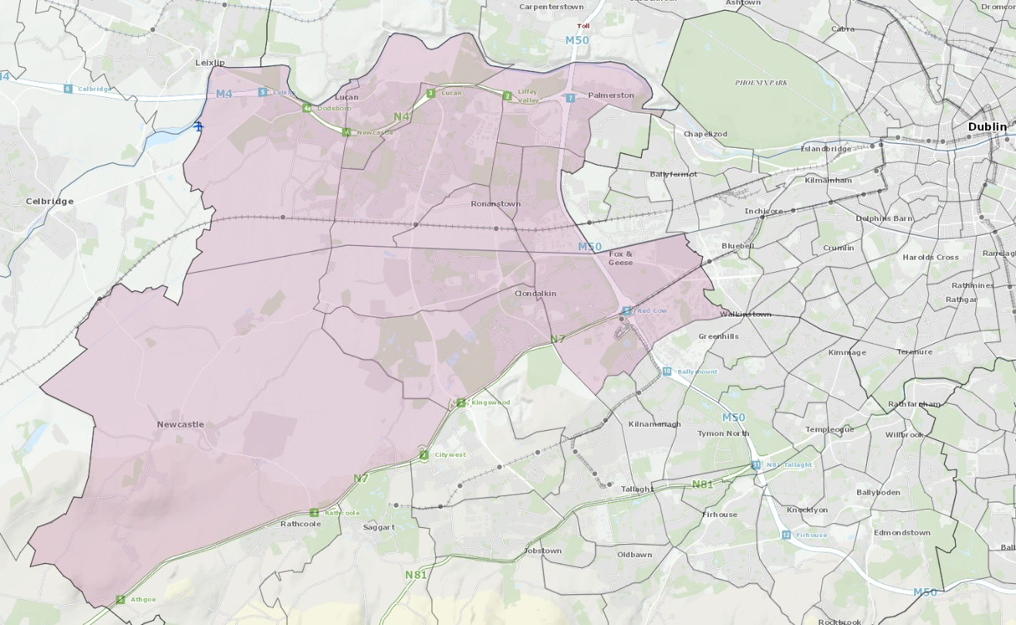
Figure 1 Geographical Area Covered by CDATF and Funded Services

1.5 Organisation Structure
The CDATF is a Company Limited by Guarantee (CLG) that has recently attained charity status. It can be understood as having a dual role. This role is to provide services to the community directly and contribute to an integrated approach amongst National Drugs Strategy funded projects in the area. Both roles are overseen by the board of the CDATF. The board is made up of local community members, voluntary reps, and statutory representatives. This partnership approach is at the heart of the work of the CDATF.
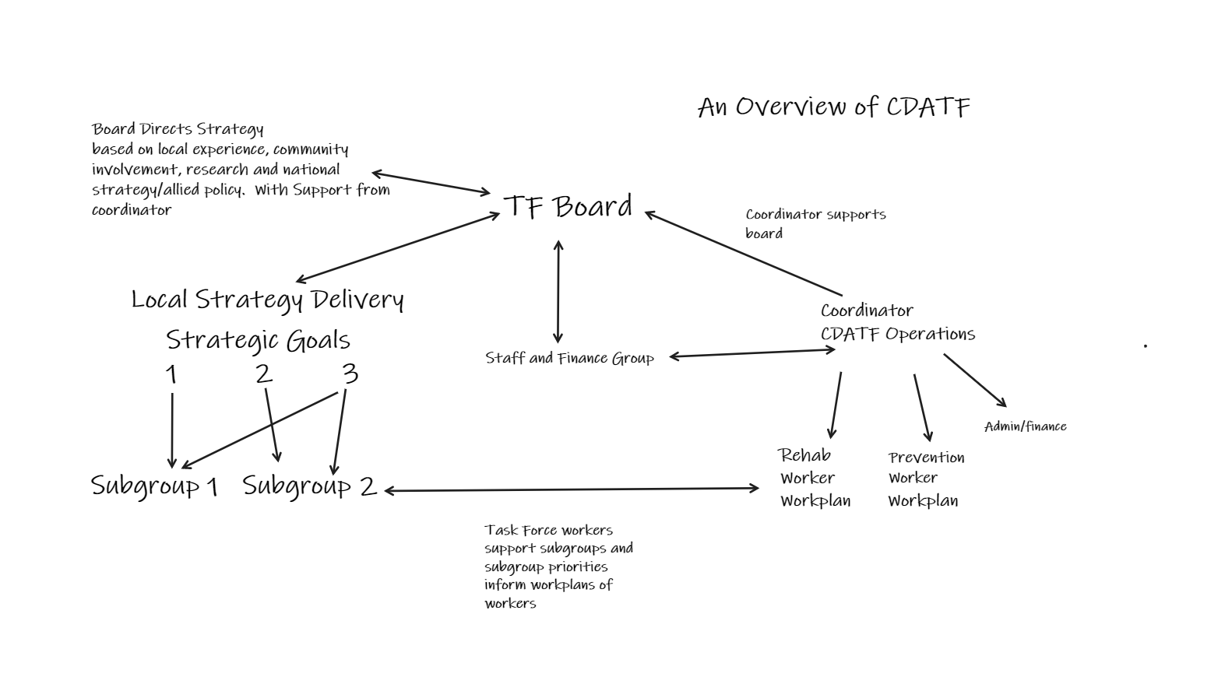
Figure 2 CDATF Organisational Overview

2 Strategic Direction
CDATF’s strategic direction is set out in the Strategic Plan. The plan is guided by our mission statement. How we perform this mission is underlined by a set of four values which inform our approach. We endeavour to fulfil our mission through advancing our three strategic goals.
2.1 Mission Statement
“To re-establish and strengthen the role of the community in tackling the causes and consequences of drug and alcohol misuse; facilitate the re-establishment of meaningful and effective partnerships; and support the development of a holistic approach to dealing with both the causes and consequences of drug and alcohol misuse in the CDATF area.” (11)
2.2 Our Values and Approach

1 A Community Development Approach
2 A Person Centred Approach
3 A Human Rights Based Approach
4 An Evidence Based Approach

2.3 Strategic Goals

Goal 1 Deal with the effects of drug and alcohol misuse.

Goal 2 Strengthen the role of the community in addressing the causes of drug and alcohol misuse.

Goal 3 Positively influence mainstream services and contribute to more integrated responses.

2.4 Strategy Plan
CDATF’s strategic plan was written in 2018. A process to review this strategy was commenced in 2021 and new priorities and actions were identified for 2022-2025 (see appendix 1). These new strategy actions are in line with the mid term review for the National Drugs Strategy and include six Strategic Implementation Priorities.
3 Governance
CDATF is a Company Limited by Guarantee and a registered charity. The organisation receives funding from the HSE and Department of Health. As such there are several governance frameworks that the organisation must comply with on an annual basis.

The Board of the CDATF is responsible for overseeing the performance and governance of the organisation. The performance of the organisation are the goals the CDATF set out in strategic plan. The governance applies to the performance of the organisation, how it makes decisions and achieves its goals. There are several legal, financial, and regulatory standards that must be adhered to in order to govern the performance of CDATF well.

As the CDATF is a registered charity status we are obliged to provide a return to the Charities Regulatory Authority (CRA). This return outlines how the governance of the CDATF adheres to the CRA governance code. There are six principles in the code. CDATF has demonstrated its compliance with the code by developing a plan to adhere to the principles and have evidence of work towards this plan.

This compliance checklist has been completed by the organisation and was signed off on 13th October 2022 at the board’s monthly meeting. We have declared our compliance with the CRA Governance Code as fully compliant with the code, (Declaration A).

4 Detailed Analysis of CDATF Area

4.1 CDATF Area Profile
The CDATF cover the Dublin Mid-West constituency area of Clondalkin, Lucan, Palmerstown and Newcastle and has a population of 117,976 (10). The South Dublin County Council has described the demographic change across the county as extremely varied with Lucan LEA increasing by 22.1% (+10,073) and Clondalkin LEA increasing by 10.9% (+5,090) (13).

4.2 Deprivation
The Pobal HP Deprivation Index is a series of maps measuring the relative affluence or disadvantage of a particular geographical area in the Republic of Ireland. Clondalkin resides in the South Dublin County area and scored -4.0 in 2016 (14). These figures represent a wide geographical area including many affluent areas outside of the CDATF catchment area. A more accurate representation of deprivation can be observed in a recent SDCCPPN ‘poverty map’ which highlighted areas of deprivation ranging between -12.06 to -17.55 (15). These figures put many areas in the CDATF area among the most deprived in the state.

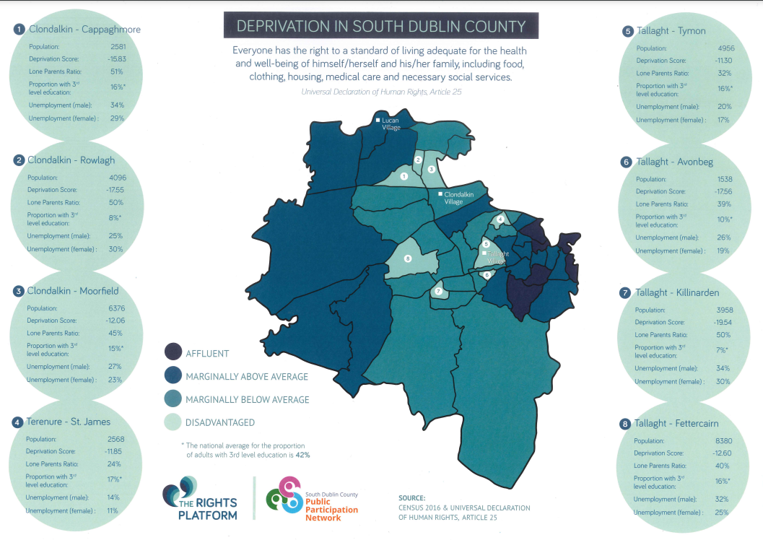
Figure 3 Deprivation Map South County Dublin

4.3 Housing
According to Census 2016, the total households with tenure of social rented residing in South Dublin were 10,921. This represented 11.8% of the total households. This proportion was higher than the State average of 9.4% and the Dublin regional average of 10.6% (10).

Relative to other areas, South Dublin had the fifth highest rate of social housing households in the State. Of the four Dublin local electoral areas (LEAs), South Dublin had the second highest rate. The highest rate being in Dublin City (13%), followed by South Dublin, DLR (6.8%) and the lowest in Fingal (6.7%)(10).

4.4 Lone Parent Households
According to Census 2016, the total ‘Lone Parent’ families with children under the age of 15 residing in South Dublin was 15,559. This represented 24.0% of the families with children under the age of 15. Lone mothers accounted for 22.6% (7,723) and lone fathers 1.5% (509). This proportion was higher than the State average of 20%, the Eastern and Midlands average of 21.1% and the Dublin regional average of 23.5% (16) .

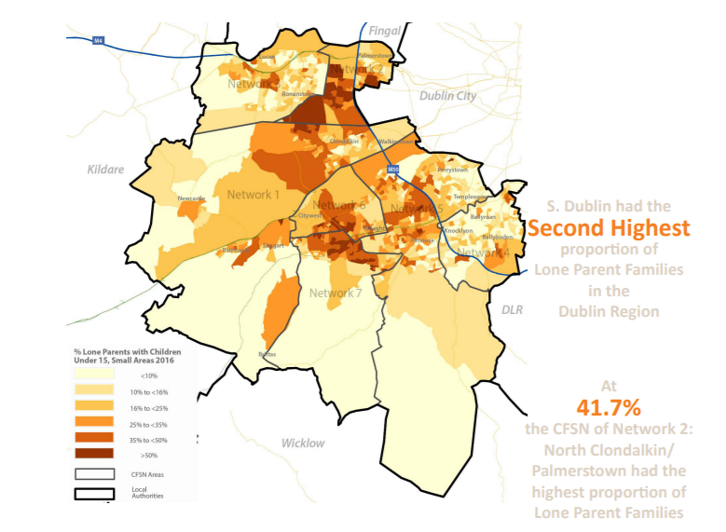
Figure 4 Lone Parents Households South Dublin 2016

4.5 Youth Population
The CDATF area possesses a higher ‘Young Dependency Rate’ than many other areas in Dublin. This rate is calculated as a percentage of the population between 0 and 15, compared to the 15-64 age group. The average across Dublin is 28% whereas in Clondalkin this rate is as high as 34.6% in South Clondalkin, and 29.7% in North Clondalkin. Ronanstown and Balgaddy Road in North Clondalkin have particularly high youth dependency rates (16).

4.6 Emerging Adults
There were 23,129 young people aged 18 to 24 years residing in South Dublin according to Census 2016. This figure represented 8.3% of the total population in South Dublin. This proportion was higher than the State average of 8.2%, lower than the Eastern and Midlands average of 8.6% and the Dublin regional average of 9.3% (10). Relative to all other LEAs, South Dublin had the eight highest proportion of young people aged 18 to 24 years with Galway City having the highest at 14.2% and Leitrim the lowest at 5.9%. Of the four Dublin LAs, Dublin City had the highest at 10.4% and DLR (10.1%) the second highest proportion of 18 to 24 year olds. The lowest rates being in South Dublin (8.3%) and Fingal (7.6%) (16).

4.7 Ethnicity
South Dublin is very ethnically diverse by Irish standards. When compared to the greater Dublin region it contains the second lowest proportion of ‘White Irish’, the second highest proportion of ‘White Irish Travellers’ and the second highest proportion of ‘Black or Black Irish’(16).

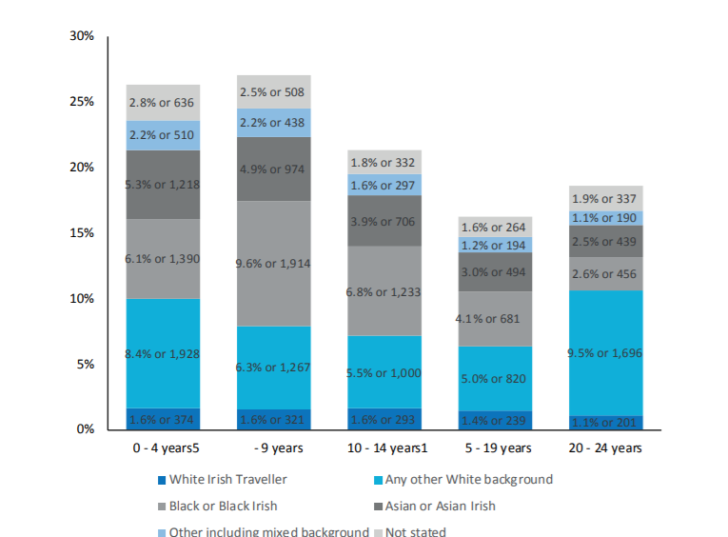
Figure 5 Ethnicity by Youth-Age Group Census 2016

4.8 Employment
According to Census 2016, the total population unemployed and residing in South Dublin was 18,265. This represented 13.3% of the total labour force (At Work and Unemployed). This proportion was higher than the State average of 12.9%, the Eastern and Midlands average of 12.4% and the Dublin regional average of 11.6% (16).

4.9 Education
In 2016, the total students that sat the Leaving Certificate examination in South Dublin was 2,794. Of this figure, 69.7% or 1,948 of the students progressed to third level. This proportion was below the State average of 77.8% and relative to all other local authorities was the second lowest rate of progression in the country. On a comparative basis, DLR had the highest at 91.6% and Dublin City the lowest at 66.4% (16).

According to Census 2016, the total population residing in South Dublin with ‘Third Level’ education was 56,821. This represented 32.6% of the total population in South Dublin that had completed their education. This proportion was lower than the State average of 33.4% and the Dublin regional average of 40.7% (10).

5 Profile of Drugs Use in CDATF Area
5.1 Drugs Use
A complete picture of the number of people receiving treatment for drug and alcohol use in the CDATF area is difficult to access. Data is available from the Health Research Boards through the National Drug Treatment Reporting System (NDTRS) but not all services are included in this system, as a result, NDTRS figures greatly underestimate the level of treatment and drug related need in the area. In 2021 the NDTRS data supplied to CDATF by the Health Research Board show that a total of 563 people engaged in treatment and rehabilitation services in the local area (17). This compares with data from 2020 that showed that 381 individuals engaged in treatment and rehabilitation services locally(18). This marks a rise of 48% on the previous year which is likely a correction due to service provision being more restricted during the pandemic in 2020.

These 563 cases of treatment are dominated by three substances. These are cocaine, heroin and alcohol which accounted for 395 of the 563 cases reported. Cocaine was the substance most people resident in Clondalkin sought treatment for in 2021 representing almost a quarter of all cases. This was followed by heroin with 134 cases and alcohol with 111 cases. Cannabis and benzodiazepines represented 63 treatment cases and 34 cases respectively(18).

Figure 6 Reason for Referral by Drug

5.1.1 Cocaine
Cocaine use has become increasingly prevalent in Irish society in recent years. This can be seen in a gradual upward trend recorded in the Irish National Drugs and Alcohol Survey (19).
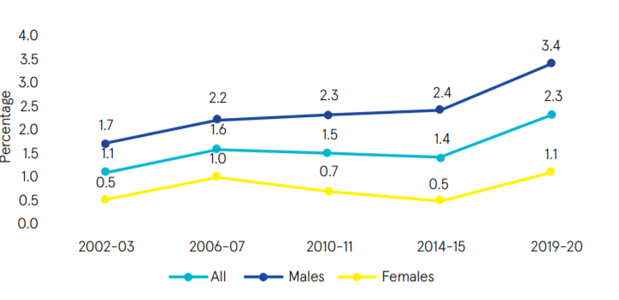
Figure 7 Increase in National Cocaine Use 2002-2020

At a local level 150 people resident in Clondalkin were recorded in the NDTRS figures as being treated for cocaine use in 2021. These figures are a significant increase on the figures for 2020 which were 98 and 2019 which was 75 and are likely swelled by a growing number of people being treated for crack cocaine use over the past five years in the area. Between the years 2015 and 2019 the numbers of people accessing treatment for crack cocaine as a main substance issue increased from 8 to 15 and as a secondary issue from 23 to 32 (18).

5.1.2 Alcohol
In 2021 there were 111 people treated for problematic alcohol use issues. Again, a significant increase was observed from the 2020 figures showing 90 people sought help for problematic alcohol use issues. When combined with those receiving treatment for alcohol as an additional problem this number rises to 155. Of these 59 were classified as dependent drinkers which was a slight rise on 2020’s figure of 55.

Figure 8 Extent of Problem Drinking NDTRS 2021
5.1.3 Opiate/Heroin
The total number of people treated for problematic opiate use according to NDTRS figures in 2021 was 134. Of these, approximately 56% had ever injected heroin.

A supplementary source of information for opiate use in Clondalkin is the Methadone Central Treatment List (CTL). This list logs all people receiving opiate substitute treatment. The CTL listing for 2020 showed that there were 550 individuals residing in the CDATF area receiving opiate substitute treatment. Of these none were under the age of 24 with the majority of 496 being over 35 years of age. (waiting for figures 2021)

Gender | Clinic | NDTC | GP | Prison | Total
Male | 169 | <10 | 173 | 30 | 377
Female | 97 | 0 | 66 | <10 | 173
Figure 9 Central Treatment List Clondalkin 2020

5.2 Demographics of Treated Use
As stated above the figures produced by NDTRS are not an ideal dataset to describe the scale of the drugs issue in Clondalkin. There are several issues with these data. For instance, not all services currently report through the NDTRS for example. However, they are presented below as an indicator of trends in treated drugs use that can be extrapolated to the wider area.

5.2.1 Age Group
Again in 2021 most treated cases in the area were spread across the age groups between 25 years and 45 years representing almost 66% of treated cases. This was lower than the previous year’s figure which was 70%. The number of people in the 45-49 age group rose sharply accounting for 11% of all treated cases in 2021 as opposed to 2020’s figure when it represented approximately 5%. The number of treated cases in young people or emerging youth 0-24 remained steady. However, the number of 10-17 year old cases rose by approximately 50% when contrasted to 2020.

Figure 10 Age Grouping of Treated Cases 2021

5.2.2 Accommodation
Of the total number treated in 2021 most reported as having stable accommodation. A small percentage were homeless and another small percentage in unstable accommodation.

Figure 11 Accommodation Status

5.2.3 Education & Employment
Of those treated for substance use issues in 2021 over 60% were unemployed or unable to work. About 28% of those in treatment in 2021 were in employment and the remaining 22% were made up of people in education/training, retired or had an unknown status. In Ireland the minimum school leaving age by law is 16 years old. Of those in treatment in 2020 over 33% left school before 16 years of age. Of the 381 cases treated in 2020 only 203 of these completed the Leaving Certificate examination.

Figure 12 Employment Status of People in Treatment CDATF

5.2.4 Gender
There is a split of 62% male to 38% female in terms of the gender breakdown for treated cases in the CDATF area in 2021. This compares against 68% male and 32% female in 2020.

Figure 13 Gender of Treated Cases 2021

5.3 Source of Referral
Most people referred themselves for treatment in 2020 and this was the case again in 2021 with self referral accounting for 58% of total. Significant sources of referral other than self-referral were drug treatment centres, family, friends, and professionals such as GP’s or mental health professionals.

Figure 14 Source of Referral 2021

6 Emerging Trends in Drugs Use

6.1 Strategy Review
As part of a review of the CDATF strategy commenced in 2021 a survey was conducted to garner views on prevalence and nature of substance misuse, it’s impact on CDATF communities and appropriate responses, which was completed on-line/in hard copy by 125 respondents. The findings are provided below (20). Verbatim quotations are included to provide further clarity and context to the responses.

6.1.1 Profile of Respondents
Analysis of the respondent profile reveals that
- 69% were female (n=86) with 31% male (n=39)
- 73% (n=91) live in the CDATF area while 54% (n=67) also work in the area, 15% (n=18) have family or attend education in the area.
- The majority of respondents were from Clondalkin Village, Rowlagh, Moorfield, Cappaghmore, Lucan, Bawnogue, Deansrath, Ronanstown & Neilstown
- Adults aged 36-45 had the highest number of responses (n = 52), followed by adults aged 46-55 (n = 29) and adults aged 26-35 (n=27).
- Young people aged 25 and under made up 5% of responses (n = 6) with people aged 55+ accounting for 8% of the responses (n = 11).

6.1.2 The Current Situation
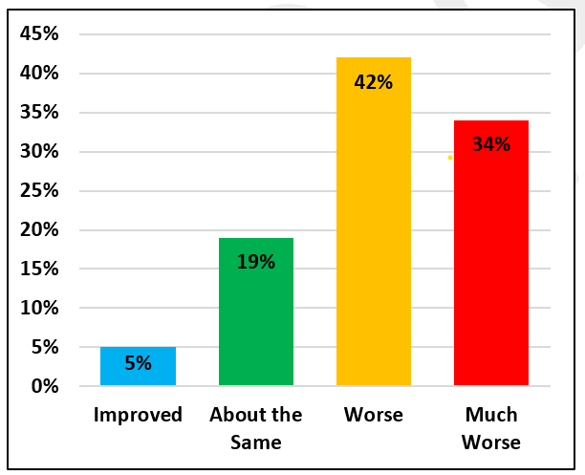
Respondents were asked about their perception of the extent to which the substance misuse and its impacts have improved or worsened over the past four years. 76% (n=95) felt that the situation was worse or much worse while 24% (n=30) felt it had remained unchanged or had improved. The view that the substance misuse landscape is more challenging now than it was four years ago was shared by the stakeholders and key informants in the consultation
Figure 15 Perception of Change

The areas of Bawnogue, Neilstown, Balgaddy, Canal, Rowlagh, Quarryvale and Ronanstown were identified as the most impacted by substance misuse in the CDATF area. Contributors conveyed a range of visible and non-visible impacts of substance misuse spanning, community infrastructure, family, young people, educational and life opportunities, health and well-being, community resilience and the presentation of increased ruthlessness and violence.

“Fear that no one talks about their kids getting involved sucked in shame keeps people so quiet as does the fear of retributions, it's anti-social behaviour, intimidation of local shop owners and their customers, increase in the numbers murdered also”

“Impact on families breaking up, financial burden, school dropouts, generational addiction and poverty, Drugs move to quieter areas, but issues follow then, Communities feel fearful and powerless. People start to avoid certain areas, under report issue as nothing is being done and it lowers the confidence in policing”

“Visible distress in people and their families. Mental and physical health deterioration in drug users’ personal well-being. Nonvisible distress on family members trying to support this misuse in their home. A sense of hopelessness and huge stress on the whole family”

6.1.3 The Main Causation Factors
When asked as to what they felt the reasons for their much worse/worse prognosis with the option of choosing three responses, 53% (n=66) felt that the normalisation of drug use was the primary underlying factor with 48% (n=60) indicating that the trend of starting to use drugs at a younger age was the primary driver.
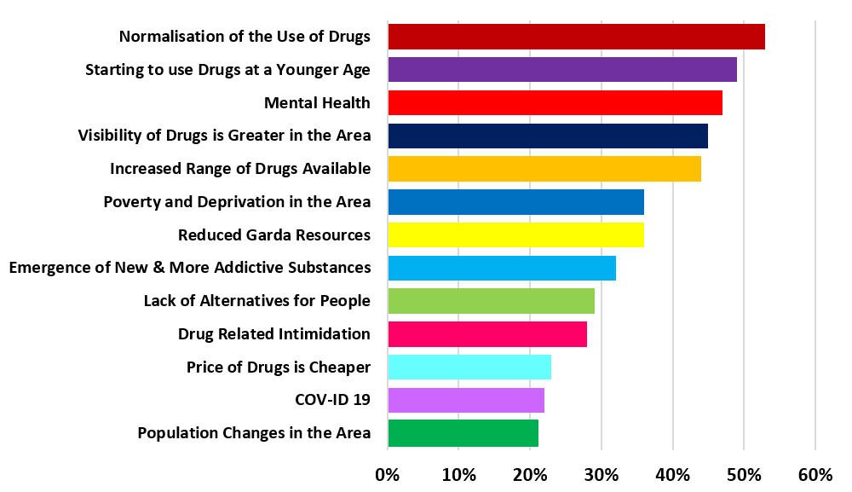
46% (n=57) felt that poor mental health across the CDTAF community was the main contributing factor with the visibility of drug use and the increased range of drugs available also cited by a significant proportion of respondents. The emergence of new and more addictive substances and the poverty and deprivation in the area and its impact on the life chances of young people were highlighted as causation factors for the escalation of substance misuse in the CDATF area.
Figure 16 Causation Factors
“Drugs have become more accessible and very public in terms of supply and therefore normalised in Clondalkin communities.” It is happening at a much younger age than even 3-4 years ago; higher strength weed is more addictive and the younger they start the harder it is to identify other issues that may be going on such as mental health”.

“The bling of the drug dealing lifestyle makes it really hard to divert young people from this pathway. Drug prevention and education needs to start in primary school and there is a need to look at what people in the community can do to get the pride back into Clondalkin.”

“Kids dropping out of school early; Gangs of teenagers hanging out together in various places around the village; Increase in school bullying; Increased aggression and fighting amongst teenagers; Drugs and their impact are everywhere, and it is so hard for young people not to get involved”

6.1.4 Main Problem Drug
Survey respondents were asked to identify the main problem drug in their area. They had the option of choosing three options from a pre-set list. Cocaine, Alcohol, Cannabis and Crack Cocaine were identified as the main problem drugs. These findings are broadly in line with NDTRS prevalence figures and findings from CDATF research. One slight anomaly is the reduced rating of heroin as a main problem drug in this 2022 survey. Heroin was the second most frequently presenting drug for those accessing treatment in the CDATF area in 2020.

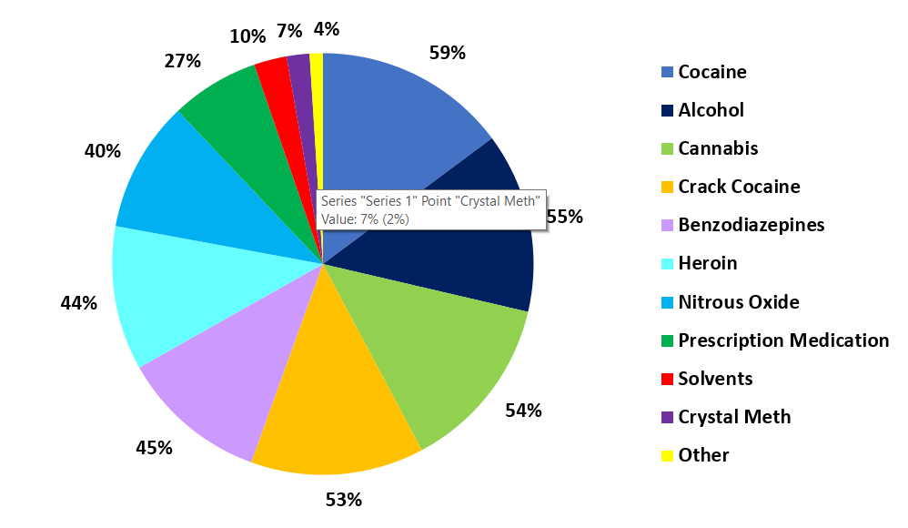

6.1.5 The Level of Investment
In response to the question on the level of resources currently available in the CDATF area to address substance misuse issues, 84% (n=105) felt that the current level of investment was either inadequate or very inadequate. Only 6% (n=9) felt that the current investment was adequate.

“The people that are helping are doing their very best but are not funded properly and with covid it has sometimes been hard to get consistency with the amount of time taken off, restrictions and distance.”

“There aren’t enough staff and services for underage drug and alcohol users. The adult services need more funding and need to be open over the weekend too. There needs to be more drop-in services for people in the evenings and weekends. The Gardai need more awareness and understanding of drug related crimes and intimidation”

6.1.6 What More is Needed
In response to a question to choose their top three preferences for what more is needed to address the impact of substance misuse in the CDATF area:
- 73% wanted more Investment in services and supports for children and teenagers to prevent substance misuse as they get older
- 63% choose more investment in community-based front line drug services
- 54% wanted more education and awareness within the community about the harms caused by drug and alcohol misuse
- 44% felt that more investment in Family Support is needed
- 42% want additional Gardai Resources
- 38% felt that greater investment in Community Development was needed to enable the community to come together and have their voice heard on substance misuse issues
- 37% opted for more investment in new or alternative approaches to drug treatment and rehabilitation
- 33% felt that Local politicians need to lobby government more effectively in relation to the drug and alcohol misuse issues in the Clondalkin area
- 27% felt that the decriminalisation of some substances would have a positive impact in the CDATF area.

6.1 Poly-Drug Use
The most recent research carried out by CDATF suggested that polydrug use is the norm in the CDATF area (9). Cannabis use was reported to be widespread and normalized within social and recreational practices of many residents in the area across all age groups. At the time the most commonly, mixed drugs were herbal cannabis, various prescription pills such as benzodiazepines and ‘Z drugs’ mixed with alcohol (9).

6.3 Nitrous Oxide
At local level in 2020 there were significant anecdotal reports of Nitrous Oxide use amongst youth. Usage of this substance was highly visible due to sightings of substantial amounts of related paraphernalia such as empty cannisters and balloons. CDATF received many reports directly through the board and related structures regarding this substance. A survey of services returned many reports of young people engaging with nitrous oxide use. This usage of nitrous oxide appeared to evolve in 2021 with reports of usage of larger industrial sized cannisters becoming a concern.

6.3 Crack Cocaine
Crack cocaine has been a considerable concern for the CDATF since at least 2013 (21) and there were a number of high profile seizures in 2019 and 2020 regarding this substance (22). The NDTRS figures for crack cocaine over the past five years also attest to growth in the numbers of people seeing treatment for crack cocaine use (18). Crack has been reported to be growing significantly in other Task Force areas (23, 24). If these reports are accurate, it is plausible that the CDATF area is dealing with similar levels of use. At a wider level prevalence surveys have indicated a sharp rise in cocaine whilst not being able to access sufficient data to provide a reliable prevalence estimate (25). There have also been additional reports of increased crack use through the CDATF Treatment and Rehabilitation group.

6.4 Alcohol
Alcohol was reported to be the drug with the most negative impact on the quality of life and the wellbeing of people living in the CDATF area. The increasing availability of alcohol in shops, pubs and off licenses tied to its low cost and ease of access for all ages are seen to have negatively impacted on the area. Its use as a standalone drug or underpinning cannabis, stimulant and opiate use is so pervasive that nondrinkers were regarded as an oddity (9).

6.5 Covid Related Drugs Issues
A survey was carried out with services in 2021 to enable them to highlight emerging issues amongst the people they serve. The impact of Covid brought to light many issues for services and exacerbated issues additionally. These issues included delayed hospital appointments which stunted attempts at recovery for many clients. Young people were reported to have suffered inordinately due to the impact of Covid restrictions. A significant issue arising from the survey faced by youth included severe mental health issues due to loss of in person supports. Finally, there were reports of young men being surrounded by criminal gangs and becoming entangled in drug related crime as a result.

7 Activity Report 2021
CDATF is an organization with a dual mandate. In the first instance the role of the TF is to work with funded agencies to coordinate a joined up strategic response to the complex issues associated with substance use. Additionally, the CDATF employs staff members that supplement this strategy through the provision of services and support around strategic issues.

7.1 Staffing
There were a number of changes to the staffing of CDATF in 2021. A new coordinator was appointed in February 2021 to oversee the work of the organization and support the board in 2021. In addition, existing staff members were granted flexible work arrangements by reducing their working week to four days. Finally, Eleanor Floyd left the organization. Eleanor was financial administrator for the CDATF and had been with the organization since 2000. Laura Fox underwent a lengthy traineeship with Eleanor before she left and took over her duties as office and finance administrator in September 2021.

7.2 Organisational Review
An organisational review was carried out in early 2021. As a result of this new ways of working were identified. The logic model planning system was adopted by all staff. Flexible working arrangements were introduced in line with the lessons learned throughout the Covid 19 pandemic.

It was highlighted that the board would benefit from recruitment as part of the review. Following a successful recruitment campaign many new board members joined the board. A new chairperson also joined the board in September 2021.

A governance review was caried out following this review. This involved overhauling of the staff handbook and updating the director’s handbook. Training was provided to the board on governance by an external subject matter expert.

A need was also identified to perform an interim review of the CDATF strategy, and a process commenced to carry out this work before the end of the year. A tender call was issued, and Business Improvement Solutions were awarded the tender.

7.3 CDATF Achievements 2021

Outlined below is a summary of the main outcomes achieved in 2021 in line with the CDATF local strategy. Also displayed are how these align with both the CDATF local strategy and the National Drugs Strategy Reducing Harm, Supporting Recovery.

Lead and Work Descriptor | Local Drugs Strategy Goal | National Drugs Strategy Goal/Action | Achievements in 2021
CDATF Rehabilitation  SAFE | Goal 1  Dealing with the effects of drugs and alcohol misuse | Goal 2  Minimise the harms caused by the use and misuse of substances and promote rehabilitation and recovery  Action  2.2.28  Continue to expand Harm Reduction Initiatives focused on people who inject drugs. | Targeted SUs received support and information about supports and services in their local areas, harm reduction interventions and referrals as required.  Reduction in drug litter and anti-social behaviour at the Fonthill train station and on the trains.  Members of the Steering Committee have increased knowledge and understanding of harm reduction and substance misuse issues.  Communication and information sharing was improved as a result of the relationships developed between Steering Committee members.  Completion of the SAFE Interim Review and completion of the recommended actions from the report.  STATS:  Approx 84 engagements service users in reporting period from Feb-Aug 2021.  17 – NSP  18 – Key working  46 – Information & Awareness (on train)  11 – Referrals (Family support in Leitrim, Methadone in Kildare and Outreach worker in Kilkenny, MQI, ARAS)
CDATF Rehabilitation  T&R Subgroup | Goal 3  Having a positive influence on mainstream services and contributing to more integrated responses | Goal 2  Minimise the harms caused by the use and misuse of substances and promote rehabilitation and recovery  Action  2.2.30  Continue to target a  reduction in drug related deaths and  non-fatal overdoses. | The T&R Subgroup was reviewed and relaunched in line with the CDATF local area strategy.  The T&R Subgroup agreed priorities for the year and agreed a work plan.  The new structure of the Subgroup has resulted in a more focused response and collaborative working towards addressing the issues emerging in the community.  The Subgroup responded to the needs of SUs in the community by prioritising emerging issues in the community, as reported by the Subgroup members.  Members of the community and staff from CDATF projects have a collective understanding of the prominent issues facing SUs in the community.  Communication and interagency working is improved as a result of the relationships developed between Subgroup members.  Subgroup members are more informed and involved in the work of the CDATF and local strategy.
CDATF Rehabilitation  Service User Involvement | Goal 2  Strengthening the role of the community in addressing the causes of drug and alcohol misuse. | Goal 4:  Support  participation of individuals, families  and communities  Action  4.2.44 Promote the participation of service users and their families, including those in recovery, in local, regional  and national decisionmaking structures and  networks in order to  facilitate their involvement  in the design, planning and development of services and policies. | Meaningful progression opportunities were created for the SU Rep as a result of the development of the Volunteer role with the CDATF. Role was developed in consultation with needs and interests of the SU Rep.  SUs in the local area are supported by the volunteer SU Rep and have a voice through this new structure.  SU Rep was involved in TF structures such as T&R Subgroup and participated in the development of the local area strategy, specifically around the Dual Diagnosis and Recovery objectives.  Work of the CDATF was enhanced because of meaningful participation form the SU Rep.
CDATF Rehabilitation  Recovery | Goal 1  Dealing with the effects of drugs and alcohol misuse | Goal 4:  Support  participation of individuals, families  and communities  Action  4.2.44 Promote the participation of service users and their families, including those in recovery, in local, regional  and national decisionmaking structures and  networks in order to  facilitate their involvement  in the design, planning and development of services and policies. | Issues faced by people in recovery are responded to by the T&R Subgroup as a result of the prioritization of the issue, and gaps in the continuum of care are responded to.  People in recovery have meaningful progression opportunities in the local area.  Members of the community and staff from CDATF projects have a collective understanding of recovery.  Communication and information sharing is improved as a result of the relationships developed between members of the Subgroup working together on recovery initiatives.  Membership of the T&R Subgroup is increased and includes those with expertise in recovery, including those working in the area, and those with lived experience.
CDATF Rehabilitation  Dual Diagnosis | Goal 1  Dealing with the effects of drugs and alcohol misuse | Goal 2: Minimise the  harms caused by the use and misuse  of substances and promote rehabilitation  and recovery  Action 2.1.18 Help individuals  affected by  substance misuse to  build their recovery  capital.  Action  2.1.17 Further strengthen  services to support  families affected by  substance misuse. | Issues faced by people experiencing dual diagnosis are responded to by the T&R Subgroup as a result of the prioritization of the issue, and gaps in the continuum of care are responded to.  People experiencing dual diagnosis have meaningful progression opportunities in the local area.  Members of the community and staff from CDATF projects have a collective understanding of issues facing people experiencing dual diagnosis.  Members of the community and staff from CDATF projects have a clear understanding of the referral pathways and procedures for people experiencing dual diagnosis.  Communication and information sharing is improved as a result of the relationships developed between members of the Subgroup.  Membership of the T&R Subgroup is increased and includes those with expertise of DD issues, including those working in the area, and those with lived experience. was funded through CDATF grants in a Tier 2 Community drugs service for pre and post detox / treatment supports, crisis intervention, trauma support and addiction specific support.  Counselling grants also provided to service to provide respite to service users.
CDATF Rehabilitation  Training | Goal 2  Strengthening the role of the community in addressing the causes of drug and alcohol misuse. | Goal 4:  Support  participation of individuals, families  and communities  Action  4.2.44 Promote the participation of service users and their families, including those in recovery, in local, regional  and national decisionmaking structures and  networks in order to  facilitate their involvement  in the design, planning and development of services and policies. | 18 students (including members of the community and staff from CDATF projects & stakeholders) received the level 7 Certificate qualification in Addiction Studies from Maynooth University.  Individual outcomes for students -  •2 students from the course went on to join the local North Clondalkin Community Safety Forum;  •3 students joined local Community Reps Forum;  •5 students gained employment in the sector;  •6 students went on to further education in Addiction Studies (Maynooth University & DCU), Community & Youth Work (Maynooth University), Psychology (DBS), Forensic Psychology & Criminology (Kilroy’s College) and further studies in MI (URUS).  Members of the community and staff from CDATF projects & stakeholders have increased knowledge and understanding of substance misuse issues as a result of completing the course.  TF project staff that have completed the course are upskilled and have knowledge of the NDRF which is a priority for working in addiction support services.  Communication and information sharing has been improved as a result of the relationships developed between students and community members/staff from projects.  Completing the course has provided pre-development education and capacity building for community members who wish to take a more active role in their community or go on to further education/employment.
CDATF Prevention  Schools | Goal 1  Dealing with the effects of drugs and alcohol misuse | Goal 1  Promote and protect  health and wellbeing  Action  1.2.3 Support the SPHE  programme. | Post Covid, developed a strategy to re-engage with schools in Clondalkin catchment. This involved the design and dissemination of leaflet and follow up phone calls. This led to meetings where need was discussed.  A needs analysis was carried out as a result of engagement with schools and responsive interagency team approach to whole school work was conceptualized as a renewed response and has been developed(EPI).  Stakeholder consultation of key organizations occurred and agreement achieved on goals of EPI.
CDATF Prevention  YDAP Support | Goal 1  Dealing with the effects of drugs and alcohol misuse | Goal 1 Promote and protect health and wellbeing  1.2.5 Improve supports for young people at risk of early substance use. | To develop the YDAP under 18’s service a management group was formed and held 4 meetings in 2021.  A full training needs analysis carried out. Training needs were identified, and programme of training delivered including, Motivational Interviewing, MI mentoring, NDRF training.  The pilot project was reviewed and this led to improved focus and direction being achieved for the project.  A model of care was finalised and allows for a more uniform approach in the CDATF area for young people.  A leaflet was produced to raise awareness of the service as part of ongoing re-branding project.  The project is more clearly defined and this should lead to improved understanding for all organisations locally in relation to what the YDAP service can and will provide.  Both workers began to implement MI tools and Case management practice.  A reporting template was agreed to identify gaps and blocks in existing services for young people and can be used now to inform additional resource allocation
CDATF Prevention  EPYC Sub-group | Goal 3  Having a positive influence on mainstream services and contributing to more integrated responses | Goal 1 Promote and protect health and wellbeing  Action  1.2.5 Improve supports for young people at risk of early substance use. | Members of the community and staff from Com/Vol and Statutory services providers have had opportunity to increase knowledge and understanding of substance misuse issues for young people and their families.  The EPYC has provided opportunities for referral pathways to be improved by brining agencies together.  A clear workplan has emerged for this group focusing on priority issues for the group. These include young people’s involvement in criminality, DRI, the YDAP, mental health for local community, the EPI, a youth forum and emerging trends.  This group has developed emerging trends reporting mechanism to identify blocks or gaps in service provision locally.
CDATF Prevention  Community Representatives | Goal 2  To continue to strengthen the capacity of the community in challenging the root causes of drug and alcohol misuse including the harmful outcomes of drug policy, poverty  and inequality. | Goal 4: Support  participation of individuals, families  and communities  Action  4.1.39 Support and  promote community  participation in all  local, regional and  national structures. | An advertisement campaign was rolled out through local newspapers and social media to engage with new reps.  A number of reps were identified to cover the geographical area of the Task Force, through engagement with NCCDP and the students from the Community Addiction Studies 8 individuals were identified and approached.  The initial discussions on an art project also took place in late 2021.  Additional training of Community Reps was rolled out with 4 Com Reps engaging in MI Training.  An issue was raised by a Com Rep from the Balgaddy area which led to CASP initiating a process to provide a physical outreach space for service users.  The PO continued to support the Community Reps as a group and individually which enabled their full participation and ensured appropriate referrals were made where necessary.

7.4 Funded Projects Achievements 2021
Lead and Work Descriptor | Local Drugs Strategy Goal | National Drugs Strategy Goal/Action | Achievements in 2021
Carline Learning Centre | Goal 1  Dealing with the effects of drugs and alcohol misuse | Goal 1 Promote and protect health and wellbeing  Action  1.2.5  Improve supports for young people at risk of early substance use. | In the academic year 2020/2021 the Learning Centre successfully supported students from the Clondalkin area to remain in education despite experiencing challenging events in previous educational settings, in their home and in their communities.  The social care team, part funded by the TF, provided continuous social care supportive interventions to successfully progress each student into their chosen progression option.
Neart Le Cheile, Cairdeas | Goal 2  Dealing with the effects of drugs and alcohol misuse | Goal 4  Support participation of individuals, families and communities.  Action  4.2.44  Promote the participation of service users and their families, including those in recovery, in local, regional and national decisionmaking structures and networks in order to facilitate their involvement in the design, planning and development of services and policies. | Cairdeas continued to provide an advocacy service to service users in 2021. 35 people accessed this service in the reporting period. A range of issues were dealt with including access to homeless list/services. Access to DAFT website. Bus pass and other benefits support. Referral to CASP and Tus Nua for addiction support. Access to education and training. Referrals to family/child services.  The Stepladder training programme is a pre-development training course. The programme is for people who use drugs, are on methadone or are drug free although not stable in drugs use. The aim of the training is to create opportunities for people to build their skills in education and training while building their confidence and self-esteem. This programme was cancelled in 2020 as a result of Covid 19 but all participants were supported by advocacy service in 2021.  Service Users Developing Solidarity (SUDS) ran naloxone training in conjunction with UISCE in 2021. The group also organized an event for Overdose Awareness Day which involved a tree planting ceremony in the local community along with a memorial plaque. Leaflets were distributed on overdose awareness as part of this event.
YDAP | Goal 1  Dealing with the effects of drugs and alcohol misuse | Goal 2  Minimise the harms caused by the use and misuse of substances and promote rehabilitation and recovery  Action  2.1.22  Expand the range,  availability and  geographical spread  of problem drug and  alcohol services for  those under the age of  18. | IN 2021 the Y-DAP pilot project in the CDATF catchment area continued to develop. A new management structure was agreed to provide overall direction to the project. A new terms of reference was written to outline the roles of all stakeholders.  Additional funding was sourced from CDATF funds to provide additional staff resources to the project in 2021. In December 2021 a YDAP coordinator post was advertised to help develop the viability of the YDAP.  Significant outcomes were achieved in terms of developing appropriate case management systems, developing a model of care and overhaul of existing systems.  Staff received training in MI and practice mentoring in use of MI methodology.
Clondalkin Tus Nua (Station 1) | Goal 1  Dealing with the effects of drugs and alcohol misuse | Goal 2  Minimise the  harms caused by the use and misuse  of substances and promote rehabilitation  and recovery  Action  2.1.18 Help individuals  affected by  substance misuse to  build their recovery  capital. | Station 1 Rehabilitation Programme:  Service Users continued to avail of Services in Station One through the tiered rehabilitation programme.
Clondalkin Tus Nua  (Family Support) | Goal 1  Dealing with the effects of drugs and alcohol misuse | Goal 2  Minimise the  harms caused by the use and misuse  of substances and promote rehabilitation  and recovery  Action  2.1.17 Further strengthen services to support families affected by substance misuse. | Family Support:  Continued to provide Individual Family Support Interventions.  Continued to provide individuals one to one support sessions.
Clondalkin Youth Services | Goal 1  Dealing with the effects of drugs and alcohol misuse | Goal 1 Promote and protect health and wellbeing  Action  1.2.5 Improve supports for young people at risk of early substance use. | The Clondalkin Youth Service Prevention Funded worker continued to provide supports for young people at risk of early substance use.
CASP | Goal 1  Dealing with the effects of drugs and alcohol misuse | Goal 2  Minimise the  harms caused by the use and misuse  of substances and promote rehabilitation  and recovery  Action  2.1.13 Expand the  availability and  geographical  spread of relevant  quality drug and  alcohol services and  improve the range  of services available,  based on identified  need. | Those who remained homeless continued to be offered showers/food and associated services in person.  Continued to offer family support service in 2021.  Individual supports provided throughout 2021.
CTDG | Goal 1  Dealing with the effects of drugs and alcohol misuse | Goal 2  Minimise the  harms caused by the use and misuse  of substances and promote rehabilitation  and recovery | The traveller substance use worker continued to offer support to travellers experiencing substance use and related issues in 2021.

8 Board Membership 2021

Name | Representation
Pat Bennett | Chairperson
Noreen Byrne | Vice Chairperson
Ann Corrigan | Voluntary Representative
Emily Smartt | Voluntary Representative
Maria Finn | Voluntary Representative
Rosie McGlone | Voluntary Representative
William Carey | Public Representative
Eoin O’Broin | Public Representative
Madeleine Johansson | Public Representative
Sheilann Monaghan | Voluntary Representative
Eddie Mullins | Statutory Representative (Prisons Service)
Pat Conway | Statutory Representative (HSE)
Inspector Liam Casey | Statutory Representative (An Garda Siochana)
Jonathan Hayden | Statutory Representative (SDCC)
Grainne Finnegan | Statutory Representative (TUSLA)
Tiernan Heaney | Voluntary Representative

9 Appendices
Appendix A References
1. Wright M. The Dublin Region: Advisory Regional Plan and Final Report: Part One: GPSO; 1966.
2. Council SDC. 2018.
3. CDATF. CDATF Annual Report 2019. 2020.
4. Office CS. Census 1991.
5. CODAN.
6. Dean G, O'Hare A, O'Connor A, Kelly M, Kelly G. The" opiate epidemic" in Dublin: are we over the worst? Irish medical journal. 1987;80(5):139-42.
7. O’Gorman A, editor Illicit drug use in Dublin. Illicit drug use in Europe, Proceedings of the Seventh Annual Conference on Drug Use and Drug Policy, Amsterdam Amsterdam; 1997.
8. Butler S. Rabbitte revisited: the First Report of the Ministerial Task Force on Measures to Reduce Demand for Drugs-ten years on. ADMINISTRATION-DUBLIN-. 2007;55(3):125.
9. O’Gorman A, Driscoll A, Moore K, Roantree D. Outcomes: Drug harms, policy harms, poverty and inequality. Dublin: Clondalkin Drug and Alcohol Task Force. 2016.
10. CSO. 2016 Census 2017.
11. CDATF. CDATF Local Drugs Strategy 2018-2025. 2018.
12. Reducing Harm, Supporting Recovery: A Health-led Response to Drug and Alcohol Use in Ireland 2017-2025: Irish Department of Health; 2017.
13. SDCC. South Dublin Local Economic and Community Plan. 2016.
14. Pratschke THJ. The 2016 Pobal HP Deprivation Index for Small Areas (SA)
15. SDCCPPN. SDCCPPN Poverty Map. 2020.
16. CYPSC. South Dublin Children and Young People's Services Committee Evidence Baseline Report, 2017. . 2017.
17. HRB. NDTRS Treatment Data 2021 Clondalkin. 2022.
18. HRB. NDTRS Treatment Data 2020.
19. HRB. Irish National Drugs and Alcohol Survey. 2020.
20. Solutions BI. Interim Review CDATF Strategic Plan 2018-2025. 2022.
21. O'Heaire G. Cracking on: a harm reduction report. Dublin: The Bawnogue Youth and Family Support Group. 2013.
22. Ward M. TD Says Canal Drug Dealing "Getting Out Of Hand" after Crack Cocaine Found In Tent. 2021.
23. Force TDT. Crack Now the Most Problematic Substance. The Echo Newspaper. 2021.
24. Cocaine RIBC. 2021.
25. HRB. Irish National Drug and Alcohol Survey 2020. 2021.

Appendix B Strategic Plan Implementation Table 2022-2025

7.1 NDS Priority One
Strengthen the prevention of drug and alcohol use and the associated harms among children and young people
Action | Lead/Partner | Timeline | Outcomes
1.Pilot the Education Prevention Intervention Team (EPIT) as an enhanced area-based prevention approach targeting the 4P’s (Parents, Pupils, Policy, and Professionals) | EPYC (Lead) with YDAP & Crosscare as partners | Pilot in 2022  Ongoing review with aspiration that it is  mainstream provision by 2025 | -Piloting of the EPIT  -Improved mental health and well-being of YP  -Young People progress and achieve in education  -Strengthening Social Personal & Health Education (SPHE) supports to schools in CDATF area  -Improved family relationships  -Increased awareness of and stronger resilience to the harms of drugs and alcohol in schools  -Improved inter-agency working  -More effective targeting of at-risk young people
2.Review membership of local, county, and regional committees to maximise CDATF influence in prevention policy and strategy (CYPSC, JPC, LDC, YPAR, PPN) | TF | End of 2022 and  Annually thereafter | -A written Review which provides basis for below.  -CDATF to have increased influence in key policy forums  -CDATF to have better insights into wider strategy and policy development  -A greater awareness of CDATF across their area
3.Promote access to parenting and family programmes for services engaging with high-risk families | EPYC & TF Projects | Ongoing | -Improved access to Strengthening Family, Parents Under Pressure (PUP) and Triple P programmes  -Improved parenting  -Stronger family units and enhanced prevention
4. Strengthen the sustainability of YDAP | YDAP (Lead) with CLDATF & Crosscare | 2023 | -YDAP Sustainability  -Enhanced YPAD infrastructure  -Enhanced U18 inter-agency working

7.3 NDS Priority Two

Enhance access to and delivery of drug and alcohol service in the community
Action | Lead/Partners | Timeline | Outcomes
5.Provide person-centred supports and effective service responses to the needs of those affected by drug and alcohol misuse | CASP, Tus Nua, Neart Le Cheile, YDAP, CTDG | Ongoing | -Improved access to CLDATF funded services  -Changed relationship with drug/s of choice (Stabilisation, reduced use, drug free)  -Achievement of care plan goals
6.Increase meaningful progression opportunities (aftercare, community integration) and champion a culture of dual recovery across all services | CASP, Tus Nua, EPYC, T&R | Ongoing | -Improved progression opportunities  -More Recovery options (Café & Choir)  -Increased Recovery Capital  -Improved Rehabilitation  -Increased access to educational opportunities
7.Implementation of the National Drug Rehabilitation Framework (NDRF) | Treatment & Rehabilitation Officer (T&RO)  All CDATF funded projects | Ongoing and reviewed annually | -Increased capacity among services for NDRF implementation  -Improved inter agency working  -Enhanced access to services  -Greater alignment with current policy (Slaintecare)
8.Enhance and develop community-based alcohol programmes | T&R | 2024 | -Improved knowledge of community-based alcohol programmes  -Improved access for people requiring support for alcohol misuse

7.4 NDS Priority Three

Develop integrated care pathways for high-risk drug users to achieve better health outcomes
Action | Lead/Partners | Timeline | Outcomes
9.Apply the NDRF model to develop integrated care pathways (inter agency, outreach, street work, prisons) for the defined high-risk user | T&R/RO | Ongoing | -Improved integrated care pathways for high-risk drug users in the CDATF area  -Increased access to hard to reach people impacted by substance misuse  -Improved engagement with the travelling community and ethnic minorities  -Reduced mortality due to substance misuse  -Reduced homelessness  -Reduced exploitation  -Improved health & well-being  -Achievement of care plan goals

7.5 NDS Priority Four

Address the social determinants and consequences of drug use in disadvantaged communities
Action | Lead/Partners | Timeline | Outcomes
10.Strengthen the voice of the community through ensuring area wide representation on the CDATF community reps forum and service user involvement | EPYC/PO & CDATF Projects | Ongoing | -Stronger community voice on social determinants and consequences  -Enhanced progression opportunities for the community  -Increased Community representation on the CDATF Board  -Improved service user involvement  -Better understanding of service user needs  -Enhanced collaboration between projects
11.Engage with key stakeholders to facilitate their renewed commitment to the DATF model of community-based partnership through active participation on CDATF Board and committees | CDATF Board | Ongoing | -More effective and representative CDATF Board  -Meaningful Involvement in strategy development and review  -Restructuring of sub committees
12.Respond to Drug Related Intimidation (DRI) in the CDATF area | EPYC, YDAP, CTN (Tus Nua) Gardai, CASP, Community Safety Forum | 2022 and Ongoing | -Implement DRIVE framework  -Reduced Intimidation  -Improved community policing  -Improved community safety

7.6 NDS Priority Five

Promote alternatives to coercive sanctions for drug-related offences
Action | Lead/Partners | Timeline | Outcomes
13.Provide a mechanism to engage all CDATF stakeholders on the decriminalisation debate and articulate the findings | CDATF | 2023 | -Improved community involvement  -Shared understanding  -Cohesive approach  -Improved stakeholder engagement

7.7 NDS Priority Six

Strengthen evidence-informed and outcomes-focused practice, services, policies, and strategy implementation
Action | Lead/Partners | Timeline | Outcomes
14.Set out research and evaluation requirements for the period 2022-25.  - Quantify the needs of Young People in the CDATF area (How many accessing Jigsaw, how many on waiting list for CAMHS and YDAP, what additional needs are presenting)  - Explore new and emerging trends (including drug of choice, high risk groups, socio-economic profiles, ethnic origin) through a reporting template that can be updated quarterly  - Community impact analysis of projected population growth to inform a submission to the County Development Plan  - Research the impact of “cautions” did they continue to use after the caution  - Continue to highlight the vulnerability of young people to manipulation by criminal gangs and involvement in the drugs economy  - Identify the extent of core underfunding of TF services  Action | CDATF Board EPYC, T&R,  Lead/Partners | Annually commencing 2022  Ongoing  Baseline template in place by end of 2022  2023  2024  Ongoing  2023  Timeline | -Increased production of high-quality research and evaluation  -Defined areas of research for TF to work on  -Strengthened evidenced informed interventions  -Improved inter-agency working  -Increased efficiency in service delivery  -More effective targeting of at-risk young people  -Improved access to and understanding of high-risk groups  -Enhanced understanding of need in the CDATF area  -Improved understanding of the social determinants of drug use in the CDATF area  -Increased understanding of future population growth in CDATF  -Enhanced business case for future funding  -Stronger evidence base to inform the decriminalisation debate  -Improved understanding among policy makers and judiciary in relation to the vulnerability of young people  -Enhanced business case for funding increase  Outcomes
15.Agree reporting template (Outputs, Outcomes, and Indicators) for the CLDATF Strategic Plan 22-25 | EPYC, T&R, TF | End of 2022 for SLA meetings and annually thereafter | -Improved impact measurement  -Improved Performance Measurement  -Improved strategy implementation  -Enhanced evaluation across all CDATF services
16.Continue to work with all funded services to address data collection challenges | EPYC, T&R, TF | Ongoing | -Improved data collection  -Stronger evidencing of need  -Increased capacity to demonstrate value for money
17.Use the CDATF strategy as a framework for every partner to agree and evaluate collective effort. | CDATF and funded projects | Ongoing | -Improved partnership working  -More cohesive strategy
18.CDATF to support compliance with relevant regulatory bodies (CRA, CRO, HSE) | CDATF Board | Ongoing | -Improved compliance against regulatory and statutory standards  -Best practice policies and procedures
19.Support CDATF and funded services with implementation of the National Standards for Safer Better Healthcare | CDATF | By 2023 | -Improved compliance against regulatory and statutory standards  -Best practice policies and procedures
20.CDATF to oversee the creation of a repository of generic policies and procedures which services can access to facilitate compliance against regulatory and national standards. | CDATF, Staff finance & governance subgroup | 2023 | -Improved collaboration among all CDATF funded services  - Improved compliance against regulatory and statutory standards

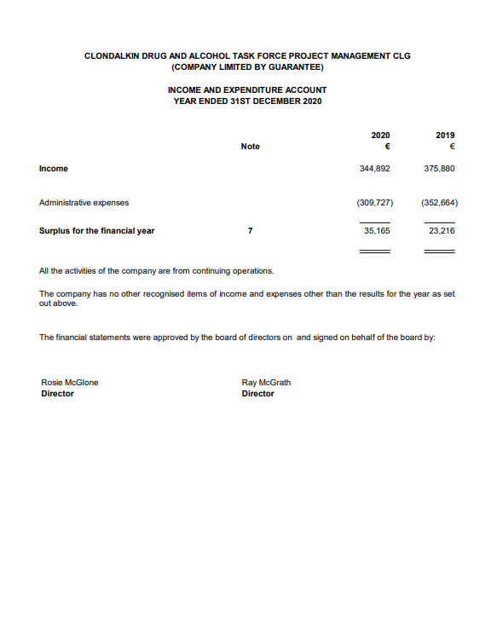
Appendix 3 Financial Statements
