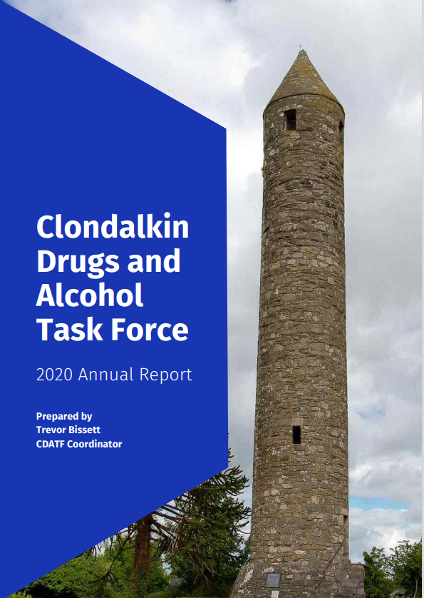
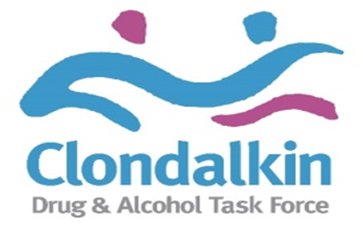
Contents
Introduction Page 3
1 CDATF Overview Page 5
2 Strategic Direction Page 8
3 Governance Page 9
4 Detailed Analysis of CDATF Area Page 10
5 Profile of Drugs Use in CDATF Area Page 14
6 Emerging Trends in Drugs Use Page 20
7 Activity Report 2020 Page 22
7.1 Impact and Response to Covid 19 Page 22
7.2 Main Work CDATF Page 24
8 Board Membership Page 37
9 Appendices Page 38
References Page 38
Accounts Page 39

Introduction
I am pleased to present the annual report for 2020 for the Clondalkin Drugs and Alcohol Task Force, (CDATF). Established in 1997, Drugs Task Forces are local area responses to the causes and consequences of drugs use in areas most badly affected by these issues. For most of the past 25 years the CDATF has provided this local area response in Clondalkin only. More recently the CDATF has expanded the response more to the Lucan, Palmerstown and Newcastle areas.

The Task Force model was founded as a partnership response to the complex issues presented by drugs. The establishment of CDATF reflected the belief that problematic substance use and its associated problems are generated and intensify largely due to socioeconomic issues. Through the work of the CDATF the aim is to tackle these issues using a joined-up approach. This joined up approach is coordinated by the CDATF in collaboration with other projects funded to provide services and is crystalised in our strategic plan and three strategic goals. These strategic goals are progressed through the efforts of the CDATF, funded projects and other key stakeholders in the area.

In 2020 the CDATF organisation and funded projects continued their work in support of the local area strategy. The impact of Covid-19 on service delivery was profound but also underlined the need in the CDATF area, by shining a new light on the levels of deprivation that exist in the area. The year was also very challenging for the CDATF organisation which experienced staff shortages through the year whilst being forced by the pandemic to pivot to a new and alien way of working.

Despite these challenges, there are many achievements from 2020. The CDATF organisation itself continued to coordinate the SAFE initiative. This project provided a timely and effective response to high levels of drugs litter at the local train stations as well as providing significant outreach support to drugs users commuting to Clondalkin via train. The CDATF also continued to provide a level seven certificate in addiction studies, which was required to be run online for the first time. CDATF also provided grants for services to provide respite to services users and widen family support services to new areas under the CDATF remit. A new under 18’s service was piloted in the area that provides outreach supports and interventions for the significant cohort of young people in the area.

The funded projects in the area innovated rapidly in response to the pandemic. It is highly commendable that throughout such an uncertain period the continuation most of the rehabilitation programmes, family support services and other supports for drugs users, their families and the wider community was maintained. In addition, youth services found new ways to engage with young people and early school leavers were particularly well supported in their learning by one funded project. Other notable work carried out during the year included a podcast series and related awareness raising activities produced through the SUDS group.

All the work outlined above and described in detail in section 7 of this report would not have occurred without the efforts of the CDATF funded projects. On behalf of the CDATF Board I would like to say how grateful we are to them all for their continued and considerable input into the local strategy. Finally, the Board and I would like to express deepest gratitude to the staff of CDATF for all of their efforts in 2020.

Pat Bennett
Chairperson
CDATF

1 CDATF Overview

1.1 History of Clondalkin
Clondalkin is a suburban town situated 10 kilometres west of Dublin city centre within the administrative jurisdiction of South Dublin. It is one of three new western Dublin towns proposed in the Myles Wright Report to cater for the growing population of the Dublin region at the time. The other proposed towns were Tallaght and Blanchardstown (1). The vision for these new towns was that they would be partially self-sufficient communities (2).
During the early 1970s and 1980s these towns experienced rapid growth in population, continuing to this day. This growth was fuelled by, a demand for low-cost housing, the decentralisation of industry from Dublin city, and the development of industrial infrastructure. This growth was not without issues and areas of Clondalkin came to be severely affected by poverty and social disadvantage (3).
The centre point of Clondalkin is its historic village which features a round tower dating from the 8th century. The village is bordered by the neighbourhoods of Surleen and Knockmitten. To the north of the village is the Grand Canal. Beyond the canal are the neighbourhoods of Quarryvale, Rowlagh, Neilstown and Balgaddy. To the south and west of the canal the neighbourhoods of Bawnogue, Deansrath and Clonburris can be found.
1.2 Early Demographic Profile
It is 30 years since the 1991 Census which recorded a very high percentage of young people relative to other age groups residing in Clondalkin. At the time, 37% of the population were aged 1-14 years and only 3% of the population were over 65 (4). Also, at this time it was reported that households headed by lone parents made up 17.9% of households in Clondalkin (5). There were few employment opportunities at the time which was reflected by a high unemployment rate. As a whole, the Clondalkin unemployment rate was 26% but this was as high as 44% in some areas (4). A damaging pattern of early school leaving was also evident in the 1991 census that reported that 40% of the population in Clondalkin left school at the age of 15 or under (4).
1.3 Emergence of Opiate Use and Community Response
Much of Dublin experienced a large increase in opiate use during the 1980’s peaking around 1985 (6). At the time the problem was overwhelmingly concentrated among young males between 15 – 24 years old (7). Though initially associated with inner city neighbourhoods the ‘opiate epidemic’ also reached out to the newly established suburb of Clondalkin.
In the early days the heroin problem in Clondalkin was mainly situated in North Clondalkin. Community groups in the Quarryvale area of North Clondalkin emerged and were instrumental in establishing Clondalkin Addiction Support Programme (CASP) as a grass roots response to the growing problem of heroin use in the area. Needs related to opiate use also emerged in Southwest Clondalkin at a later stage.
The Clondalkin Drug and Alcohol Task Force was established in 1997 as a statutory response to the issues associated with opiate use (8). It was one of 14 Local Drugs Task Forces established by the Government in response to the heroin epidemic occurring mainly in the Dublin region. The aim of these Task Forces was to take a partnership approach to complex issues and provide locally appropriate responses.
Since then, problematic drug use in Ireland has changed significantly and while heroin use remains a significant problem there is growing public concern regarding problems associated with polydrug use including cannabis, cocaine, alcohol and prescribed drugs such as benzodiazepines and other Z drugs (9).
1.4 Catchment Area and Strategy Response
The title of the Clondalkin Task Force is a misnomer. It serves Clondalkin and the surrounding areas of Lucan, Palmerstown and Newcastle. These areas form the Dublin Mid-West Dail constituency with a population of 117,976 in 2016 (10).
To date, the CDATF has developed three local area strategies. Under our current strategy, the CDATF aims to respond to drugs and alcohol issues, work all stakeholders and improve the coordination and delivery of services in the area (11). This strategy was developed with local stakeholders to synthesise the views and needs of the local community with the goals of the government’s national drugs strategy Reducing Harm, Supporting Recovery (12). It is delivered on through the work of local service providers in partnership with the community, voluntary and statutory sectors.

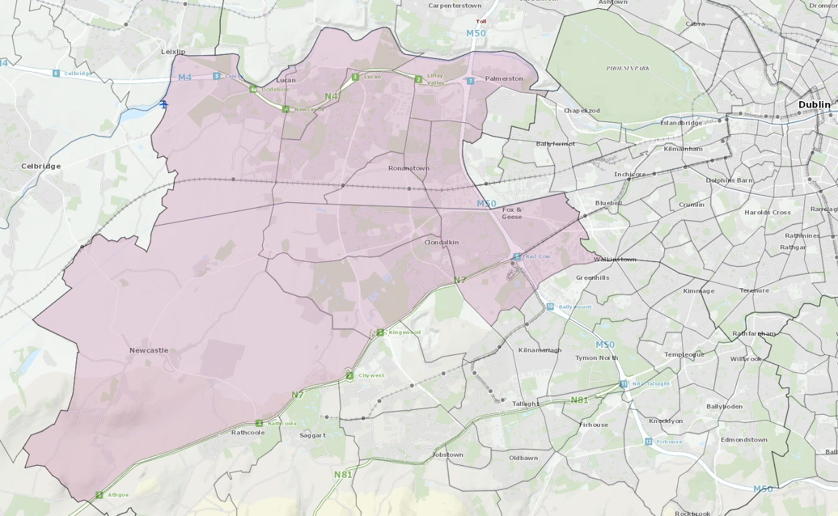
Figure 1 Geographical Area Covered by CDATF

1.5 Organisation Structure
The CDATF is a Company Limited by Guarantee (CLG) that has recently attained charity status. It can be understood as having a dual role. This role is to provide services to the community directly and contribute to an integrated approach amongst National Drugs Strategy funded projects in the area. Both roles are overseen by the board of the CDATF. The board is made up of local community members, voluntary reps, and statutory representatives. This partnership approach is at the heart of the work of the CDATF.
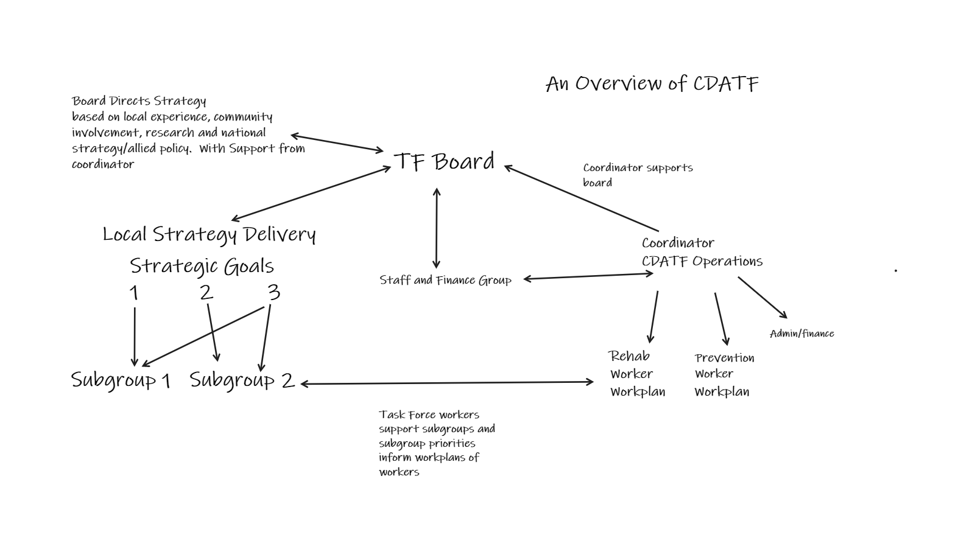
Figure 2 CDATF Organisational Overview

2 Strategic Direction
CDATF’s strategic direction is guided by our mission statement. How we perform this mission is underlined by a set of four values which inform our approach. We endeavour to fulfil our mission through advancing our three strategic goals.
2.1 Mission Statement
“To re-establish and strengthen the role of the community in tackling the causes and consequences of drug and alcohol misuse; facilitate the re-establishment of meaningful and effective partnerships; and support the development of a holistic approach to dealing with both the causes and consequences of drug and alcohol misuse in the CDATF area.”
2.2 Our Values and Approach

1 A Community Development Approach
2 A Person Centred Approach
3 A Human Rights Based Approach
4 An Evidence Based Approach

2.3 Strategic Goals

Goal 1 Deal with the effects of drug and alcohol misuse.

Goal 2 Strengthen the role of the community in addressing the causes of drug and alcohol misuse.

Goal 3 Positively influence mainstream services and contribute to more integrated responses.
3 Governance
CDATF is a Company Limited by Guarantee and a registered charity. The organisation receives funding from the HSE and Department of Health. As such there are a number of governance frameworks that the organisation must comply with on an annual basis.

The Board of the CDATF is responsible for overseeing the performance and governance of the organisation. The performance of the organisation are the goals the CDATF set out in strategic plan. The governance applies to the performance of the organisation, how it makes decisions and achieves its goals. There are several legal, financial and regulatory standards that must be adhered to in order to govern the performance of CDATF well.

As the CDATF has recently attained charity status we are obliged to provide a return to the Charities Regulatory Authority (CRA). This return outlines how the governance of the CDATF adheres to the CRA governance code. There are six principles in the code. CDATF has demonstrated its compliance with the code by developing a plan to adhere to the principles and have evidence of work towards this plan.

This compliance checklist has been completed by the organisation and was signed off on the 14th of October 2021 at a CDATF board meeting. We have declared our compliance with the CRA Governance Code as fully compliant with the code, (Declaration A).

4 Detailed Analysis of CDATF Area

4.1 CDATF Area Profile
The CDATF cover the Dublin Mid-West constituency area of Clondalkin, Lucan, Palmerstown and Newcastle and has a population of 117,976 (10). The South Dublin County Council has described the demographic change across the county as extremely varied with Lucan LEA increasing by 22.1% (+10,073) and Clondalkin LEA increasing by 10.9% (+5,090) (13).

4.2 Deprivation
The Pobal HP Deprivation Index is a series of maps measuring the relative affluence or disadvantage of a particular geographical area in the Republic of Ireland. Clondalkin resides in the South Dublin County area and scored -4.0 in 2016 (14). These figures represent a wide geographical area including many affluent areas outside of the CDATF catchment area. A more accurate representation of deprivation can be observed in a recent SDCCPPN ‘poverty map’ which highlighted areas of deprivation ranging between -12.06 to -17.55 (15). These figures put many areas in the CDATF area among the most deprived in the state.

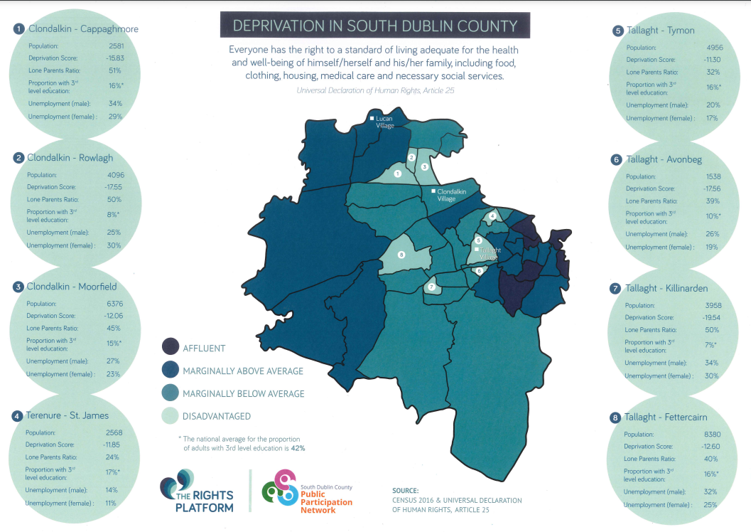
Figure 3 Deprivation Map South County Dublin

4.3 Housing
According to Census 2016, the total households with tenure of social rented residing in South Dublin were 10,921. This represented 11.8% of the total households. This proportion was higher than the State average of 9.4% and the Dublin regional average of 10.6% (10).

Relative to other areas, South Dublin had the fifth highest rate of social housing households in the State. Of the four Dublin local electoral areas (LEAs), South Dublin had the second highest rate. The highest rate being in Dublin City (13%), followed by South Dublin, DLR (6.8%) and the lowest in Fingal (6.7%)(10).

4.4 Lone Parent Households
According to Census 2016, the total ‘Lone Parent’ families with children under the age of 15 residing in South Dublin was 15,559. This represented 24.0% of the families with children under the age of 15. Lone mothers accounted for 22.6% (7,723) and lone fathers 1.5% (509). This proportion was higher than the State average of 20%, the Eastern and Midlands average of 21.1% and the Dublin regional average of 23.5% (16) .

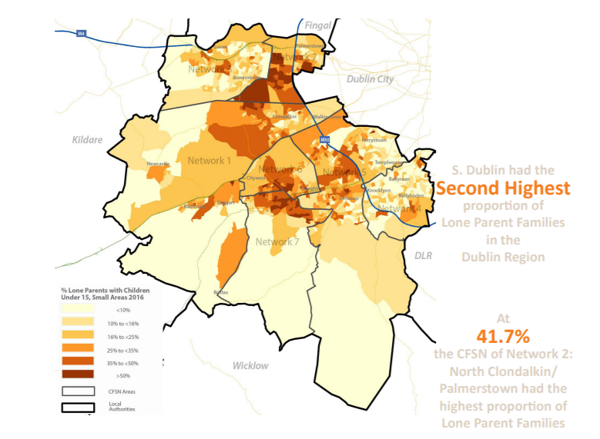
Figure 4 Lone Parents Households South Dublin 2016

4.5 Youth Population
The CDATF area possesses a higher ‘Young Dependency Rate’ than many other areas in Dublin. This rate is calculated as a percentage of the population between 0 and 15, compared to the 15-64 age group. The average across Dublin is 28% whereas in Clondalkin this rate is as high as 34.6% in South Clondalkin, and 29.7% in North Clondalkin. Ronanstown and Balgaddy Road in North Clondalkin have particularly high youth dependency rates (16).

4.6 Emerging Adults
There were 23,129 young people aged 18 to 24 years residing in South Dublin according to Census 2016. This figure represented 8.3% of the total population in South Dublin. This proportion was higher than the State average of 8.2%, lower than the Eastern and Midlands average of 8.6% and the Dublin regional average of 9.3% (10). Relative to all other LEAs, South Dublin had the eight highest proportion of young people aged 18 to 24 years with Galway City having the highest at 14.2% and Leitrim the lowest at 5.9%. Of the four Dublin LAs, Dublin City had the highest at 10.4% and DLR (10.1%) the second highest proportion of 18 to 24 year olds. The lowest rates being in South Dublin (8.3%) and Fingal (7.6%) (16).

4.7 Ethnicity
South Dublin is very ethnically diverse by Irish standards. When compared to the greater Dublin region it contains the second lowest proportion of ‘White Irish’, the second highest proportion of ‘White Irish Travellers’ and the second highest proportion of ‘Black or Black Irish’(16).

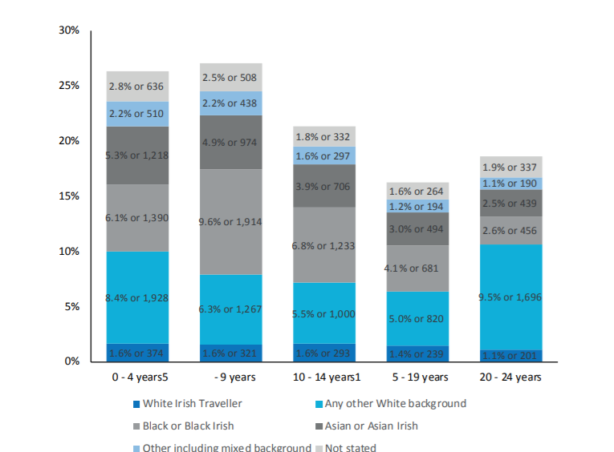
Figure 5 Ethnicity by Youth-Age Group Census 2016

4.8 Employment
According to Census 2016, the total population unemployed and residing in South Dublin was 18,265. This represented 13.3% of the total labour force (At Work and Unemployed). This proportion was higher than the State average of 12.9%, the Eastern and Midlands average of 12.4% and the Dublin regional average of 11.6% (16).

4.9 Education
In 2016, the total students that sat the Leaving Certificate examination in South Dublin was 2,794. Of this figure, 69.7% or 1,948 of the students progressed to third level. This proportion was below the State average of 77.8% and relative to all other local authorities was the second lowest rate of progression in the country. On a comparative basis, DLR had the highest at 91.6% and Dublin City the lowest at 66.4% (16).

According to Census 2016, the total population residing in South Dublin with ‘Third Level’ education was 56,821. This represented 32.6% of the total population in South Dublin that had completed their education. This proportion was lower than the State average of 33.4% and the Dublin regional average of 40.7% (10).

5 Profile of Drugs Use in CDATF Area

5.1 Drugs Use
A complete picture of the number of people receiving treatment for drug and alcohol use in the CDATF area is difficult to access. Data is available from the Health Research Boards through the National Drug Treatment Reporting System (NDTRS) but not all services are included in this system, as a result, NDTRS figures greatly underestimate the level of treatment and drug related need in the area. The 2020 data from the NDTRS for the CDATF area show that 381 individuals engaged in treatment and rehabilitation services locally(17).

These 381 cases of treatment are dominated by three substances. These are cocaine, heroin and alcohol which accounted for 273 of the 381 cases reported. Cocaine was the substance most people resident in Clondalkin sought treatment for in 2020 followed by alcohol and heroin. Cannabis and benzodiazepines represented 45 treatment cases and 26 cases respectively(17).

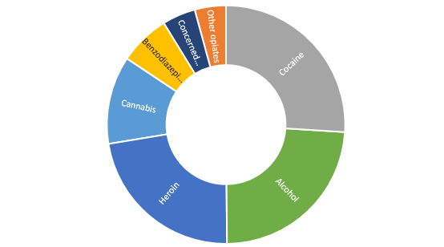
Figure 6 Reason for Referral by Drug

5.1.1 Cocaine
Cocaine use has become increasingly prevalent in Irish society in recent years. This can be seen in a gradual upward trend recorded in the Irish National Drugs and Alcohol Survey (18).
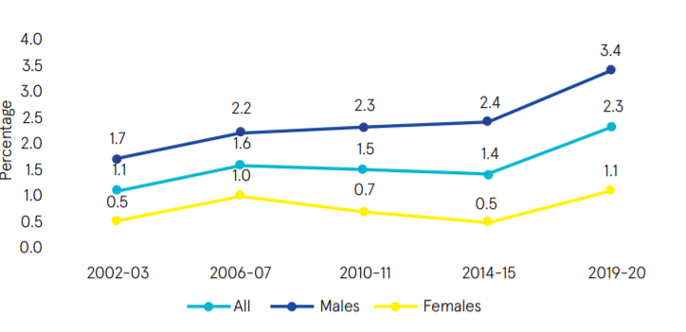
Figure 7 Increase in National Cocaine Use 2002-2020

At a local level 98 people resident in Clondalkin were recorded in the NDTRS figures as being treated for cocaine use in 2020. These figures are a significant increase on 2019’s 75 and are likely swelled by a growing number of people being treated for crack cocaine use over the past five years in the area. Between the years 2015 and 2019 the numbers of people accessing treatment for crack cocaine as a main substance issue increased from 8 to 15 and as a secondary issue from 23 to 32 (17).

5.1.2 Alcohol
In 2020 there were 90 people treated for problematic alcohol use issues. When combined with those receiving treatment for alcohol as a secondary issue this number rises to 133. Of these 54 were classified as dependent drinkers.

Figure 8 Extent of Problem Drinking NDTRS
5.1.3 Opiate/Heroin
The total number of people treated for problematic opiate use according to NDTRS figures in 2020 was 85. Of these, approximately 8% had ever injected heroin.

Figure 9 Ever Injected Heroin

A supplementary source of information for opiate use in Clondalkin is the Methadone Central Treatment List (CTL). This list logs all people receiving opiate substitute treatment. The CTL listing for 2020 showed that there were 550 individuals residing in the CDATF area receiving opiate substitute treatment. Of these none were under the age of 24 with the majority of 496 being over 35 years of age.

Gender | Clinic | NDTC | GP | Prison | Total
Male | 169 | <10 | 173 | 30 | 377
Female | 97 | 0 | 66 | <10 | 173
Figure 10 Central Treatment List Clondalkin 2020

5.2 Demographics of Treated Use
As stated above the figures produced by NDTRS are not an ideal dataset to describe the scale of the drugs issue in Clondalkin. There are a number of issues with these data. For instance, not all services currently report through the NDTRS for example. However, they are presented below as an indicator of trends in treated drugs use that can be extrapolated to the wider area.

5.2.1 Age Group
The majority of treated cases in 2020 were spread across the age groups between 25 years and 45 years representing almost 70% of treated cases. The number of treated cases in young people or emerging youth 0-24 amounted to about 15%.

Figure 11 Age Grouping of Treated Cases 2020

5.2.2 Accommodation
Of the total number treated in 2020 most reported as having stable accommodation. A small percentage where homeless and another small percentage in unstable accommodation.

Figure 12 Accommodation Status

5.2.3 Education & Employment
Of those treated for substance use issues in 2020 over 60% were unemployed or unable to work. About 25% of those in treatment in 2020 were in employment and the remaining 15% were in education/training or had an unknown status. In Ireland the minimum school leaving age by law is 16 years old. Of those in treatment in 2020 over 33% left school before 16 years of age. Of the 381 cases treated in 2020 only 203 of these completed the Leaving Certificate examination.

Figure 13 Employment Status of People in Treatment CDATF

5.2.4 Gender
There is a split of 68% to 32% in terms of the gender breakdown for treated cases in the CDATF area in 2020.

Figure 14 Gender of Treated Cases 2020

5.3 Source of Referral
Most people referred themselves for treatment in 2020. Significant sources of referral other than self-referral were drug treatment centres, family, friends, and professionals such as GP’s or mental health professionals.

Figure 15 Source of Referral 2020

6 Emerging Trends in Drugs Use
6.1 Poly-Drug Use
The most recent research carried out by CDATF suggested that polydrug use is the norm in the CDATF area (9). Cannabis use was reported to be widespread and normalized within social and recreational practices of many residents in the area across all age groups. At the time the most commonly, mixed drugs were herbal cannabis, various prescription pills such as benzodiazepines and ‘Z drugs’ mixed with alcohol (9).

6.2 Nitrous Oxide
At local level in 2020 there were significant anecdotal reports of Nitrous Oxide use amongst youth. Usage of this substance was highly visible due to sightings of substantial amounts of related paraphernalia such as empty cannisters and balloons. CDATF received many reports directly through the board and related structures regarding this substance. A survey of services returned many reports of young people engaging with nitrous oxide use.

6.3 Crack Cocaine
Crack cocaine has been a considerable concern for the CDATF since at least 2013 (19) and there were a number of high profile seizures in 2019 and 2020 regarding this substance (20). The NDTRS figures for crack cocaine over the past five years also attest to growth in the numbers of people seeing treatment for crack cocaine use (17). Crack has been reported to be growing significantly in other Task Force areas (21, 22). If these reports are accurate, it is plausible that the CDATF area is dealing with similar levels of use. At a wider level prevalence surveys have indicated a sharp rise in cocaine whilst not being able to access sufficient data to provide a reliable prevalence estimate (23). There have also been additional reports of increased crack use through the CDATF Treatment and Rehabilitation group.

6.4 Alcohol
Alcohol was reported to be the drug with the most negative impact on the quality of life and the wellbeing of people living in the CDATF area. The increasing availability of alcohol in shops, pubs and off licenses tied to its low cost and ease of access for all ages are seen to have negatively impacted on the area. Its use as a standalone drug or underpinning cannabis, stimulant and opiate use is so pervasive that nondrinkers were regarded as an oddity (9).

6.5 Covid Related Drugs Issues
A survey was carried out with services to enable them to highlight emerging issues amongst the people they serve. The impact of Covid brought to light many issues for services and exacerbated issues additionally. These issues included delayed hospital appointments which stunted attempts at recovery for many clients. Young people were reported to have suffered inordinately due to the impact of Covid restrictions. A significant issue arising from the survey faced by youth included severe mental health issues due to loss of in person supports. Finally, there were reports of young men being surrounded by criminal gangs and becoming entangled in drug related crime as a result.

7 Activity Report 2020
CDATF is an organization with a dual mandate. In the first instance the role of the TF is to work with funded agencies to coordinate a joined up strategic response to the complex issues associated with substance use. Additionally, the CDATF employs staff members that supplement this strategy through the provision of services and support around strategic issues. It is a challenging task to find solutions to such complex issues ordinarily. However, 2020 was a year like no other due to the global crisis of the Covid-19 pandemic. Unfortunately, CDATF experienced significant amounts of staff shortages at critical periods in 2020 due to staff turnover and extended leave. This impacted service provision across both roles outlined above. Nonetheless, CDATF remained operational throughout the year and pivoted in order to progress the strategic goals of the organisation.

7.1 Impact of Covid-19
The CDATF is an agency that works in partnership with a number of projects that are funded to provide services to people who use drugs, their families, young people and the wider community. We conducted a local area survey to identify how Covid-19 impacted on service delivery and what can be learned from it. It was reported overall that the pandemic brought about a heightened observability of the level of deprivation in the area. The pandemic also resulted in an acknowledgement of the digital divide that exists for many service users. Just as most features of normal life were disrupted during the pandemic this was also the case for services users in the area who undoubtedly experienced a massive disruption of services.

7.1.1. Levels of Deprivation More Observable
As outlined in the demographic profile above many people in the CDATF area are living in very deprived conditions. Through the local area survey, services have reported to CDATF that these conditions were laid bare in many ways by the Covid pandemic. One service suggested that, ‘local communities are struggling with a number of critical challenges such as unemployment, poverty, a lack of social resources, anti-social behaviour in their communities and crime.’ Another service became involved in a local food drive in response to a reported increase in food poverty which brought to light other issues such as the impact of bereavement.

7.1.2 A Digital Divide
It was reported that there was a clear digital divide evident in how easily many service users found it to adapt to online meetings and supports. One service reported that access to devices was problematic, saying, service users found it was hard to maintain links with the service as they normally drop in with an appointment and do not have access to devices.

7.1.3 Disruption to Normal Services
Social distancing, the move to online or phone meetings and closure of mainstream services such as schools contributed to a significant disruption to services in 2020. Social distancing guidelines issued by the government severely restricted services ability to provide group work supports. At a practical level, many of the services such as holistic therapy became impossible to provide due to the uncertainty regarding the transmissibility of the Covid-19 virus and had to be suspended entirely.

7.2 Workplan CDATF
The work of CDATF and funded agencies was particularly challenged during the year 2020. The organisation was established on the principles of community development. In practice, these principles have always been enacted through face to face interaction, coming together with groups of people and connecting with those who are isolated or marginalised.

Outlined below is a summary of the main outcomes achieved in 2020 in line with the CDATF local strategy. Also displayed are how these align with both the CDATF local strategy and the National Drugs Strategy Reducing Harm, Supporting Recovery.

Lead Agency | Local Drugs Strategy Goal | National Drugs Strategy Goal/Action | Achievements in 2020
CDATF Rehabilitation | Goal 1  Dealing with the effects of drugs and alcohol misuse | Goal 2  Minimise the harms caused by the use and misuse of substances and promote rehabilitation and recovery  Action  2.2.28  Continue to expand Harm Reduction Initiatives focused on people who inject drugs. | The SAFE Initiative continued to run during 2020 providing outreach and harm reduction supports and assertive case management to people using the train to come to Clondalkin to purchase drugs. SAFE Steering Committee and Operations Group were chaired and coordinated by T&R Officer following the departure of the CDATF Coordinator in September 2020. The oversight of the Strand 2 funded Assertive Case Manager continued within the SAFE Operations Group.  An review process was agreed by the SAFE Steering Committee and CDATF funding was sought to deliver on this for 2021.  Harm reduction & Safer Injecting training delivered by T&R Officer to staff of CTN and partner services that are involved in the SAFE Initiative.
CDATF Rehabilitation | Goal 3  Having a positive influence on mainstream services and contributing to more integrated responses | Goal 2  Minimise the harms caused by the use and misuse of substances and promote rehabilitation and recovery  Action  2.2.30  Continue to target a  reduction in drug related deaths and  non-fatal overdoses. | The T&R Subgroup continued to meet during 2020, mostly looking at updates from services and impact of Covid and related difficulties. T&R grant money provided to projects to provide extra counselling hours. CATF funding also provided to to local Service User Reps group to run event for International Overdose Awareness Day
CDATF Rehabilitation | Goal 2  Strengthening the role of the community in addressing the causes of drug and alcohol misuse. | Goal 4:  Support  participation of individuals, families  and communities  Action  4.2.44 Promote the participation of service users and their families, including those in recovery, in local, regional  and national decisionmaking structures and  networks in order to  facilitate their involvement  in the design, planning and development of services and policies. | The Addiction Studies course was run online in 2020. Despite some difficulties, there was a 100% completion rate for the programme. There was an increase in student numbers from Clondalkin area in 2020 (1 3 residents and staff from local projects, up from 7 in 2018).  All students received added qualification of SAOR training and participated in an end-of-year Self Care & Clinical Supervision session (funded by CDATF).
CDATF Rehabilitation | Goal 1  Dealing with the effects of drugs and alcohol misuse | Goal 2: Minimise the  harms caused by the use and misuse  of substances and promote rehabilitation  and recovery  Action 2.1.18 Help individuals  affected by  substance misuse to  build their recovery  capital.  Action  2.1.17 Further strengthen  services to support  families affected by  substance misuse. | Counselling was funded through CDATF grants in a Tier 2 Community drugs service for pre and post detox / treatment supports, crisis intervention, trauma support and addiction specific support.  Grants also provided to service to provide respite to service users.  CDATF supported community based drugs project to expand family support interventions into Lucan area and meet needs of families affected by substance use.
CDATF Prevention | Goal 1  Dealing with the effects of drugs and alcohol misuse | Goal 1  Dealing with the effects of drugs and alcohol misuse  Action  1.2.5 Improve supports for  young people at risk of  early substance use. | Specific piece of work with one post primary school to address the reported increase of drug taking and dealing outside the school ground. Two meetings took place in 2019. This is a collaborative approach working with outside agencies to engage more effectively with the young people in question.
CDATF Prevention | Goal 1  Dealing with the effects of drugs and alcohol misuse | Goal 1 Promote and protect health and wellbeing  Action  1.2.4 Promote a health  promotion approach to  addressing substance  misuse | Sought funding for cannabis awareness campaign across the South Dublin County. Facilitated youth services to develop a programme across Tallaght and Clondalkin DTF areas. Aim of programme was to raise awareness of dangers of cannabis use from the perspective of young people.
CDATF Prevention | Goal 3  Having a positive influence on mainstream services and contributing to more integrated responses | Goal 1 Promote and protect health and wellbeing  Action  1.2.5 Improve supports for young people at risk of early substance use. | In partnership with CYPSC responded to identified priority to develop services for under 18’s. Advertised tender for research, including recommendations that would form business plan. Model agreed and signed off in 2020.  Finalised research into normalisation of drugs economy amongst youth in CDATF area.
Carline Learning Centre | Goal 1  Dealing with the effects of drugs and alcohol misuse | Goal 1 Promote and protect health and wellbeing  Action  1.2.5  Improve supports for young people at risk of early substance use. | In the academic year 2019/2020 the Learning Centre successfully supported 30 young students from the Clondalkin area to remain in education despite experiencing challenging events in previous educational settings, in their home and in their communities.  17 students completed the junior certificate program and graduated from the learning centre. The social care team, part funded by the TF, provided continuous social care supportive interventions to successfully progress each student into their chosen progression option. 30% of our graduating group returned to mainstream education to complete the leaving certificate program, 40% of the group progressed to further education and training programmes such as Youth Reach, 20% of the graduating students returned to the learning centre as they were only 15 years at graduation and the remaining 10% of the group are awaiting further educational placements.  The learning centre continued to provide an education programme to all students during the covid-19 school closures. This programme was facilitated using the online platform zoom, where we had 18 live classes per day. We also designed an outreach educational program where students were supported with hard copy educational work which was delivered to their homes by the social care team. The social care team worked on site throughout the lockdown periods and supported teachers in the online space, completed outreach home visits to students and families and provided weekly food packs to the families of all students.
Neart Le Cheile, Cairdeas | Goal 2  Strengthening the role of the community in addressing the causes of drug and alcohol misuse. | Goal 4  Support participation of individuals, families and communities.  Action  4.2.44  Promote the participation of service users and their families, including those in recovery, in local, regional and national decisionmaking structures and networks in order to facilitate their involvement in the design, planning and development of services and policies. | Cairdeas continued to support service users over zoom and on the phone. Through exploring what approach to take for raising awareness of overdose in the community and to mark International Overdose Awareness Day (IOAD)  SUDS decided the approach would be a social media campaign which aligned with the objectives established at the beginning of the year. This resulted in SUDS planning and producing a podcast that was shared across all social media platforms with support from a professional podcasting company,  The Podcast Studios, to mark IOAD. On the podcast, SUDS discussed with guest speaker, Denis O Driscoll, Former HSE Chief Pharmacist, and Project Lead with the Naloxone Demonstration Project the issue of overdose, ways to recognise it, ways to prevent it and ways we all, individually, as a community, and nationwide, can reduce the number of lives lost through overdose through education, awareness and getting involved in spreading the word SUDS also initiated a collaborative community effort with five Drug Support Services in Clondalkin to light up the respective buildings in purple in solidarity and support for all those who lost their lives through overdose and their families, and to raise awareness regarding the issue of overdose in the wider community. These pictures were posted across Twitter and Facebook on August 31st 2020 and made this a community wide effort in support of IOAD.  To make this possible SUDS rented a lighting system for outside the building and SUDS members organised in collaboration with the participating services nights to attend each service and take pictures to have ready for distribution throughout social media on August 31st, in remembrance of those who lost their lives through overdose.  SUDS also organised the lighting of a candle in local services on August 31st where keyring torches were distributed to service users with the #overdoseawareness logo on each as well as a floral candle arrangement for each organization to remain lit on the day. In organising this, SUDS had to source the torches and cards for each package and prepare the displays to be set up in each service.  The events organised above were done in collaboration with CDATF. SUDS spent many meetings through zoom focusing on what to do, how to do it and why before settling on the above ideas. The energy and enthusiasm that SUDS brought to each meeting made it possible to plan and subsequently progress with the ideas above. To organise the diverse number of events above, each with its own challenges, and whilst meeting remotely the group became very task orientated with all involved taking responsibility for a task weekly to bring it all together. Having IOAD to focus on through this period really seemed to energise the group. When the plans were established, everyone committed to making them happen against the challenge of working remotely. The result of this work was the production of a successful, far-reaching podcast that garnered much attention and praise and the creation of a platform for SUDS to continue to raise and discuss issues of interest or concern.  Subsequently SUDS produced another podcast discussing Recovery for Recovery month with prominent guest speakers. This podcast was also shared and made available across all social media platforms. Using SUDS newly established twitter page and Facebook to promote our campaign, we got a lot of support from services within the Dublin region and also further afield, a goal we had set for ourselves at the beginning of 2020. As a result of the whole campaign, SUDS were invited to, and attended the launch of IOAD Ireland through zoom
YDAP | Goal 1  Dealing with the effects of drugs and alcohol misuse | Goal 2  Minimise the harms caused by the use and misuse of substances and promote rehabilitation and recovery  Action  2.1.22  Expand the range,  availability and  geographical spread  of problem drug and  alcohol services for  those under the age of  18. | Establishment of Y-DAP pilot project in the CDATF catchment has been an achievement. All the relevant key agencies and organisations in the area are now aware of Y-DAP and strong inter agency links and work has occurred and referral pathways are in place (e.g Bridge House, Yoda, Tusla, Tus Nua, Casp, Crosscare wider services such as food bank, family support, Garda Diversion Projects).  The establishment of Y-DAP service delivery through outreach, in house meetings and crisis meetings has led to significant outcomes in relation to harm reduction, reducing use and the general health and well being of young people.  The project has reached out to meet the needs of young people, their families and the community where they at during 2020 through outreach and street work. This was a key feature of the work, particularly during the Covid lockdowns/restrictions.  Y-DAP is particularly happy with the connection made in the community and this is evident through self referral, peer referral and family referral.
Clondalkin Tus Nua (Station 1) | Goal 1  Dealing with the effects of drugs and alcohol misuse | Goal 2  Minimise the  harms caused by the use and misuse  of substances and promote rehabilitation  and recovery  Action  2.1.18 Help individuals  affected by  substance misuse to  build their recovery  capital. | Station 1 Rehabilitation Programme:  63 Service Users Availed of Services in Station One  Pre programme induction supports: 35  11 Service Users referred on to Drug Free Programme  5 Service Users referred on to Stabilisation Programme/pre detox supports  7 Service Users referred on to P5 aftercare supports.  9 Service Users felt treatment was complete after shot-term interventions (4-12weeks)  P1 Stabilisation Programme/ P2 Recovery Preparation: 12 Service Users received a mix of supports including referral to residential treatment / detox, community detox, support in applying to Cuan Dara, support whilst awaiting access to St Francis Farm Residential Programme  P3 Drug & Alcohol Free Programme: 21  Outcomes for Service Users included progression into full-time employment, into P4 Progression and Integration Pathways ACE Programme, 3rd level educational courses  P4 Progression and Integration Pathways ACE Programme: Service Users progressed to a mix of full-time employment, 3rd level education and placements in community services.  P5 Aftercare: Service Users accessed aftercare supports in Station 1 this included key working and case management, referrals for additional supports, brief and crisis interventions, counselling.
Clondalkin Tus Nua  (Family Support) | Goal 1  Dealing with the effects of drugs and alcohol misuse | Goal 2  Minimise the  harms caused by the use and misuse  of substances and promote rehabilitation  and recovery  Action  2.1.17 Further strengthen services to support families affected by substance misuse. | Family Support:  Individual Family Support Interventions: 290  Crisis Interventions: 28  Individual availed of one to one support sessions: 72  New services users in 2020: 40  Family Support Group attendance: 96 (Jan to March) (Due to COVID 19 restrictions and health & safety this service is being provided on an individual basis)  In house Family Support Group Interventions provided in 2020  Wednesday Evening Family Support Group (1st quarter) Tuesday Morning Family Support Group (1st quarter)  Wellness and Stress Management (Gender Specific)  Counselling budget of 6,000 provided 135 one to one counselling session to 14 people
Clondalkin Youth Services | Goal 1  Dealing with the effects of drugs and alcohol misuse | Goal 1 Promote and protect health and wellbeing  Action  1.2.5 Improve supports for young people at risk of early substance use. | The Clondalkin Youth Service Prevention Funded worker worked in collaboration with the new Y-DAP Pilot Project supporting the referral process into Y-DAP and out of Y-DAP.  The Prevention Worker sat on the CFSN Network and YPAR sub group which are important structures for identifying young people at risk. As part of this, the Prevention worker collaborated with other key statutory and voluntary organisations to meet the needs of those young people at risk and played a key role in providing wrap around supports.  The primary focus of the Prevention Funded worker was to provide interventions/support to young people who have some issues with drugs/and or alcohol but may not require the level of support that Y-DAP would provide.  Another primary focus was on early intervention, identifying and engaging with young people at risk of engaging in substance misuse. The Prevention worker provided interventions to young people that were not in education, training or employment that required additional supports.  The Prevention worker also supported Y-DAP with networking in the Lucan-Adamstown Community. For example worked in collaboration with Y-DAP to provide information session to teachers of Adamstown Community College. The Prevention worker plays a vital role in supporting referral into Clondalkin Youth Service youth groups for appropriate supports. The Prevention worker also carried out street work with other youth service colleagues to target hotspots and engaged with young people indented by Gardaí and others working in the community.
CASP | Goal 1  Dealing with the effects of drugs and alcohol misuse | Goal 2  Minimise the  harms caused by the use and misuse  of substances and promote rehabilitation  and recovery  Action  2.1.13 Expand the  availability and  geographical  spread of relevant  quality drug and  alcohol services and  improve the range  of services available,  based on identified  need. | Fast tracked access to HSE MMT services was facilitated by an increase in collaborative work with HSE addiction services, with CASP nurse attending HSE clinical team meetings and undertaking assessments for both CLAC and CASP.  Clinics for MMT service continued to be offered 7 days a week Access to harm reduction services continued in person throughout the pandemic, with access to needle exchange offered 5 days a week.  Those who remained homeless continued to be offered showers/food and associated services in person.

8 Board Membership 2020

Name | Representation
Ray McGrath | Chairperson
Noreen Byrne | Vice Chairperson
Ann Corrigan | Voluntary Representative
Doreen Carpenter | Voluntary Representative
Maria Finn | Voluntary Representative
Rosie McGlone | Voluntary Representative
Eoin O’Broin | Public Representative
Madeleine Johansson | Public Representative
Pat Conway | Statutory Representative
Inspector Liam Casey | Statutory Representative
Cathy Purdy | Statutory Representative
Mags Doyle | Education Sector Representative
Tiernan Heaney | Voluntary Representative

9 Appendices
Appendix 1 References

1. Wright M. The Dublin Region: Advisory Regional Plan and Final Report: Part One: GPSO; 1966.
2. Council SDC. 2018.
3. CDATF. CDATF Annual Report 2019. 2020.
4. Office CS. Census 1991.
5. CODAN.
6. Dean G, O'Hare A, O'Connor A, Kelly M, Kelly G. The" opiate epidemic" in Dublin: are we over the worst? Irish medical journal. 1987;80(5):139-42.
7. O’Gorman A, editor Illicit drug use in Dublin. Illicit drug use in Europe, Proceedings of the Seventh Annual Conference on Drug Use and Drug Policy, Amsterdam Amsterdam; 1997.
8. Butler S. Rabbitte revisited: the First Report of the Ministerial Task Force on Measures to Reduce Demand for Drugs-ten years on. ADMINISTRATION-DUBLIN-. 2007;55(3):125.
9. O’Gorman A, Driscoll A, Moore K, Roantree D. Outcomes: Drug harms, policy harms, poverty and inequality. Dublin: Clondalkin Drug and Alcohol Task Force. 2016.
10. CSO. 2016 Census 2017.
11. CDATF. CDATF Local Drugs Strategy 2018-2025. 2018.
12. Reducing Harm, Supporting Recovery: A Health-led Response to Drug and Alcohol Use in Ireland 2017-2025: Irish Department of Health; 2017.
13. SDCC. South Dublin Local Economic and Community Plan. 2016.
14. Pratschke THJ. The 2016 Pobal HP Deprivation Index for Small Areas (SA)
15. SDCCPPN. SDCCPPN Poverty Map. 2020.
16. CYPSC. South Dublin Children and Young People's Services Committee Evidence Baseline Report, 2017. . 2017.
17. HRB. NDTRS Treatment Data 2020.
18. HRB. Irish National Drugs and Alcohol Survey. 2020.
19. O'Heaire G. Cracking on: a harm reduction report. Dublin: The Bawnogue Youth and Family Support Group. 2013.
20. Ward M. TD Says Canal Drug Dealing "Getting Out Of Hand" after Crack Cocaine Found In Tent. 2021.
21. Force TDT. Crack Now the Most Problematic Substance. The Echo Newspaper.
22. Cocaine RIBC.
23. HRB. Irish National Drug and Alcohol Survey 2020. 2021.

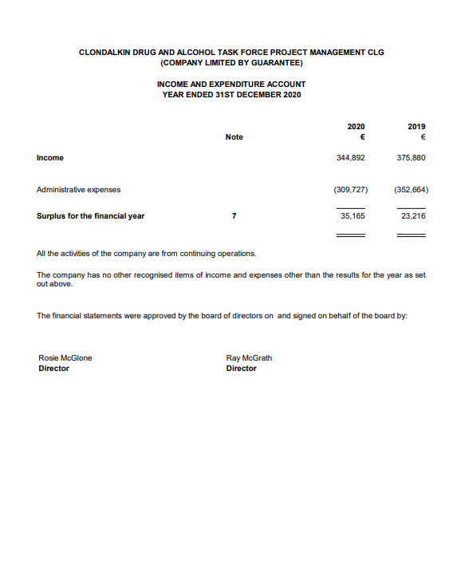
Appendix 2 Financial Statements

