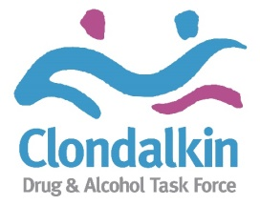

ANNUAL REPORT 2019

PART 1 – CDATF ORGANISATION OVERVIEW

1.1 Background
Clondalkin (Cluain Dolcain, meaning Dolcan’s meadow) is a suburban town situated 10km west of Dublin city centre and under the administrative jurisdiction of South Dublin. Clondalkin is one of three new western Dublin Towns proposed in the Myles Wright Report (1967) to cater for the growing population of the Dublin Region. The other proposed towns were Tallaght and Blanchardstown. The basic concept of these western towns was that they would be major and partially self-sufficient communities (South Dublin County History, 2018). Between the early 1970s and mid-1980s these towns experienced rapid growth in population, continuing to this day.
Clondalkin is a new suburban town which was developed in the 1970s and 1980s as a result of a growing demand for local authority and low-cost private housing, the decentralisation of traditional industries from Inner Cities and the development of a modern civil and industrial infrastructure. Twenty years later the Clondalkin, as planned, has not materialised. Instead, as with other new suburban towns in West Dublin the profile is one of poverty and social and economic disadvantage (CDTF, 1997).
North Clondalkin which comprises the neighbourhoods of Quarryvale, Rowlagh, Neilstown and Balgaddy is separated from the Village and Southwest Clondalkin by the Grand Canal and the Cork/Dublin railway line and the only access to it is over a narrow bridge. This creates problems of distance and isolation. Southwest Clondalkin comprises the neighbourhoods of Bawnogue, Deansrath and Clonburris and the Village area comprises the old Village and the neighbourhoods of Surleen and Knockmitten.
In 1991 the Census noted that there was a very high percentage of young people relative to other age groups in Clondalkin (37% of the population were aged 1-14 years) and that only 3% of the population were over 65. At this time, according to CODAN (1991) households headed by lone parents made up 17.9% of households in Clondalkin. The unemployment rate as a whole for Clondalkin was 26% but this was as high as 44% in some DED areas (CSO, 1991). The 1991 census shows that 40% of the population in Clondalkin left school at the age of 15 or under.
There was recognition of problem opiate use, mainly heroin from 1993 which continued to grow from there on. The problem was overwhelmingly concentrated among young males between 15 – 24 years old.
It was identified that the growing heroin problem was mainly situated in North Clondalkin but that there was also a need to deal with the emerging problem in South West Clondalkin. Moreover, community groups in the Quarryvale area of North Clondalkin has been instrumental in establishing Clondalkin Addiction Support Programme (CASP) as a response to the growing problem of heroin use in North Clondalkin. Thus the process of mobilising a response to the problem had already been begun in the North Clondalkin area by focusing on the needs of drug users and their families.
The Clondalkin Drug and Alcohol Task Force was established in 1997 and is one of 14 Local Drugs Task Forces established by the Government in response to the heroin epidemic occurring mainly in the Dublin region. Since then problematic drug use in Ireland has changed significantly and while heroin use remains a significant problem there is growing public concern regarding problems associated with polydrug use including cannabis, cocaine, alcohol and prescribed drugs such as benzodiazepines and other Z drugs.
In terms of CDATF Lucan, Palmerstown and Newcastle are the geographical areas covered. Clondalkin, Lucan, Palmerstown and Newcastle form the Dublin Mid-West Dail constituency with a population of 117,976 in 2016.
To date the Clondalkin Drug and Alcohol Task Force has developed three area action plans (1997 / 2001 / 2018) and in line with our current plan 2018 – 2025 the Clondalkin Drug & Alcohol Task Force continues to work in collaboration with all the key stakeholders to access funding, develop services in response to drug misuse and improve the coordination and delivery of services in the area. This strategy is delivered and coordinated across the five goals of the government’s strategy Reducing Harm, Supporting Recovery – A health led response to drug and alcohol use in Irealnd (2017 – 2025) through the work of local service providers in partnership with the community, voluntary and statutory sectors.

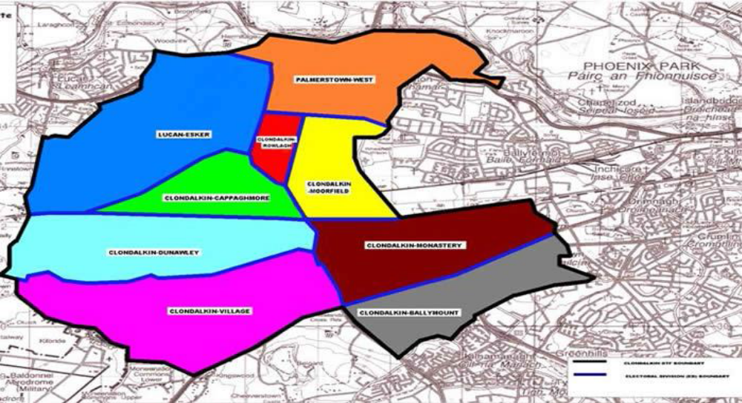

1.2 Organisation Aims & Vision

Our Aim
To re-establish and strengthen the role of the community in tackling the causes and consequences of drug and alcohol misuse; facilitate the re-establishment of meaningful and effective partnerships; and support the development of a holistic approach to dealing with both the causes and consequences of drug and alcohol misuse in the CDATF area.

Our Vision
The vision underpinning the strategy of the Clondalkin Drug & Alcohol Task Force for 2018-2025 is to continue to promote and actively support an approach to the work which is based on the principles of community development and is both person-centered and human rights-based.

1.3 Organisation Structure

CDATF

Board of Directors & Members
CDATF Coordinator
(Full Time)
Prevention & Education Officer
(0.8 FTE)
Treatment & Rehabilitation Officer
(Full Time)
Financial Administrator
(0.2 FTE)
Administrator
(0.5 FTE)
Drugs Outreach Worker (Under 18s)
Full Time

PART 2 – OVERVIEW OF THE DRUGS PROBLEM IN THE CDATF AREA (CLONDALKIN, PALMERSTOWN, LUCAN AND NEWCASTLE)

2.1 CDATF Area Profile

The CDATF cover the Dublin Mid-West constituency area of Clondalkin, Lucan, Palmerstown and Newcastle which has a population of 117,976 (Census, 2016). According to the South Dublin County Local Economic and Community Plan 2016 – 2021 (2016) the demographic change across the county is extremely varied with Lucan LEA increasing by 22.1% (+10,073) and Clondalkin LEA increasing by 10.9% (+5,090)

As of 2011 the total population aged ‘18-24’ residing in South Dublin was 24,852. This accounts for 9.4% of the population in the county and is the 7th highest rate in the State. This rate is higher than the State average (9%) but lower than the Dublin Region (10.3%). As expected, rates are higher in the more urban parts of the county and rates are highest in the Tallaght Central (10.5%) and Clondalkin (10.3%) LEAs.

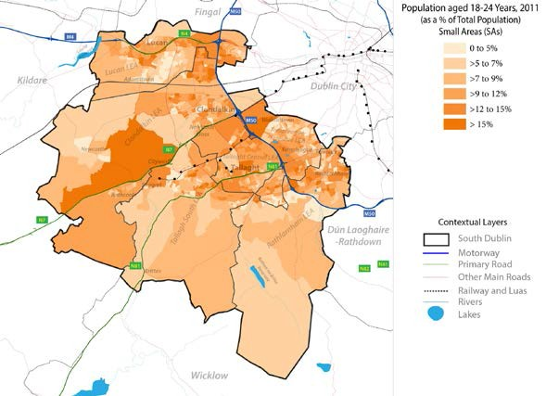
Deprivation
As a result of the economic downturn, Absolute Index Scores have decreased right across the country between 2006 and 2011 with Couth Dublin shifting by -6.7 points, the 8th lowest decrease of all local authorities. Rates of deprivation vary greatly across South Dublin with Tallaght South, Clondalkin and Tallaght Central all classed as ‘Marginally below Average’. The most disadvantaged areas within the county (‘Extremely Disadvantaged’ (1 SA) and ‘Very Disadvantaged’ – 35 SAs) are in parts of Clondalkin, and Ronanstown.

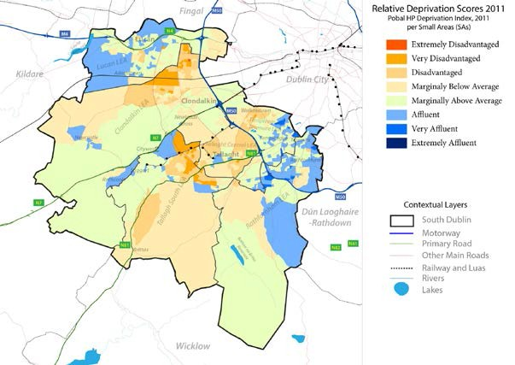

Housing
According to Census 2016, the total households with tenure of social rented residing in South Dublin were 10,921. This represented 11.8% of the total households. This proportion was higher than the State average of 9.4% and the Dublin regional average of 10.6% (South Dublin CYPSC, 2017: 117).

Relative to all other LAs, South Dublin had the fifth highest rate of households social renting in the State. Of the four Dublin LAs, South Dublin had the second highest rate. The highest rate being in Dublin City (13%), followed by South Dublin, DLR (6.8%) and the lowest in Fingal (6.7%).

Extreme variations are evident when examining the distribution of households social renting across the CFSNs. The highest rates by far, in the CDATF area, were recorded in the CFSN of Network 2: North Clondalkin/ Palmerstown (24.7% or 1,907). These rates were considerably higher than the other CFSNs in the CDATF area; Network 1: South Clondalkin & Environs (10.4% or 1,577) and Network 3: Lucan (5.8% or 866) (South Dublin CYPSC, 2017: 117).

The map below details the distribution of households social rented at SA level throughout South Dublin. There is a clear spatial pattern, the highest concentrations in Jobstown, Ronanstown and Tymon Park. SAs with the highest proportions of over 88% were located in Sundale, Jobstown and Saint Cuthbert’s Road. There are also 1,114 households in receipt of HAP payments across the CDATF area with 170 families located outside of the SDCC area (SDCC, 2019).
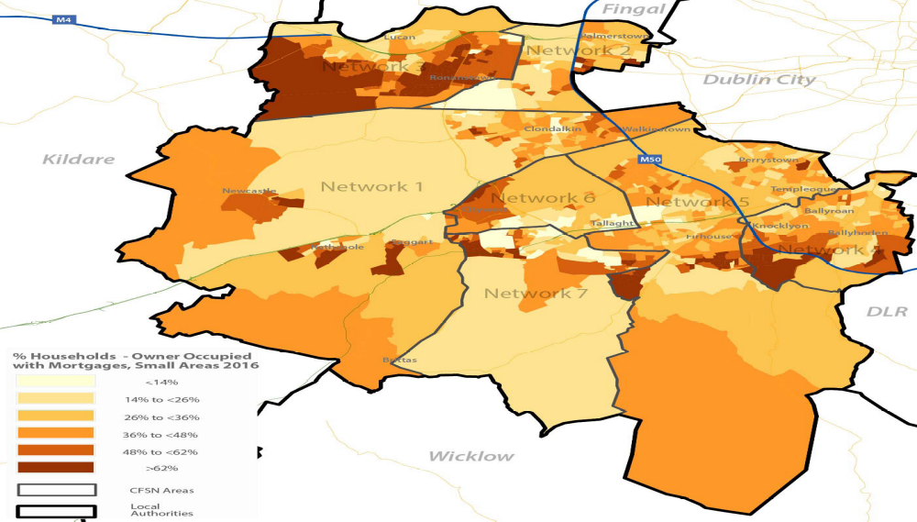

Lone Parent Households
As of 2011 there were 9,154 Lone Parent families in South Dublin with children aged under 15 years of age. This equates to 27.6% of the total number of families with young children in the county and is the 4th highest rate in the State. Within South Dublin there is a clear polarization effect with highest concentrations of Lone Parent Families in areas such as Ronanstown and Collinstown. At the LEA level, Clondalkin (37.9%) has more than double the rates within other LEAs.
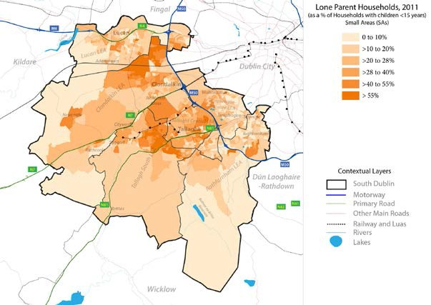
Non Irish Population
South Dublin has the 5th highest Non-Irish National rate in the State with 13.2% of its population originating from outside Ireland. Within South Dublin there is a very clear spatial pattern to the distribution with very high rates (>50%) evident in parts of Tallaght, Lucan, Adamstown and Clondalkin. The largest Non-Irish National groups residing in South Dublin are Polish (3.2%) and Rest of World (5.3%) – African, Asian and other non-EU countries. At the LEA level, highest rates are in the Lucan (19.6%) area.
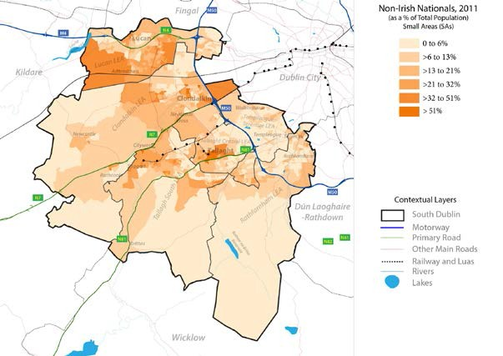
Employment & Education
As of 2011, the total population classed as unemployed (both unemployed and looking for first job) in South Dublin was 26,039. This figure represents an unemployment rate of 19.6% of the total labour force of 132,573 (population aged 15+ At Work and Unemployed). South Dublin has the 3rd highest number classed as unemployed and the 16th highest unemployment rate. The rate in South Dublin is higher than all other Dublin local authorities. There is a stark contrast with unemployment rates across the county with much higher rates in Clondalkin (25.2%).

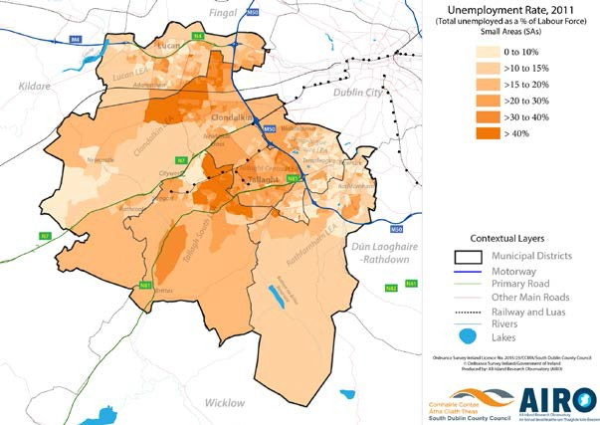

In 2016, the total students that sat the Leaving Certificate examination in South Dublin was 2,794. Of this figure, 69.7% or 1,948 of the students progressed to third level. This proportion was below the State average of 77.8% and relative to all other local authorities was the second lowest rate of progression in the country. On a comparative basis, DLR had the highest at 91.6% and Dublin City the lowest at 66.4%.
According to Census 2016, the total population residing in South Dublin with ‘Third Level’ education was 56,821. This represented 32.6% of the total population in South Dublin that had completed their education. This proportion was lower than the State average of 33.4% and the Dublin regional average of 40.7%.

Variations are evident when examining the distribution of people with ‘Third Level’ education across the CFSNs. The CFSNs of Network 3: Lucan had the second highest rates behind Rathfarnham at 43.5% (or 11,607). This rate is considerably higher than the other CFSNs; Network 1: South Clondalkin & Environs (26.2% or 7,533) and Network 2: North Clondalkin/Palmerstown (17.3% or 2,677) (South Dublin CYPSC, 2017: 87 - 91).

2.2 Profile of Drug use

Opiate Use
The total number of clients in treatment in the Clondalkin Drugs and Alcohol Task Force area from January – December 2019 is as follows:

Gender | Clinic | Trinity | GP | Prison | Total
Male | 173 | <10 | 182 | 26 | 386
Female | 92 | 0 | 79 | <10 | 173

The Methadone Treatment Data Analysis per L/RDATF for 2019 indicates that there were at least 559 individual’s resident in the CDATF in treatment for opiate addiction. This represents 5% of the number of clients in treatment in the region, the fifth highest after the North Inner City DATF, South Inner City DATF, South East Reginal DATF and Tallaght DATF.

A complete picture of the number of people receiving treatment for drug and alcohol use in the CDATF area is difficult to access. Data is available from the Health Research Boards through the NDTRS but not all services are included in this system, as a result, NDTRS figures underestimate the level of treatment and drug related need in the area. However, data from the NDTRS for the CDATF area states that 450 individuals engaged in treatment and rehabilitation services locally.

Reason for Referral: Gender:
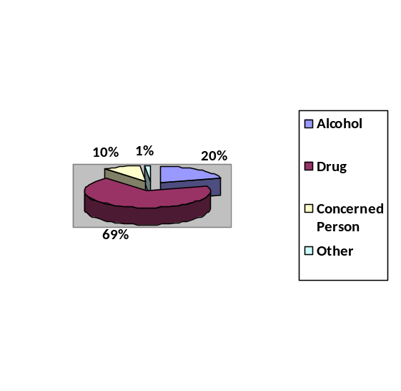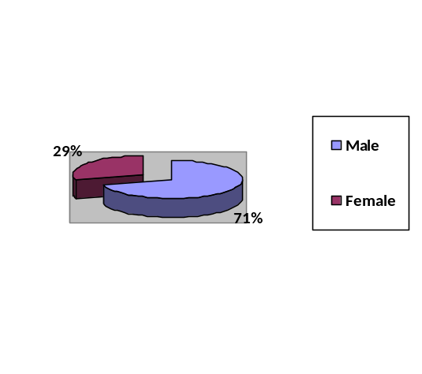

Age Group

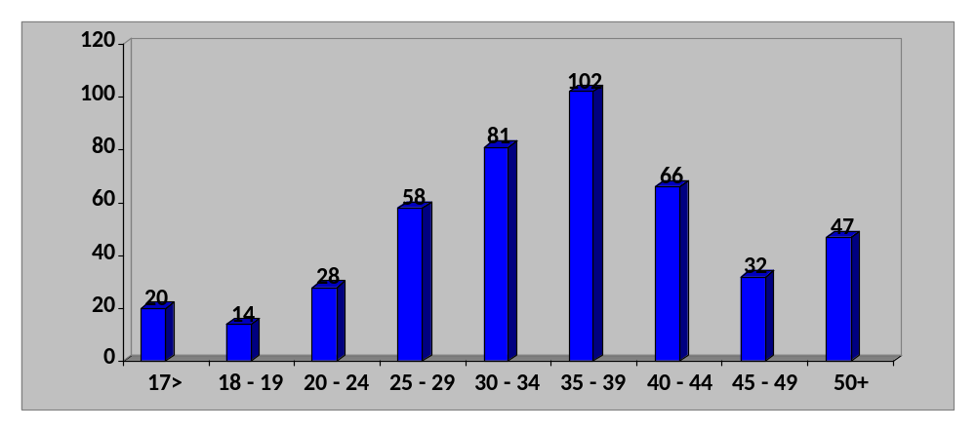

Reason for Referral

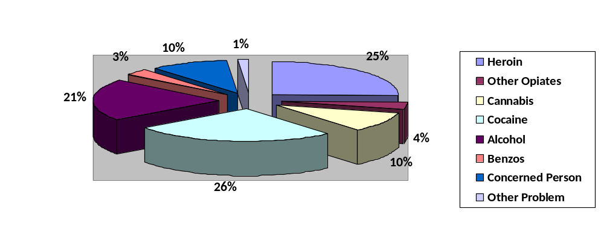
Accommodation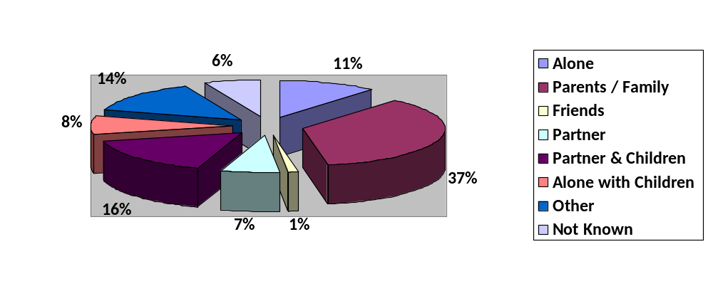
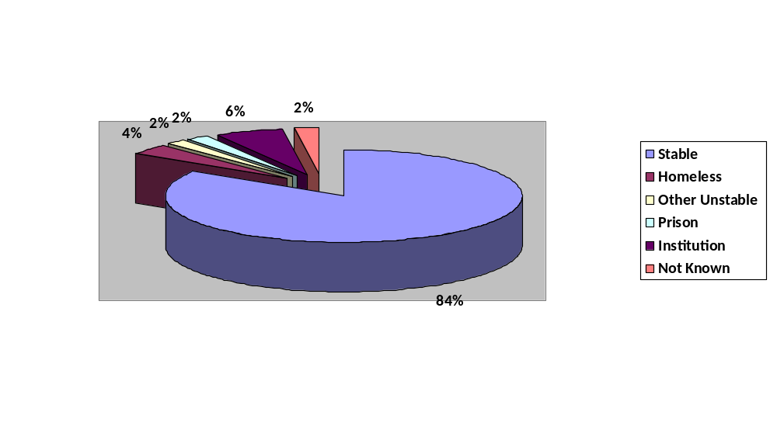
Education & Employment

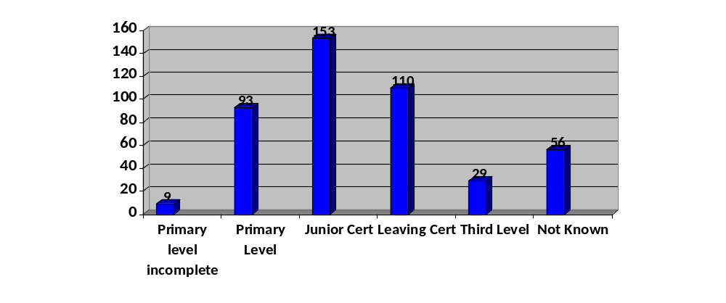
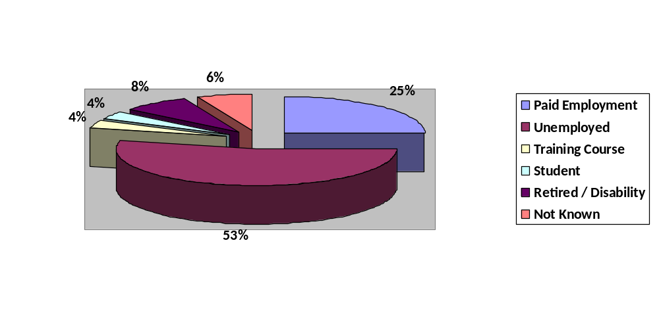196 people accessing services uses more than one drug and 191 people presented for one drug only. 122 people had issues with two substances, 47 people had issues with three substances, 19 people had issues with four substances and 8 people had issue with five substances. 88 people had a history of injecting drug use, 254 people had no history of injecting drug use and 45 people their injecting history was unknown. 18 individuals had injected in the past month.
Treatment Interventions & Outcomes

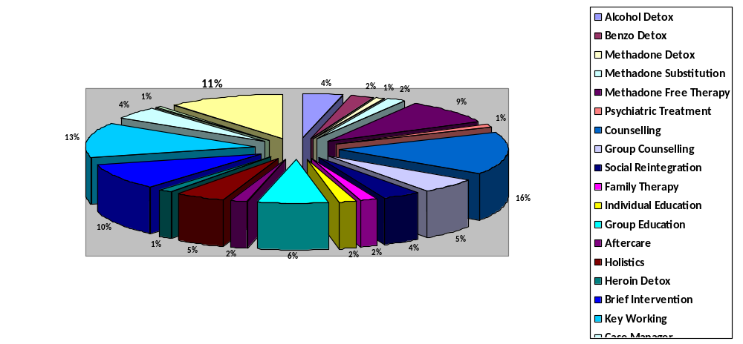

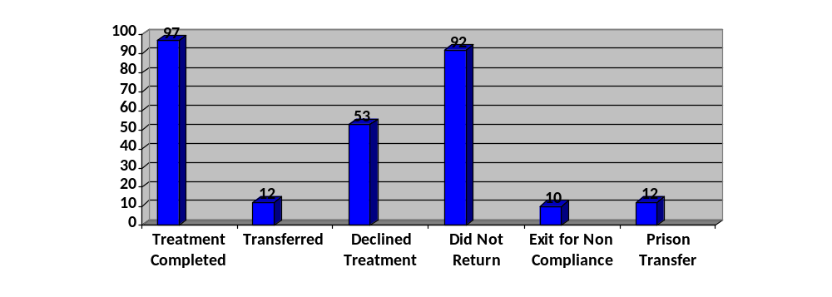
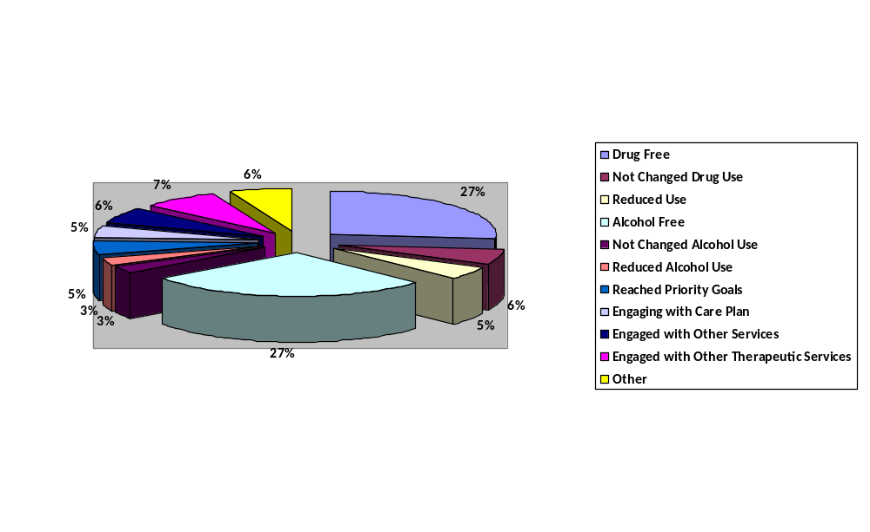

2.2 b Emerging Trends in Drug use

Research commissioned by the CDATF (O’Gorman et al, 2016) found that poly drug use continues to be the norm in the CDATF area and if reported to most frequently involve cannabis (herbal) various prescription pills such as benzodiazepines and ‘Z drugs’ mixed with alcohol.

Cocaine, New Psychoactive Substances (NPS) such as mephedrone, and various ecstasy type substances were reported to be widely used in recreational settings. Heroin and crack cocaine continue to be used by a small proportion of habitual users.

Drug trends were reported to fluctuate based on what was available in the local drugs marker and what was value for money – particularly drugs used in youth recreational settings such as New Psychoactive Substances, Ketamine and various forms of ecstasy.

Cannabis use mostly herbal cannabis (grass and weed) than hashish or resin was reported to be widespread and accommodated into social and recreational practices of many residents in the area across all age groups.

Cocaine was reported to be the second (illicit) drug of choice among people in the CDATF area with its use now widely accepted across age, gender and social class. Cocaine use as reported to be used by young people ( though the quality of what type are using was debatable) and by older ‘working men’ as a status drug at weekends - this raised concern about increased levels of cardiac disease and cocaine-related deaths among this age group. Cocaine was reported to be mainly used in pub and party settings to prolong and enhance the effects of alcohol use followed by benzodiazepine use to ease the ‘come down’ of stimulant use.

Alcohol was reported to be the drug with the most negative impact on the quality of life and the wellbeing of people living the CDATF area. The increasing alcohol outlets in shops, pubs and off licenses and its low cost and ease of access for all ages are seen to have negatively impacted on the area. Its use as a standalone drug or underpinning cannabis, stimulant and opiate use is so pervasive that nondrinkers were regarded as an oddity.

Young people were also more attracted to using cheaper New Psychoactive Substances (NPS), ecstasy and ketamine and ‘party products of dubious quality and ever-changing content, many sourced from the internet. These young drug users also did not engage with local drug services. They associated these series with injecting heroin users and did not see themselves as having a problem particularly as they were not injecting drugs.

In the National Advisory Committee on Drugs and Alcohol (NACDA, 2012) population survey almost half (43%) of young adults in the region have used cannabis and at best estimates this would be a minimum in the CDATF area. Service providers working with young people reported cannabis use to be commonplace among young teenagers (13 -14 year olds), and in particular by boys. These reports match the high levels of cannabis use found in National Surveys of School Going Youth (HBSC, 2010). Workers locally raised concerns about the impact of cannabis use on young people’s developmental and mental health and their attendance and participation in school and other education programmes.

Members of the Traveller community and service providers working with them reported an increase in the use of prescription drugs, cannabis and cocaine in the community. For women the use of prescription drugs intravenous Melanotan use (as a tanning aid) and sharing of injecting equipment within their family group were regarded with concern. For men concerns were raised about the use of steroids and performance enhancing drugs.
(O’Gorman, O’ Driscoll, Moore: 2016)

2.3 Main issues that were addressed in 2019

- Information from the HSE addiction services, substance misuse treatment and rehabilitation services in the community and voluntary sector have indicated that the prevalence of substance misuse in the area remains a major cause for concern given the social, environmental and economic impact on individuals and families affected as well as the broader community.
- The issue of dual diagnosis and the complex needs of those presenting to services and limited pathways, particularly for those under the age of 18 years.
- The increase in the number of clients presenting who are new to the services and whose primary substance is cocaine / crack cocaine.
- The increasing numbers of those presenting to services, primarily through outreach, with problematic crack cocaine use who are not from the area. These numbers have been quite significant from the Kildare, Midlands & Wicklow areas.
- Polydrug use involving cannabis, various prescription pills such as pregabalin, benzodiazepines and ‘Z drugs.
- The continued use of heroin by a small proportion of habitual, aging opiate users.
- The widespread use of cocaine and crack cocaine among people in the CDATF area across age, gender and social class presenting to services for support.
- The number of drug related deaths in the form of both overdosing and suicide within the CDATF community.
- The impact of cannabis use and crack cocaine use among young people in terms of their development and mental health, school attendance and participation in other educational programmes.
- The significant increase in young people (12 – 18 years) in the area using crack cocaine and involvement in the drugs economy.
- The lack of knowledge and awareness of substance misuse and the barriers facing members of the Traveller community in accessing services.
- The delivery of culturally appropriate drug interventions to Travellers who are using drugs and their families.
- Drug debt and intimidation of families for the payment of young person’s drug debt or drug habit.
- The number of young people funding their daily usage of this drug by both holding and dealing, particularly in a number of housing estates in the CDATF area that is having significant impacts on those communities.
- The deliberate targeting of young people at risk by drug dealers including young Travellers. This is having a destabilizing affect on a number of housing estates in the CDATF area.
- The reported increase in use of cocaine and alcohol amoung members of the Traveller community in the area.
- The numbers of individuals and families in difficulty who are detached from any service provision.
- The engagement and participation of the community, people who use drugs and family members in capacity building programmes to support involvement in service development and delivery and local decision-making structures.
- Supporting the community of Balgaddy to deal with unique issues to this community pertaining to drug use, drug dealing, housing issues, anti-social behavior and the needs of young people and families.
- The delivery of training across all Tiers locally and to the community and voluntary service providers including SAOR, Addiction Studies (Level 7), Crack Cocaine training, Non-Violent Resistance Training, WRAP Train the Trainer, Drug Education, Harm Reduction and Governance Code.
- The need for service user training in Naloxone therefore marked International Overdose Awareness Day (IOAD) delivering peer led Naloxone training to those who use drugs and dispensing of injectable and nasal Naloxone to those who use drugs.
- Expansion of the SAFE Initiative to incorporate other DATF areas (local and regional) and to appoint an assertive case manager to coordinate the SAFE Initiative.

2.4 CDATF Strategic Priorities 2018 - 2025

Strategic Goal One: Dealing with the Effects of Drug & Alcohol Misuse

Objectives | Outcome Indicators
1. To work towards addressing the broader social and economic contributing factors of drug and alcohol misuse in partnership with community, voluntary and statutory agencies. | The Task Force will continue to facilitate the delivery of services and programmes that assist individuals and families facing challenges associated with drug and alcohol misuse. Under this goal the CDATF will be working towards;  • Increased clarity in relation to underlying principles governing the delivery of drug and alcohol services.  • The embedding of harm reduction as a guiding principle in all service delivery.  • The creation of broader and more improved options for those affected and increase opportunities for ‘positive life choices’ in relation to:  • Treatment, rehabilitation and aftercare.  • Personal progression (in relation to education, training and employment options).  • Accommodation (especially in relation to improved options for those experiencing or threatened with homelessness).  • The provision of additional evidenced based prevention programmes for parents, children and young people most at risk of drug and alcohol misuse.  • The development of more specific and targeted programmes for young people under 18 engaged in drug and alcohol misuse and their families.  • Creating safer and more meaningful opportunities for those most affected in developing a collective response to drug related crime and intimidation.  • Developing a clear outcome in the ongoing discussion regarding the decriminalization of drugs for personal use.  • Supporting the full and active participation of those most affected in all CDATF decision-making structures.
2. To continue to provide person- centered supports and effective service responses to the needs of those affected by drug and alcohol misuse.

3. To build on and increase meaningful progression opportunities for those affected by drug and alcohol misuse.

4. To create more opportunities for improving collaboration and developing an integrated response to drug related crime and intimidation

5. To facilitate consultations with key stakeholders at local level regarding the decriminalization of drugs for personal use and inform national policy

Strategic Goal Two: Strengthening the Role of the Community in Addressing the Causes of Drug & Alcohol Misuse

Objectives | Outcome Indicators
1. To continue to strengthen the capacity of the community in challenging the root causes of drug and alcohol misuse including the harmful outcomes of drug policy, poverty and inequality. | The Task Force will continue efforts to strengthen the capacity of local community to understand and effectively challenge the root causes of drug and alcohol misuse. These efforts will have the task of rebuilding community infrastructure at their core but will also focus on rebuilding real and effective partnerships between mainstream services and community-based responses. Under this goal the CDATF will be working towards:  A strengthening of the capacity of local community interests to have an influence. Progress in this direction will be evident in the extent to which community representatives are:  • Facilitated to become more actively engaged in understanding and addressing the causes of drug and alcohol misuse.  • Actively engaged with and participating in decision making structures at local and national level including the CDATF.  • Feel safer and develop trust in the process of partnership and interagency working at local and national level.  • Have a greater capacity to be more effective in their efforts to lobby and influence decisions which impact on their lives.
2. To facilitate the participation of those most affected in identifying and developing appropriate responses to drug and alcohol misuse.

3. To build the capacity of those most affected by drug and alcohol misuse to engage in decision making at all levels.

Strategic Goal Three: Having a Positive Influence on Mainstream Services & Contributing to More Integrated Responses

Objectives | Outcome Indicators
1. To broaden the understanding and response to drug and alcohol misuse based on the recognition that that the causes are multidimensional; crossing a range of social, economic and policy linked factors. | The Task Force will facilitate a concerted effort to improve effectiveness (and cost-effectiveness) of mainstream service delivery. Under this goal the CDATF will be working towards highlighting the lessons emerging from local practice in the shaping and targeting of service delivery through;  Raising awareness of the fact that effectively tackling the drug and alcohol issue is not just about drug and alcohol misuse in isolation but implicates a wide spectrum of social and economic policy. Progress in ensuring that this approach is embedded in practice will be evident through mainstream service providers:  › Communicating with each other more effectively.  › Achieving a ‘depth’ in efforts to improve integration, ensuring for example that effective collaboration takes place at front line service level, and at decision making level.  › Adopting an approach to review that is less restrictive and one- dimensional taking into account qualitative as well as quantative benefits and the broader family and community effects of particular responses.  › Acknowledging the broader social and economic contributing factors to drug and alcohol misuse and the range of social and economic benefits accruing from a more holistic approach.  › Acknowledge the importance, and potential mutual benefit accruing, from sustainable partnerships.  › With these mutual benefits in mind, engagement in negotiation, joint service planning and review (seeing local organisations as knowledge and expertise to be harnessed rather than just as a mechanism for service delivery).  › Are more flexible and responsive to local needs with the capacity to change, contract and expand when needs change.  › Are less restrictive in terms of policies in relation to access where these conditions can act as a barrier to access.  › Direct increased resources towards community development infrastructure, in recognition of the vital role this plays in effective responses.
2. To engage with key stakeholders in renewing their commitment to the DATF model of community-based partnership
3. To build on existing evidence based on local knowledge and expertise which will demonstrate the longer-term benefits of a more holistic approach to drug and alcohol misuse

4. To seek to influence the development of appropriate responses to drug and alcohol misuse by bringing local knowledge and expertise to the planning and delivery of mainstream services and local development programmes.

Coordination and Operational Priorities
- Support the engagement of key stakeholders to implement the New National Drugs Strategy Reducing Harm, Supporting Recovery: A health-led response to drug and alcohol use in Ireland 2017 – 2025 in the context of the local area.
- Implement the actions of the NDS where DATFs have been assigned a role.
- Engage with key stakeholders to implement the CDATF Strategic Plan 2018 – 2025: Reclaiming Community Development as an Effective Response to Drug Harms, Policy Harms, Poverty & Inequality.
- Improve current operational structure and create structure for future development.
- Reviewed and evaluated current funded actions in line with CDATF new Strategic Plan 2018 – 2025 ‘Reclaiming Community Development as an Effective Response to Drug Harms, Policy Harms, Poverty and Inequality’.
- Engaged in a participatory process with funded services and the CDATF board to identify key priority actions within the CDATF area.
- Engaged with funded services to identify lessons and insights in shaping effective mainstream responses to the issues associated with substance misuse.
- Establish systems to facilitate continuous internal and external evaluation and review as a means of building the Task Force spheres of influence on the basis of evidence, demonstrative results and lessons emerging.
- Develop a broader and more appropriate set of review and evaluation indicators to support ongoing evaluation of the task force and funded actions in line with the needs of the CDATF community.
- Continue to work effectively and in collaboration with all key stakeholders, highlight and address gaps in representation and facilitate the development of improved interagency collaboration among key stakeholders.
- Continue to influence policy development at all levels through lobbying and advocacy work.
- Identify and develop responses to strategic policy issues at local, regional and national level.
- Carry out a review of current strategic and operational structures and identify and implement organizational change where necessary.
- Continue to monitor the implementation of CDATF interim funded projects and agree any changes in this regard with project promoters, channels of funding and the DPU where appropriate.
- Carry out consultations with service providers regarding new and emerging needs.
- Developed research tender to identify new and emerging patterns of drug use among young people (12 – 21 years) and the exploration of the ‘naturalization’ of involvement in drug use and the drugs economy for young people.
- Developed and launched the ‘Clondalkin Model’ to highlight models of good practice in relation to Harm Reduction Interventions (SAFE), Culturally Appropriate Substance Misuse Interventions for Travellers, Drug Education Using a Whole School Approach and Dual Diagnosis.
- Ensure the completion of effective operational and administrative tasks including financial management, staff management and adhering to the reporting requirements of various funders.

Strategic & Operational Partnerships

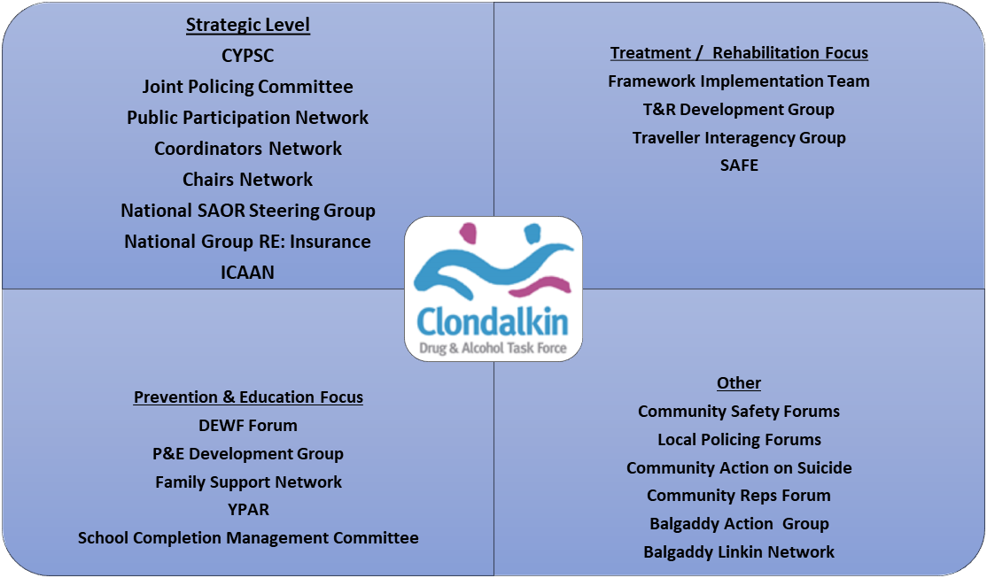
3.0 CDATF Progress Report 2019
RHSR Goal | RHSR Objective | RHSR Action | CDATF Strategic Goal & Outcome Indicators | CDATF Inputs & Outcomes 2019
1. Promote & Protect Health & Well Being | 1.1.1 | Ensure that the commitment to an integrated public health approach to drugs and alcohol is delivered as a key priority. Delivered by:  - Developing an initiative to ensure that the commitment to an integrated public health approach to drugs and alcohol is delivered as a key priority.  - Developing a guidance document to ensure substance use education is delivered in accordance with quality standards.
1. Promote & Protect Health & Well Being | 1.1.2 | Improve the delivery of substance use education across all sectors, including youth services, services for people using substances and other relevant sectors.  a) Organising a yearly national forum on evidence-based and effective practice on drug and alcohol education; and  b) Developing a guidance document to ensure substance use education is delivered in accordance with quality standards. | Strategic Goal 1 – DEALING WITH THE EFFECTS OF DRUG & ALCOHOL MISUSE  Strategic Goal 1 – DEALING WITH THE EFFECTS OF DRUG & ALCOHOL MISUSE  Strategic Goal 1 – DEALING WITH THE EFFECTS OF DRUG & ALCOHOL MISUSE | CDATF was one of 6 DATFs involved in developing and organising the Prevention & Education Conference in 2019. The DAEWF group held 20 meetings in 2019.  Initial steps have been taken to engage with local schools to train and roll out the SHAHRP programme locally.
1. Promote & Protect Health & Well Being | 1.2.3 | Support the SPHE programme.  a) Promoting continued effective communications between local schools and Drug and Alcohol Task Forces given the importance placed on the continued building of strong school community links; and  b) Ensuring that all SPHE teachers, guidance counsellors and Home School Community Liaison coordinators can avail of continuing professional development. |  | CDATF worked with 2 Post Primary Schools in the CDATF area. Training programme developed and implemented in line with identified need and school drugs policy developed.  2 x 4-hour sessions with the school staff team and worked in partnership with the Gardai to look at new and emerging trends. 50 teachers engaged in the training and further training to be rolled out in 2020.  Specific piece of work with one post primary school to address the reported increase of drug taking and dealing outside the school ground. Two meetings took place in 2019. This is a collaborative approach working with outside agencies to engage more effectively with the young people in question.
1. Promote & Protect Health & Well Being | 1.2.4 | Promote a health promotion approach to addressing substance misuse. In line with the Action Plan for Education  - Commencing and rolling out a national programme to support the implementation of the Wellbeing Guidelines to all primary and post-primary schools; and  - Developing Wellbeing Guidelines for Centre’s of Education and Training. |  | 25 young people benefited from 2 personal development programmes funded through CDATF which aimed to create a place of sanctuary and safety within themselves, promote the development of positive self-esteem and promote the development of positive self confidence and general wellbeing.
1. Promote & Protect Health & Well Being | 1.2.5 | Improve supports for young people at risk of early substance use.  - Providing a continuum of support including a Student Support Plan as appropriate, for young people who are encountering difficulty in mainstream education.  - Providing access to timely appropriate interventions such as resilience-building programmes, and/or counselling, educational assessments and/or clinical psychological assessments, as appropriate.  - Implementing School Attendance Strategies in line with TUSLA’s guidance.  - Prioritizing initiatives under the new DEIS programme to address early school leaving; and  - Providing supports including homework clubs, additional tuition, career guidance/ counselling support, community awareness of drugs programme and youth work in collaboration with schools and other youth programmes/schemes. |  | CDATF provide funding to a specialist education facility for young people who have been excluded from mainstream education. 30 young people attend daily and engage in education (21 hours per week) with a total of 57 engaged in 2019. 28% of those engaged in 2019 had substance misuse issues. In 2019 there were 720 one to ones provided in 2019 and 120 home visits. 3 cases were closed.
1. Promote & Protect Health & Well Being | 1.2.6 | Ensure those who do not seem to thrive in a traditional academic setting complete their education. Reviewing Senior Cycle programmes and Vocational Pathways in senior cycle with a view to recommending areas for development.
1. Promote & Protect Health & Well Being | 1.2.7 | Facilitate increased use of school buildings, where feasible, for afterschool care and out of hours use to support local communities. Engaging with property owners and school authorities to facilitate increased use of school buildings, where feasible, for afterschool care and out of hours use to support local communities.
1. Promote & Protect Health & Well Being | 1.2.8 | Improve services for young people at risk of substance misuse in socially and economically disadvantaged communities. Developing a new scheme to provide targeted, appropriate, and effective services for young people at risk of substance misuse, focused on socially and economically disadvantaged communities | Strategic Goal 1 – DEALING WITH THE EFFECTS OF DRUG & ALCOHOL MISUSE | 2018 saw CDATF engage in consultations with local stakeholders in the development of a plan for an Under 18s Substance Misuse Service locally. 2019 saw CDATF review & evaluate all funded actions and re-allocate resources to create new roles for Youth Substance Misuse Workers.  CDATF fund initiatives in the Youth Services locally to support those at risk of substance misuse. In 2019 320 young people engaged in targeted prevention activities funded through the youth services by CDATF. Activities such as one to ones, group work, outreach, summer camps and drop ins were facilitated to target those most in need of services (aged 10 – 24). Programmes to promote health and wellbeing, raise awareness of drug use and delay initiation or divert away from drug use were delivered.  - 16 programmes ran in 2019.  - 220 young people engaged in summer camps.  - 304 drop-in session hours delivered.  - 4600 total contacts.  CDATF funded Family Support Worker with the Garda Diversion Project engaged with 8 families, 9 individuals in 2019. 4 were new families and 4 were carried over from 2018. 144 home visits took place, 60 drop ins, 60 hours dedicated to case conferences and 48 hours of group work.  A group of young people engaged in the Youth Services developed the ‘Think B4 You Drink’ Alcohol Awareness Campaign. 6 young people (aged between 14 – 17) attended 6 x 2-hour sessions on alcohol awareness. They also attended a full week to develop film / poster campaign.
1. Promote & Protect Health & Well Being | 1.3.9 | Mitigate the risk and reduce the impact of parental substance misuse on babies and young children.  - Developing and adopting evidence-based family and parenting skills programmes for services engaging with high risk families impacted by problematic substance use.  - Building awareness of the hidden harm of parental substance misuse with the aim of increasing responsiveness to affected children.  - Developing protocols between addiction services, maternity services and children’s health and social care services that will facilitate a coordinated response to the needs of children affected by parental substance misuse; and  - Ensuring adult substance use services identify clients who have dependent children and contribute actively to meeting their needs either directly or through referral to or liaison with other appropriate services, including those in the non-statutory sector. |  | 53 families attended Hidden Harm Project in CDATF area in 2019. This included grandparents, parents and young people were substance misuse was the primary issue.  92 individuals engaged in Hidden Harm services locally with 3,864 sessions delivered in 2019. 425 family review meetings took place.  22 individuals engaged in group work with 3,696 sessions in 2019. Group work included parent support, family support, gender specific groups, and WRAP.  12 new family cases in 2019 and 10 cases were closed. Families were also supported to access the food bank.  CDATF funded Family Therapy within the project to provide a safe environment for all family members to identify needs and develop new coping skills. 7 families benefited from this intervention with 10 individuals participating. 63 sessions in total were delivered over a 6-8-week cycle for each family.
1. Promote & Protect Health & Well Being | 1.3.10 | Strengthen the life-skills of young people leaving care in order to reduce their risk of developing substance use problems. Considering how best to provide necessary once-off supports for Care Leavers to gain practical lifelong skills in line with Action 69 of the Ryan Report in order to reduce their risk of developing substance use problems.
1. Promote & Protect Health & Well Being | 1.3.11 | Strengthen early harm reduction responses to current and emerging trends and patterns of drug use. Establishing a working group to examine the evidence in relation to early harm reduction responses, such as drug testing, amnesty bins and media campaigns, to current and emerging trends including the use of new psychoactive substances and image and performance enhancing drugs and other high risk behaviours, including chemsex.
2 Minimise the harms caused by the use & misuse of substances & promote rehabilitation & recovery | 2.1.12 | Strengthen the implementation of the National Drugs Rehabilitation Framework.  - Developing a competency framework on key working, care planning and case management; and  - Extending the training programme on the key processes of the National Drugs Rehabilitation Framework. | Strategic Goal 1 – DEALING WITH THE EFFECTS OF DRUG & ALCOHOL MISUSE  Strategic Goal 1 – DEALING WITH THE EFFECTS OF DRUG & ALCOHOL MISUSE  Strategic Goal 1 – DEALING WITH THE EFFECTS OF DRUG & ALCOHOL MISUSE  Strategic Goal 1 – DEALING WITH THE EFFECTS OF DRUG & ALCOHOL MISUSE  Strategic Goal 1 – DEALING WITH THE EFFECTS OF DRUG & ALCOHOL MISUSE | Localized training continues to be rolled out to support the implementation of the NDRF. 3 MOUs exist that support integrated care pathways for those:  - With Dual Diagnosis (MOU between CMH and local drug services).  - Travellers (MOU between Traveller Project and 2 local drug services).  - Seamless Referrals (MOU between 3 community drug projects re: sharing of information).
 | 2.1.13 | Expand the availability and geographical spread of relevant quality drug and alcohol services and improve the range of services available, based on identified need.  - Identifying and addressing gaps in provision within Tier 1, 2, 3 and 4 services.  - Increasing the number of treatment episodes provided across the range of services available, including:  - Low Threshold;  - Stabilization;  - Detoxification;  - Rehabilitation;  - Step-down;  - Aftercare;  c) Strengthening the capacity of services to address complex needs. |  | Counselling was funded through CDATF grants in a Tier 2 Community drugs service for pre and post detox / treatment supports, crisis intervention, trauma support and addiction specific support. 132 counselling sessions were provided to 15 individuals.  An additional 161 individuals engaged in counselling in one service with a total of 1030 session delivered. 89 of these were new referrals.  244 individuals accessed key working / case management across 2 local community substance use projects. A total of 1,984 key working sessions delivered in 2019.
 | 2.1.14 | Improve the availability of Opioid Substitution Treatments (OSTs). Examining potential mechanisms to increase access to OSTs such as the expansion of GP prescribing, nurse led prescribing and the provision of OSTs in community-based settings and homeless services.
 | 2.1.15 | Enhance the quality and safety of care in the delivery of Opioid Substitution Treatment (OST). Implementing the HSE National Clinical Guidelines on OST and reviewing in line with National Clinical Effectiveness Committee processes.
 | 2.1.16 | Improve relapse prevention and aftercare services. Developing and broadening the range of peer-led, mutual aid and family support programmes in accordance with best practice |  | CDATF supported one local community-based drugs project to expand family support interventions into the Lucan area to meet the need of families affected by substance misuse in Lucan.
 | 2.1.17 | Further strengthen services to support families affected by substance misuse. a) Developing addiction specific bereavement support programmes and support the provision of respite for family members.  b) Supporting families with non-violent resistance training to address child to parent violence; and  c) Supporting those caring for children/young people in their family as a result of substance misuse to access relevant information, supports and services. |  | Non-Violent Resistance Training rolled out to community, voluntary and statutory agencies in the CDATF area. 26 practitioners across adolescent, family and treatment services completed the training.  143 family members engaged in one to one support in family support services locally with a total of 1,055 sessions delivered in 2019. 43 families availed of residential respite services on 16 different occasions and peer led and worker supported family support groups were delivered weekly in two local services.  Also see Action 1.3.9
 | 2.1.18 | Help individuals affected by substance misuse to build their recovery capital.  - Monitoring and supporting the implementation of the Department of Social Protection’s Programme Framework for Community Employment Drug Rehabilitation Schemes, based on an integrated inter-agency approach; and  - Utilising SICAP to improve the life chances and opportunities of those who are marginalized in society, living in poverty or in unemployment through community development approaches, targeted supports and interagency collaboration. |  | Rehabilitation Community Employment Programme delivered through one Community Substance Use Project and supported by funding from CDATF & DEASP. In 2019 49 individuals engaged in rehabilitation CE. This is broken down as follows:  Pre programme induction supports: 26  Programme supports pre-entry process identifying those who meet the criteria for programmes offered.  P1 Stabilisation Programme: 16  Programme supports those wishing to stabilise or enter residential treatment.  P2 Recovery Preparation Programme:16  Programme supports pre-entry stages of community detox, residential detox or residential treatment.  P3 Drug Free Programme: 12  Programme supports ongoing therapeutic support and support into employment, education and training.  P4 Progression and Integration Pathways ACE Programme: 9  Programme supports reintegration into employment, training and education.  P5 Aftercare: 9  Aftercare supports through key working and care planning.
 | 2.1.19 | Increase the range of progression options for recovering drug users and develop a new programme of supported care and employment. Establishing a Working Group to:  - Examine the range of progression options for those exiting treatment, prison, Community Employment schemes including key skills training and community participation with a view to developing a new programme of supported care and employment; and  - Identify and remedy the barriers to accessing the range of educational, personal development, training and employment opportunities and supports, including gender specific barriers and the lack of childcare provision, for those in recovery.
 | 2.1.20 | Expand addiction services for pregnant and postnatal women.  a) Strengthening links between maternity services and addiction services.  b) Quantifying the need for additional residential placements for pregnant and postnatal women who need inpatient treatment for addiction to drugs and/or alcohol across the country.  c) Developing services to meet that need ensuring that such facilities support the development of the mother/ baby relationship.  d) Providing dedicated support for pregnant women with alcohol dependency, including examining the need to expand the role of the Drug Liaison Midwife (DLM) in this regard. Any such expansion will likely generate a need to further increase the number of such midwives.  e) Resourcing the National Women and Infants Health Programme (NWIHP) to provide drug liaison midwives and specialist medical social workers in all maternity networks;  f) Supporting maternity hospitals/ units to strengthen their methods of detecting alcohol abuse and supporting women to reduce their intake; and  g) Engaging the NWIHP to develop a consistent approach to informing women about the risks of alcohol consumption during pregnancy.
 | 2.1.21 | Respond to the needs of women who are using drugs and/or alcohol in a harmful manner.  a) Increasing the range of wraparound community and residential services equipped to meet the needs of women who are using drugs and/or alcohol in a harmful manner, including those with children and those who are pregnant; and  b) Developing interventions to address gender and cultural specific risk factors for not taking up treatment. | Strategic Goal 1 – DEALING WITH THE EFFECTS OF DRUG & ALCOHOL MISUSE | An event was funded for International Women’s Day to promote the health and wellbeing of women impacted by substance misuse. Activities included breast cancer screening, holistic and beauty treatments, arts and crafts and a presentation from Inspiring Women. 49 women attended this event.  A development group to look specifically at women, mental health and substance misuse was established in Q3 of 2019 to identify and develop evidence-based resilience programmes for women engaged in recreational / social substance use not currently engaged in services. 7 meetings took place in 2019. Membership includes CDATF, local community drugs projects, South Dublin County Partnership, South Dublin County Council and Clondalkin Action on Suicide (CAS).
 | 2.1.22 | Expand the range, availability and geographical spread of problem drug and alcohol services for those under the age of 18.  - Identifying and addressing gaps in child and adolescent service provision.  - Developing multi-disciplinary child and adolescent teams; and  - Developing better interagency cooperation between problem substance use and child and family services | Strategic Goal 1 – DEALING WITH THE EFFECTS OF DRUG & ALCOHOL MISUSE  Strategic Goal 1 – DEALING WITH THE EFFECTS OF DRUG & ALCOHOL MISUSE | As part of CDATF Review & Evaluation in 2019 it was recognised that resources needed to be re-allocated to fund youth substance misuse intervention workers. A development group was established to oversee this process and develop a clear work plan, clear KPIs and responses for young people engaged in problem drug and alcohol use. The development group consists of representation from local community drug projects, family services, informal education services, HSE adolescent addiction counsellor, youth projects and HSE adolescent addiction psychiatry. This group is chaired by CDATF. This group met 3 times in Q3 and Q4 in 2019. 2 new youth substance misuse workers will be in place in January 2020.  CDATF funded Youth Substance Misuse Outreach Worker engaged with 36 young people under 18 in 2019 who were experiencing difficulties due to substance misuse. 940 visits took place with 1598 session hours delivered. 28 young people were referred and completed education / training courses and 8 cases were closed.  Additional hours (8 hours per week for 8 months)for targeted detached outreach work was also funded as a response to the emerging needs due to the escalating drug issue in the community and to target those most in need and divert them into services for one to one support. 3 young people aged 18 - 24 engaged in one to one support, a small group of women engaged in group work to support integration into employment / education and the establishment of the CFSN, pre-development stage of young persons rehabilitation day programme and strong interagency links were developed.
 | 2.1.23 | Improve the response to the needs of older people with long term substance use issues. Examining the need for the development of specialist services to meet the needs of older people with long term substance use issues. | Strategic Goal 1 – DEALING WITH THE EFFECTS OF DRUG & ALCOHOL MISUSE
 | 2.1.24 | Improve outcomes for people with co-morbid severe mental illness and substance misuse problems.  - Supporting the new Mental Health Clinical Programme to address dual diagnosis; and  - Developing joint protocols between mental health services and drug and alcohol services with the objective of undertaking an assessment with integrated care planning in line with the National Drug Rehabilitation Framework. | Strategic Goal 3 – HAVING A POSITIVE INFLUENCE ON MAINSTREAM SERVICES AND CONTRIBUTING TO MORE INTEGRATED RESPONSES | An MOU between the mental health team and local drug services was signed in 2017 and is currently in operation. This group has been re-absorbed into the T&R sub-group, where any issues pertaining to care pathways are discussed, addressed, and on-going work is being done to address training needs among staff across both sectors.  As part of the dual diagnosis work of CDATF and local projects it was agreed to fund WRAP (Wellness Recovery Action Planning) Training for Trainers in 2019. 16 people were trained across 6 local projects including community drug projects, youth services and Traveller project. This involved 2 days training, 5 days train the trainer and facilitator support and supervision which occurred between January – June 2019.  Between July and December 2019, 6 WRAP programmes were delivered across 5 services. A total of 50 participants took part. Feedback overall was very positive, and all services have committed to embedding the WRAP programme into prevention, early intervention, treatment and rehabilitation service provision for 2020.
 | 2.1.25 | In line with Rebuilding Ireland, improve the range of problem substance use services and rehabilitation supports for people with high support needs who are homeless.  - Increasing the number of detoxification, stabilization and rehabilitation beds;  - Providing additional/enhanced assessment, key working, care planning and case management. This entails person-centered holistic care planning, including identifying and building social and recovery capital.  - Ensuring in-reach support during treatment and rehabilitation to prevent homelessness on discharge to ensure that housing and supports are in place;  - Ensuring resourcing and enhanced cooperation arrangements between nongovernmental service providers and State organisations, involved in the delivery of addiction treatment and housing services, so that the drug rehabilitation pathway is linked to sustainable supported housing-led/housing first tenancy arrangements; and  - Developing the provision of gender and culturally specific step-down services, particularly housing, for women and their children progressing from residential rehabilitation treatment who are at risk of discharge into homelessness. | Strategic Goal 3 – HAVING A POSITIVE INFLUENCE ON MAINSTREAM SERVICES AND CONTRIBUTING TO MORE INTEGRATED RESPONSES  Strategic Goal 3 – HAVING A POSITIVE INFLUENCE ON MAINSTREAM SERVICES AND CONTRIBUTING TO MORE INTEGRATED RESPONSES | 2 Community Substance Misuse services provide drop-in services and homeless supports. In 2019 262 individuals accessed drop-in services with 4,274 individual contacts made. South Dublin County Council Homeless Outreach Worker delivers clinics in both services to engage with those who are homeless or at risk of homelessness.  In one service 36 of those engaged were currently homeless and 20 engaged with SDCC homeless outreach supports with 4 individuals being accommodated.  In another service 15 – 25 individuals accessed the drop-in facilities weekly in which 1,641 meals were provided, 98 laundry services and 92 shower services.  All those engaging are offered additional supports if required such as key working, crisis intervention and primary care services.
 | 2.1.26 | Intervene early with at risk groups in criminal justice settings.  - Providing training to enable the delivery of screening, brief intervention and onward referral in line with national screening and brief intervention protocols for problem substance use;  - Further develop the range of service specific problem substance use interventions in line with best international practice; and  - Determining the prevalence of NPS use in prison settings with a view to develop specific training for staff and appropriate interventions. | Strategic Goal 3 – HAVING A POSITIVE INFLUENCE ON MAINSTREAM SERVICES AND CONTRIBUTING TO MORE INTEGRATED RESPONSES | SAOR was delivered in the CDATF area by CDATF staff in 2019. A total of 3 SAOR programmes were delivered with a total of 55 individuals trained from local community drug services, Tusla, Probation, Gardai, family support services, youth services, Garda diversion projects, homeless services and counselling services.  CDATF funds a Prison Links Worker in a Community Based Substance Misuse Service who provides in-reach and post release support for those from the CDATF area with criminal justice issues. There were 211 prison visits in 2019 with 40 clients accessing supports. 11 were referred for external supports and 7 were referred for internal supports within the prison. 4 individuals re-engaged with the service upon release. An 8-week post release support service is also offered.
 | 2.1.27 | Improve the capacity of services to accommodate the needs of people who use drugs and alcohol from specific communities including the Traveller community; the lesbian, gay, bisexual, transgender and intersex community; new communities; sex workers and homeless people.  - Fostering engagement with representatives of these communities, and/or services working with them, as appropriate;  - Considering the need for specialist referral pathways for specific groups who may not otherwise attend traditional addiction services (i.e. those who engage in chemsex);  - Providing anti-racism, cultural competency and equality training to service providers; and d) Ensuring all services engage in ethnic equality monitoring by reporting on the nationality, ethnicity and cultural background of service users for the NDTRS and treat related disclosures with sensitivity. | Strategic Goal 3 – HAVING A POSITIVE INFLUENCE ON MAINSTREAM SERVICES AND CONTRIBUTING TO MORE INTEGRATED RESPONSES | A Youth Substance Misuse worker is funded through CDATF within a local Traveller service.  Cultural Appropriate Substance Misuse counselling is funded to support Travellers experience substance misuse issues or family members within the Traveller community impacted by a loved one’s substance misuse. In 2019 9 members of the Traveller community accessed counselling with 225 counselling sessions delivered. This counselling initiative also works closely with the Traveller Project and 2 community based substance misuse services to support referral pathways into mainstream addiction support services.
 | 2.2.28 | Continue to expand Harm Reduction Initiatives focused on people who inject drugs.  - Expanding needle exchange programmes;  - Increasing the availability of screening and treatment for blood borne viruses and communicable diseases; and  - Increasing the uptake of Hepatitis C treatment. | Strategic Goal 1 – DEALIGN WITH THE EFFCTS OF DRUG & ALCOHOL MISUSE  Strategic Goal 1 – DEALIGN WITH THE EFFCTS OF DRUG & ALCOHOL MISUSE | The SAFE Initiative was established in December 2017 which aims to target those engaged in injecting drug use and crack cocaine use who travel to the CDATF area to purchase and use drugs. A targeted harm reduction intervention is provided at the train station to engage with those accessing Clondalkin as part of drug tourism, reduce drug litter and engage people into services in their own area. This initiative has seen 154 individuals at the train station alone with 33 new clients. There has been a total of 153 exchanges in total. This includes 162 crack pipes distributed, 335 needles, 201 syringes and 54 foils. Those accessing the SAFE initiative are primarily from the South West Region, South East Region and the Midlands, although there have been engagements from the South region, other Dublin areas, East Coast and Northern Ireland.  The SAFE Committee oversee this initiative and involves community drug projects from the CDATF area, South West Regional DATF area, the Midlands RDATF area and Ballyfermot DATF area as well as representation from the Gardai, Local Authority, each DATF, Youth Services and Community Safety Forums. 5 SAFE meetings took place in 2019.  NSP and Crack Pipe distribution is provided from fixed site and backpack outreach models locally. A total of 299 individuals accessed harm reduction services locally with an additional 154 accessing through the SAFE initiative. A total of 453 individuals received support through the provision of NSPs and Crack Pipes. A total of 1589 exchanges took place in 2019 in the CDATF area.  One service provides a part time nurse funded through CDATF to provide vaccinations, HIV / Hep C screening, Health Interventions & Referrals, Information and Advice. In 2019 269 contacts were made with individuals with various health needs.
 | 2.2.29 | Provide enhanced clinical support to people who inject drugs and mitigate the issue of public injecting. Establishing a pilot supervised injecting facility and evaluating the effectiveness of the initiative. | Strategic Goal 3 – HAVING A POSITIVE INFLUENCE ON MAINSTREAM SERVICES AND CONTRIBUTING TO MORE INTEGRATED RESPONSES | See Action 2.2.28
 | 2.2.30 | Continue to target a reduction in drug related deaths and non-fatal overdoses.  - Finalizing HSE-led Overdose Prevention Strategy with a particular focus on implementing preventative measures to target high-risk cohorts of the drug-using population and known overdose risk periods.  - Expanding the availability of Naloxone to people who use drugs, their peers, and family members.  - Developing synergies between Reducing Harm, Supporting Recovery and other relevant strategies and frameworks in particular “Connecting for Life” whose primary aim is to reduce suicide rates in the whole population and amongst specified priority groups; and  - Providing suicide prevention training to staff working with young people in the area of alcohol and substance use, in line with Connecting for Life. | Strategic Goal 1 – DEALIGN WITH THE EFFCTS OF DRUG & ALCOHOL MISUSE  Strategic Goal 3 – HAVING A POSITIVE INFLUENCE ON MAINSTREAM SERVICES AND CONTRIBUTING TO MORE INTEGRATED RESPONSES | CDATF in partnership with the HSE & SUDS (Service Users Developing Solidarity) organised an event to mark International Overdose Awareness Day on Tuesday 27th August 2019. CDATF worked alongside SUDS & Neart LeCheile and the HSE to organise Naloxone training for those who use opiates.  CDATF provided first aid training to SUDS members prior to the event (12 completed the training) and members of SUDS co-facilitated the training with HSE Chief Pharmacist. CDATF provided packs which included IOAD wrist bands, pins, t-shirts, information booklets on Naloxone, safer injecting, overdose signs and symptoms etc. The HSE clinical lead arranged for Naloxone to be distributed on the evening and CDATF organised a doctor to prescribe on the night. 12 people attended and completed the training and were furnished with injectable and nasal Naloxone.  CDATF have representation on the Clondalkin Action on Suicide Group (CAS) and attended 7 CAS meetings in 2019. A development group to look specifically at women, mental health and substance misuse was established in Q3 of 2019 to identify and develop evidence-based resilience programmes for women engaged in recreational / social substance use not currently engaged in services. 7 meetings took place in 2019. Membership includes CDATF, local community drugs projects, South Dublin County Partnership, South Dublin County Council and Clondalkin Action on Suicide (CAS).
3 Address the harms of drug markets & reduce access to drugs for harmful use | 3.1.31 | Keep legislation up to-date to deal with emerging trends in the drugs situation. Keep legislation under review, against the background of national, EU and broader international experiences and best practice, to deal with emerging trends, including:  a) new synthetic substances.  b) new or changed uses of psychoactive substances; and  - the evolving situation with regard to drug precursors and the surface web and dark net drug markets. | Strategic Goal 3 – HAVING A POSITIVE INFLUENCE ON MAINSTREAM SERVICES AND CONTRIBUTING TO MORE INTEGRATED RESPONSES
 | 3.1.32 | Reduce rates of driving under the influence of drugs. Implementing the measures relating to the testing of drivers for drugs and alcohol contained in the Road Traffic Act 2016. | Strategic Goal 3 – HAVING A POSITIVE INFLUENCE ON MAINSTREAM SERVICES AND CONTRIBUTING TO MORE INTEGRATED RESPONSES
 | 3.1.33 | Reduce drug offending behaviour and promote rehabilitation. Implementing the recommendations of the Final Report of the Working Group on a Strategic Review of Penal Policy of July 2014 relating to drug-offending behaviours. | Strategic Goal 3 – HAVING A POSITIVE INFLUENCE ON MAINSTREAM SERVICES AND CONTRIBUTING TO MORE INTEGRATED RESPONSES
 | 3.1.34 | Map the future direction and objectives of the Drug Treatment Court.  a) Carrying out an independent evaluation of the Drug Treatment Court; and  b) Continuing to support the operation of the Drug Treatment Court, having regard to the recommendations made in the 2013 review 53, pending the outcome of the evaluation. | Strategic Goal 3 – HAVING A POSITIVE INFLUENCE ON MAINSTREAM SERVICES AND CONTRIBUTING TO MORE INTEGRATED RESPONSES
 | 3.1.35 | Consider the approaches taken in other jurisdictions to the possession of small quantities of drugs for personal use with a view to making recommendations on policy options to the relevant Minister within 12 months. Establishing a Working Group to consider the approaches taken in other jurisdictions to the possession of small quantities of drugs for personal use in light of the Report of the Joint Committee on Justice, Defence and Equality on a Harm Reducing and Rehabilitative approach to possession of small amounts of illegal drugs to examine:  a) the current legislative regime that applies to simple possession offences in this jurisdiction and the rationale underpinning this approach, and any evidence of its effectiveness;  b) the approaches and experiences in other jurisdictions to dealing with simple possession offences;  c) the advantages and disadvantages, as well as the potential impact and outcomes of any alternative approaches to the current system for the individual, the family and society, as well as for the criminal justice system and the health system;  d) the identification of the scope of any legislative changes necessary to introduce alternative options to criminal sanctions for those offences;  e) a cost benefit analysis of alternative approaches to criminal sanctions for simple possession offences; and  f) make recommendations to the relevant Minister within twelve months. | Strategic Goal 3 – HAVING A POSITIVE INFLUENCE ON MAINSTREAM SERVICES & CONTRIBUTING TO MORE INTEGRATED RESPONSES  Strategic Goal 3 – HAVING A POSITIVE INFLUENCE ON MAINSTREAM SERVICES & CONTRIBUTING TO MORE INTEGRATED RESPONSES | CDATF met with the 2 local Community Safety Forums to discuss the new Health Led Approach to Possession of Drugs and how CDATF would support the community, Gardai and Projects once this commences in 2020.
 | 3.2.36 | Support the role of law enforcement authorities in monitoring drug markets, in particular new drug markets, surface web and darknet drug markets. Investing in capacity building measures to support the role of law enforcement authorities in monitoring drug markets, in particular new drug markets, surface web and darknet drug markets
 | 3.2.37 | Consider the case for the use of Community Impact Statements within the Criminal Justice System in Ireland. Subject to the completion of the Garda examination of Community Impact Statements, bringing forward recommendations on their implementation.
 | 3.3.38 | Strengthen the response to the illegal drug market, including the changing nature of new psychoactive substances.  a) Continuing to develop systems to monitor changing drug trends in line with the EU Early Warning System;  b) Completing the development of the HSE public alert system for adverse events due to drugs and commencing implementation;  c) Supporting government funded laboratories, tasked with analysis of drugs of abuse, to engage in novel analytical development work, in relation to psychoactive drugs but especially new psychoactive substances (licit or illicit), while continuing to fulfil their core functions;  d) Providing funding in the capital expenditure programme for the construction of a purpose built new laboratory for Forensic Science Ireland with €6m prioritised to commence the project immediately; and  e) Strengthen the legal robustness of Presumptive Drug Testing (PDT) to contribute to the timely prosecution of Section (3) drug-related offences.
4 Support participation of individuals, families & communities | 4.1.39 | Support and promote community participation in all local, regional and national structures. Supporting and promoting community participation in all local, regional and national structures. | Strategic Goal 2 – STRENGTHENING THE ROLE OF THE COMMUNITY IN ADDRESSING THE CAUSES OF DRUG & ALCOHOL USE  Strategic Goal 2 – STRENGTHENING THE ROLE OF THE COMMUNITY IN ADDRESSING THE CAUSES OF DRUG & ALCOHOL USE  Strategic Goal 3 – HAVING A POSITIVE INFLUENCE ON MAINSTREAM SERVICES & CONTRIBUTING TO MORE INTEGRATED RESPONSES | CDATF funded Community Action Network (CAN) and North Clondalkin Community Development Project to facilitate a 15 week course for anyone living in the Clondalkin / Lucan area who had family members in substance misuse, had lived experience of substance misuse or who were interested in understanding local and national decision making structures and becoming involved in their community.  The course commenced in September 2018 and finished in January 2019. 24 applications were received for the course. All participants were offered a place on the course. 19 people took up the places and commenced the course. 11 people completed the course.  A community representatives forum was established from this course with 6 members who met 8 times in 2019. Training and development were provided by CDATF and other agencies with a view to a nomination and representation process for Q1 2020 to CDATF.
 | 4.1.40 | Measure the impact of drug related crime and wider public nuisance issues on communities. Developing and piloting a Community Impact Assessment Tool in order to measure the impact of drug-related crime and wider public nuisance issues on communities. |  | CDATF in partnership with the Gardai and National Family Support Network ran a workshop on the Drug Related Intimidation Reporting Programme. 25 people attended this training from various community, voluntary and statutory agencies.  Research working group formed in Q3 of 2019 to develop a tender for research. The aims of this research are to:  - Identify new and emerging patterns of substance misuse among 12 – 21-year old.  - Highlight the experience of young people who are victims or perpetrators of drug related intimidation locally.  - Explore the naturalization of involvement in the drugs economy locally for young people (12 – 21).  - Explore and identify evidence and best practice to support prevention strategies and exit pathways out of the drugs economy for young people locally.  - To deliver a comprehensive research finding report. This will inform the development of targeted, collective responses for young people in the CDATF area.  The tender was awarded, and work commenced in November 2019. To be completed in Q2 2020.
 | 4.1.41 | Enhance the relationship between an Garda Síochána and local communities in relation to the impact of the drugs trade. Building on the achievements of Local Policing Fora in providing an effective mechanism for building and maintaining relationships between an Garda Síochána and the local communities, in particular in relation to the impact of the drugs trade | Strategic Goal 3 – HAVING A POSITIVE INFLUENCE ON MAINSTREAM SERVICES & CONTRIBUTING TO MORE INTEGRATED RESPONSES | 4 Community Safety Forum Meetings took place in South West Clondalkin with 1 Local Policing Forum Meeting and 9 Community Safety Forum Meetings took place in North Clondalkin with 9 Local Policing Forum Meetings. CDATF is represented on all of the CSF & LPF structures locally.  Gardai across all 3 stations in the CDATF area are involved in a number of development groups such as SAFE and are represented on CDATF board. To continue to build relationships and support more collaborative responses the Gardai engaged in the following training:  - 4 Gardai attended Crack Cocaine training with CDATF,  - 2 Gardai attended Non-Violent Resistance Training with CDATF,  - 2 Gardai completed SAOR training with CDATF,  - 2 Gardai completed the Level 7 Addiction Studies with CDATF  - 6 Gardai attended Drug Related Intimidation Training with CDATF.
 | 4.1.42 | Strengthen the effectiveness of the Drug-Related Intimidation Reporting Programme. An Garda Síochána and the National Family Support Network will each carry out its own evaluation of the Drug-Related Intimidation Reporting Programme to strengthen its effectiveness and, if appropriate, develop measures to raise public awareness of the programme. | Strategic Goal 3 – HAVING A POSITIVE INFLUENCE ON MAINSTREAM SERVICES & CONTRIBUTING TO MORE INTEGRATED RESPONSES | CDATF staff completed Training for Trainers in the Drug Related Intimidation Reporting Programme with the National Family Support Network. One programme was delivered in 2019. 25 people attended this workshop from various community, voluntary and statutory agencies.  CDATF engaged in the Strand 3 consultations and the development of the DRIVE Project Proposal.
 | 4.2.43 | Build capacity within drug and alcohol services to develop a patient safety approach in line with the HIQA National Standards for Safer Better Healthcare. Requiring the delivery of services within a Quality Assurance Framework, which will a) standardize services.  b) include basic tools in relation to safety, complaints, competencies and procedures around prescribing; and  c) reflect a human-rights based and person-centred approach. | Strategic Goal 3 – HAVING A POSITIVE INFLUENCE ON MAINSTREAM SERVICES & CONTRIBUTING TO MORE INTEGRATED RESPONSES
 | 4.2.44 | Promote the participation of service users and their families, including those in recovery, in local, regional and national decision-making structures and networks in order to facilitate their involvement in the design, planning and development of services and policies. Actively supporting frontline services through capacity building measures using evidence-based models of participation in line with best practice. | Strategic Goal 2 – STRENGTHENING THE ROLE OF THE COMMUNITY IN ADDRESSING THE CAUSES OF DRUG & ALCOHOL USE | CDATF funded Community Action Network (CAN) and North Clondalkin Community Development Project to facilitate a 15 week course for anyone living in the Clondalkin / Lucan area who had family members in substance misuse, had lived experience of substance misuse or who were interested in understanding local and national decision making structures and becoming involved in their community.  The course commenced in September 2018 and finished in January 2019. 24 applications were received for the course. All participants were offered a place on the course. 19 people took up the places and commenced the course. 11 people completed the course.  SUDS (Service Users Developing Solidarity) hosted 48 meetings in 2019 with 10 service users engaged. Members of SUDS participated in Drug Awareness Training, First Aid & Naloxone Training. SUDS also hosted a Recovery Café in conjunction with the Recovery Academy. CDATF liaised with SUDS and Neart LeCheile to identify needs and look at joint initiatives.
5 Develop sound and comprehensive evidence informed policies & actions | 5.1.45 | Strengthen Ireland’s drug monitoring system.  a) Continuing to monitor the drug situation and responses for national and international purposes using EMCDDA protocols and existing data collection systems, while ensuring that Ireland can respond to new data monitoring requests arising from the National Committee and the European Union during the term of the Strategy;  b) Separating the organization and budgeting of routine monitoring from research projects;  c) Requesting all remaining hospital emergency departments include the monitoring of attendances as a result of alcohol and drugs use in their electronic patient system; and  d) Developing a suitably integrated IT system which allows for the effective sharing and collection of appropriate outcome data. | Strategic Goal 3 – HAVING A POSITIVE INFLUENCE ON MAINSTREAM SERVICES & CONTRIBUTING TO MORE INTEGRATED RESPONSES
 | 5.1.46 | Support evidence informed practice and service provision.  a) Ensuring that public funding is targeted at underlying need and supports the use of evidence informed interventions and the evaluation of pilot initiatives.  b) Designating the Health Research Board as a central information hub on evidence on the drugs situation and responses to it;  c) Ensuring that mechanisms are in place to communicate this evidence in a timely manner to those working in relevant healthcare settings, including in acute and emergency care; and  d) Developing collaborative relationships with third level institutions in the area of drugs and alcohol so as to further government funded research priorities. | Strategic Goal 3 – HAVING A POSITIVE INFLUENCE ON MAINSTREAM SERVICES & CONTRIBUTING TO MORE INTEGRATED RESPONSES  Strategic Goal 3 – HAVING A POSITIVE INFLUENCE ON MAINSTREAM SERVICES & CONTRIBUTING TO MORE INTEGRATED RESPONSES | CDATF undertake annual training needs analysis locally to ascertain new and emerging trends and skills requirements to deliver evidence-based interventions in terms of prevention. Early intervention, treatment, rehabilitation and family support. The following training was provided to support local organisations in 2019:  - Governance Code Workshop – 16 people (1/2-day workshop).  - Non-Violent Resistance – 26 people (2 full days).  - WRAP Training for Trainers – 16 people (7 days training + mentoring).  - SAOR – 3 training days. 55 people. 1 full day.  - Crack Cocaine – 25 people (2 full days).  - Naloxone – 12 people (1/2 day).  - Leadership & Participation – 11 people (1 day per week over 15 weeks).  - Addiction Studies (Level 7) – 17 people (1 day per week over 35 weeks).  - Drug Related Intimidation Reporting Programme – 25 people (1/2 day).
 | 5.1.47 | Strengthen the National Drug Treatment Reporting System (NDTRS). Requiring all publicly funded drug and alcohol services to complete the NDTRS for all people who use services. | Strategic Goal 3 – HAVING A POSITIVE INFLUENCE ON MAINSTREAM SERVICES & CONTRIBUTING TO MORE INTEGRATED RESPONSES | All funded Treatment & Rehabilitation Services in CDATF currently submitting NDTRS forms to HRB.
 | 5.1.48 | Develop a prioritized programme of drug and alcohol-related research on an annual basis. Harnessing existing data sources in the drug and alcohol field in order to enhance service delivery and inform policy and planning across government and the community and voluntary sectors, and having done so, identify deficits in research in the field to enable the development of a prioritized programme on an annual basis. | Strategic Goal 3 – HAVING A POSITIVE INFLUENCE ON MAINSTREAM SERVICES & CONTRIBUTING TO MORE INTEGRATED RESPONSES | Localized research commenced in 2019 to identify new and emerging patterns of drug use among young people (12 – 21 years) and the exploration of the ‘naturalization’ of involvement in drug use and the drugs economy for young people. This research will focus on prevention and exit strategies for those engaged in the drugs economy and will inform CDATF responses.
 | 5.1.49 | Improve knowledge of rehabilitation outcomes. Undertaking a study on rehabilitation outcomes, which takes into account the experience of service users and their families, and examines their outcomes across multiple domains, building on work already undertaken. | Strategic Goal 3 – HAVING A POSITIVE INFLUENCE ON MAINSTREAM SERVICES & CONTRIBUTING TO MORE INTEGRATED RESPONSES
6 | 6.1.50 | Develop an implementation plan to operationalize a Performance Measurement System by 2020 which will support Reducing Harm, Supporting Recovery, improve accountability across the statutory, community and voluntary sectors and strengthen the Drug and Alcohol Task Force model, in consultation with relevant stakeholders and sectors.  a) Phasing in the introduction of a resource allocation model (RAM) to achieve a more equitable distribution of resources across Task Force areas. This will involve monitoring and assessing the evidence from the operation of the RAM on an annual basis;  b) Identifying where significant changes in problem drug or alcohol use are found from one year to the next, or differences are observed between areas, and analyzing why such differences have emerged with a view to successfully implementing the strategy and assisting DATFs improve their actions and interventions over time;  c) Improving the alignment of Task Force boundaries.  d) Ensuring that Task Forces have appropriate arrangements in place for the selection and renewal of the Chair and members of the Task Force and have proper procedures in place for addressing conflict of interest;  e) Building the capacity of DATFs to participate in the Performance Measurement System; and  f) Coordinating a cross Departmental approach at national and local level to allow for the gathering of the appropriate information and data streams to feed into the ongoing organic further development of the Performance Measurement Framework. | Strategic Goal 3 – HAVING A POSITIVE INFLUENCE ON MAINSTREAM SERVICES & CONTRIBUTING TO MORE INTEGRATED RESPONSES  Strategic Goal 3 – HAVING A POSITIVE INFLUENCE ON MAINSTREAM SERVICES & CONTRIBUTING TO MORE INTEGRATED RESPONSES | CDATF undertook a small piece of research to ascertain the changing demographic in the CDATF area, the level of population increases, the number of proposed new developments which will impact on resource allocation and the level of deprivation across the CDATF area. This report also identified gaps in programme / intervention / services in the area and costed these gaps in line with each action of RHSR.  CDATF also undertook a review and evaluation process in 2019. The aims of this review were to:  - Review and evaluate current funded actions in line with CDATF new Strategic Plan 2018 – 2025 ‘Reclaiming Community Development as an Effective Response to Drug Harms, Policy Harms, Poverty and Inequality’.  - To engage in a participatory process with funded services and the CDATF board to identify key priority actions within the CDATF area.  - To engage with funded services to identify lessons and insights in shaping effective mainstream responses.  This process was completed in December 2019 with resources restructured or reallocated in line with CDATF’s strategic goals.

3.0 Governance

Board of Management

Name | Role | Meetings in 2018
Ray McGrath  (Director) | Independent Chairperson | 7 board meetings  4 staff & finance subgroups  3 review meetings
Noreen Byrne  (Director)  North Clondalkin CDP | Vice Chairperson / Community Representative | 8 board meetings  4 staff & finance subgroups  3 review meetings
Cathy Purdy  South Dublin County Council | SDCC Representative  (Statutory Representative) | 5 board meetings  4 review meetings
Pat Conway  HSE Addiction Services | HSE Addiction Representative  (Statutory Representative) | 6 board meetings  3 staff & finance subgroups  2 review meetings
Inspector Liam Casey  (Director)  Gardai | An Garda Siochana  (Statutory Representative) | 5 board meetings
Maria Finn  (Director)  CASP | Voluntary Representative | 6 board meetings  3 review meetings
Rosie McGlone  (Director)  Clondalkin Tus Nua | Voluntary Representative | 4 board meetings  3 staff & finance subgroups  4 review meetings
Ann Corrigan  (Director)  Neart LeCheile | Voluntary Representative | 6 board meetings  4 review meetings
Doreen Carpenter  (Director)  Clondalkin Travellers Development Group | Voluntary Representative | 6 board meetings  3 review meetings
Mark Ward  (Director)  SDCC | Local Elected Representative | 3 board meetings
Gus O’Connell  SDCC  (Resigned July 2019) | Local Elected Representative | 2 board meetings  1 review meetings
Tiernan Heaney  Crosscare | Voluntary Representative | 9 board meetings  4 review meetings
Margaret Doyle  DDLETB | Statutory Representative | 6 board meetings  4 review meetings
Madeleine Johannson  SDCC  (Joined July 2019) | Local Elected Representative | 3 board meetings  2 review meetings
Eoin O’Broin  SDCC  (Joined Sept. 2019) | Local Elected Representative | 3 board meetings  2 review meetings

